Supporting Information for

Life Cycle Assessment of Polyethylene Packaging and Alternatives on the European Market

Manfred TACKER^{a*}, Tasja HAFNER-KUHNª, Andrin GSTÖHLª; Experience NDUAGU^{b}, Eric VOZZOLA^{c}, Timothee W. ROUX^{c}, Rafael AURAS^{d}
ª Circular Analytics TK GmbH, Canovagasse 7/1/14, 1010 Wien, AUSTRIA
^{b} ExxonMobil Technology and Engineering Company, 1545 Route 22 East, Annandale, NJ 08801, USA
^{c} Exxon Mobil Corporation, 22777 Springwoods Village Pkwy Spring, TX 77389, USA
^{d} School of Packaging, Michigan State University, East Lansing, MI 48824, USA
*Corresponding author: Manfred Tacker

This pdf file includes:
Materials and methods
Figs. S1 – S83
Tables S1 – S128

Contents
S1. Materials and Methods 3
S1.1. Datasets used 3
S1.2. Transport Distances 11
S1.3. Recycling Rate and EOL 13
S1.4. Heating Values 13
S1.5. Post-Consumer Recycled Content 14
S1.6. Material Factor 15
S1.7. Circular Footprint Formula CFF 16
S1.8. Flow Charts: Raw material to package manufacturing 19
Collation Shrinks 19
Tertiary Stretch Packaging for Pallets/ Shipping: Stretch Wraps 21
Rigid Packaging Non-Food 22
Heavy Duty Sacks 33
Flexible Packaging 39
S1.9. Recyclability assessment 68
S1.10. Functional Units 69
S1.11. Cut-Off Criteria 71
S1.12. Life Cycle Impact Assessment Methods 73
S2. Life Cycle Inventory (LCI) 73
Collation shrink films 73
Stretch films for pallet wrap 78
Rigid non-food 79
Heavy Duty Sacks 87
Flexible food category 91
S3. Sensitivity Analyses 105
Collation shrinks 105
Tertiary Packaging for Pallets: Stretch Wraps 109
Heavy Duty Sacks 113
Flexible Packaging 115
S4. Potential life cycle GWP impacts of substituting PE-based packaging in Europe 119
List of references: 123

- Materials and Methods
- Datasets used
In table S1 the following abbreviations apply: RER: Rest of Europe, RoW: Rest of the world, GLO: Glob-al, CH: Switzerland, DE: Germany, IN: India, AT: Austria, GB: Great Britain.
- ecoinvent Data Sets (* Release year of ecoinvent 3.8. Several different data sets were used.)
Phase | Name | Ecoinvent data set | Region | Reference period
Material | Aluminium, wrought alloy EU | market for aluminium, primary, ingot | aluminium, primary, ingot | IAI Area, EU27 & EFTA | 2010-2021
 | APET, granulate | polyethylene terephthalate production, granulate, amorphous | polyethylene terephthalate, granulate, amorphous | Cutoff, U | RER | 1999-2021
 | Corrugated board base paper: fluting medium | containerboard production, fluting medium, semichemical | containerboard, fluting medium | Cutoff, U | RER | 2009-2021
 | Corrugated board base paper: Kraftliner | containerboard production, linerboard, kraftliner | containerboard, linerboard | Cutoff, U | RER | 2009-2021
 | Corrugated board base paper: Testliner | containerboard production, linerboard, testliner | containerboard, linerboard | Cutoff, U | RER | 2009-2021
 | Cotton fibre | fibre production, cotton, ginning | fibre, cotton | Cutoff, U - IN | IN | 2016-2021
 | Folding Boxboard | folding boxboard production | folding boxboard/chipboard | Cutoff, U | RER | 2018-2021
 | Glass, brown | packaging glass production, white | packaging glass, white | Cutoff, U, incl. recycling content | DE | 1996-2021
 | Glass, green | packaging glass production, white | packaging glass, white | Cutoff, U, incl. recycling content | DE | 1996-2021
 | Glass, white | packaging glass production, white | packaging glass, white | Cutoff, U, incl. recycling content | DE | 1996-2021
 | HDPE, granulate | polyethylene production, high density, granulate | polyethylene, high density, granulate | Cutoff, U | RER | 2011-2021
 | Kraft paper mixed | kraft paper production | kraft paper | Cutoff, U | RER | 2015-2021
 | LDPE, granulate | polyethylene production, low density, granulate | polyethylene, low density, granulate | Cutoff, U | RER | 2011-2021
 | LLDPE, granulate | polyethylene production, linear low density, granulate | polyethylene, linear low density, granulate | Cutoff, U | RER | 2011-2021
 | Paper Sack, excl. plastic | paper sack production | paper sack | Cutoff, U - without plastic | RER | 2015-2021
 | Paper, Pulp | sulfate pulp production, from softwood, unbleached | sulfate pulp, unbleached | Cutoff, U | RER | 2017-2021
 | Paper, woodfree, coated | paper production, woodfree, coated, at integrated mill | paper, woodfree, coated | Cutoff, U | RER | 2000-2021
 | Paper, woodfree, uncoated | paper production, woodfree, uncoated, at integrated mill | paper, woodfree, uncoated | Cutoff, U | RER | 2000-2021
 | PET, granulate (bottle) | polyethylene terephthalate production, granulate, bottle grade | polyethylene terephthalate, granulate, bottle grade | Cutoff, U | RER | 2015-2021
 | PP, granulate | polypropylene production, granulate | polypropylene, granulate | Cutoff, U | RER | 2011-2021
 | PS, granulate (general purpose) | polystyrene production, general purpose | polystyrene, general purpose | Cutoff, U | RER | 2001-2021
 | PVC, bulk polymerisation | polyvinylchloride production, bulk polymerisation | polyvinylchloride, bulk polymerised | Cutoff, U | RER | 1998-2021
 | Solid board mixed | solid bleached and unbleached board carton production | solid bleached and unbleached board carton | Cutoff, U | RER | 2018-2021
 | Stahl, converter, low-alloyed | steel production, converter, low-alloyed | steel, low-alloyed | Cutoff, U | RER | 2013-2023
 | Synthetic elastomer | synthetic rubber production | synthetic rubber | RER | 1995-2021
 | Tinplated steel sheet | Modelled by Circular Analytics, based on ecoinvent 3.8 | GLO | 2021*
Production | Aluminium tube production | Modelled by Circular Analytics, based on ecoinvent 3.8 | RER | 2021*
 | Blow moulding | blow moulding | blow moulding | Cutoff, U | RER | 1993-2021
 | Can and cap production (aluminium) | Modelled by Circular Analytics, based on ecoinvent 3.8 | RER | 2021*
 | Canister and can production | Modelled by Circular Analytics, based on ecoinvent 3.8 | RER | 2021*
 | Coextrusion (tubes) | extrusion, co-extrusion of plastic sheets | extrusion, co-extrusion | Cutoff, U | RoW | 2012-2021
 | Fibre moulding | Modelled by Circular Analytics, based on ecoinvent 3.8 | AT | 2021*
 | Foaming (polymers) | polymer foaming | polymer foaming | Cutoff, U | RER | 1995-2021
 | Film shrinking | Modelled by Circular Analytics, based on ecoinvent 3.8 | RER | 2021*
 | Hot rolling, steel | hot rolling, steel | hot rolling, steel | Cutoff, U | RER w/o AT | 1997-2021
 | Injection moulding | injection moulding | injection moulding | Cutoff, U | RER | 1993-2021
 | Laminating without solvent | Modelled by Circular Analytics, based on ecoinvent 3.8 | RER | 2021*
 | Metallisation | Modelled by Circular Analytics, based on ecoinvent 3.8 | RER | 2021*
 | Sheet rolling, aluminium | sheet rolling, aluminium | sheet rolling, aluminium | Cutoff, U | RER | 2000-2021
 | stretch blow moulding (PET hollow bodies) | stretch blow moulding | stretch blow moulding | Cutoff, U | RER | 1993-2021
 | Tinplated steel sheet production | Modelled by Circular Analytics, based on ecoinvent 3.8 | RER | 2021*
 | Spinning & weaving | Modelled by Circular Analytics, based on ecoinvent 3.8 | RER | 2021*
 | Wire drawing (steel) | wire drawing, steel | wire drawing, steel | Cutoff, U | RER | 1997-2021
Energy | Europe | market (group) for electricity, medium voltage | electricity, medium voltage | Cutoff, U | RER | 2015-2021
 | Germany | market for electricity, medium voltage | electricity, medium voltage | Cutoff, U | DE | 2014-2021
 | Renewable energy mix | market for electricity, medium voltage, renewable energy products | electricity, medium voltage, renewable energy products | Cutoff, U | CH | 2011-2021
 | United Kingdom | market for electricity, medium voltage | electricity, medium voltage | Cutoff, U | GB | 2014-2021
Transport | Container ship | transport, freight, sea, container ship | transport, freight, sea, container ship | Cutoff, U | GLO | 2007-2021
 | Freight train | market for transport, freight train | transport, freight train | Cutoff, U | RER | 2016-2021
 | Truck EURO 5 | transport, freight, lorry >32 metric ton, EURO5 | transport, freight, lorry >32 metric ton, EURO5 | Cutoff, U | RER | 2009-2021
 | Van | transport, freight, light commercial vehicle | transport, freight, light commercial vehicle | Cutoff, U | RER w/o CH | 2005-2021
Recycling | Aluminium, wrought alloy EU | Modelled by Circular Analytics, based on ecoinvent 3.8 (see paragraphs below). Recycling market for treatment aluminium scrap, (pre-post-consumer) Aluminium, at remelter, wrought alloy, RER | RER | 2021*
 | APET, granulate | Modelled by Circular Analytics, based on ecoinvent 3.8 (Appendix B, Table 10) | AT | 2021*
 | Corrugated board base paper: fluting medium | containerboard production, fluting medium, recycled | containerboard, fluting medium | Cutoff, U | RER | 2009-2021
 | Corrugated board base paper: Kraftliner | containerboard production, linerboard, testliner | containerboard, linerboard | Cutoff, U | RER | 2009-2021
 | Corrugated board base paper: Testliner | containerboard production, linerboard, testliner | containerboard, linerboard | Cutoff, U | RER | 2009-2021
 | Cotton fibre | Not recycled
 | Folding Boxboard | containerboard production, fluting medium, recycled | containerboard, fluting medium | Cutoff, U | RER | 2009-2021
 | Glass, brown | packaging glass production, green | packaging glass, green | Cutoff, U | DE | 2000-2021
 | Glass, green | packaging glass production, green | packaging glass, green | Cutoff, U | DE | 2000-2021
 | Glass, white | packaging glass production, green | packaging glass, green | Cutoff, U | DE | 2000-2021
 | HDPE, granulate | Own Data sets (Appendix B, Table 13) | AT
 | Kraft paper mixed | containerboard production, fluting medium, recycled | containerboard, fluting medium | Cutoff, U | RER | 2009-2021
 | LDPE, granulate | Modelled by Circular Analytics, based on ecoinvent 3.8 (Appendix B, Table 10) | AT | 2021*
 | LLDPE, granulate | Modelled by Circular Analytics, based on ecoinvent 3.8 (Appendix B, Table 10) | AT | 2021*
 | Paper Sack, excl. plastic | containerboard production, fluting medium, recycled | containerboard, fluting medium | Cutoff, U | RER | 2009-2021
 | Paper, Pulp | treatment of waste paper to pulp, wet lap, totally chlorine free bleached | deinked pulp, wet lap | Cutoff, U | RoW | 2007-2021
 | Paper, woodfree, coated | paper production, woodfree, uncoated, 100% recycled content, at non-integrated mill | paper, woodfree, uncoated | Cutoff, U | RER | 2000-2021
 | Paper, woodfree, uncoated | paper production, woodfree, uncoated, 100% recycled content, at non-integrated mill | paper, woodfree, uncoated | Cutoff, U | RER | 2000-2021
 | PET, granulate (bottle) | Modelled by Circular Analytics, based on ecoinvent 3.8 (Appendix B, Table 10) | AT | 2021*
 | PP, granulate | Modelled by Circular Analytics, based on ecoinvent 3.8 (Appendix B, Table 10) | AT | 2021*
 | PS, granulate (general purpose) | Modelled by Circular Analytics, based on ecoinvent 3.8 (Appendix B, Table 10) | AT | 2021*
 | Solid board mixed | containerboard production, fluting medium, recycled | containerboard, fluting medium | Cutoff, U | RER | 2009-2021
 | Stahl, converter, low-alloyed | steel production, electric, low-alloyed | steel, low-alloyed | Cutoff, U | RER w/o CH & AT | 2013-2021
 | Synthetic elastomer | No recycling
 | Tinplated steel sheet | steel production, electric, low-alloyed | steel, low-alloyed | Cutoff, U | RER w/o CH & AT | 2013-2021
Waste to  energy (incineration) | Aluminium, wrought alloy EU | treatment of scrap aluminium, municipal incineration | scrap aluminium | Cutoff, U | CH | 1994-2021
 | APET, granulate | treatment of waste polyethylene terephthalate, municipal incineration | waste polyethylene terephthalate | Cutoff, U | CH | 1994-2021
 | Corrugated board base paper: fluting medium | treatment of waste paperboard, municipal incineration | waste paperboard | Cutoff, U | CH | 1994-2021
 | Corrugated board base paper: Kraftliner | treatment of waste paperboard, municipal incineration | waste paperboard | Cutoff, U | CH | 1994-2021
 | Corrugated board base paper: Testliner | treatment of waste paperboard, municipal incineration | waste paperboard | Cutoff, U | CH | 1994-2021
 | Cotton fibre | treatment of waste textile, soiled, municipal incineration | waste textile, soiled | Cutoff, U | CH | 1994-2021
 | Folding Boxboard | treatment of waste paperboard, municipal incineration | waste paperboard | Cutoff, U | CH | 1994-2021
 | Glass, brown | treatment of waste glass, municipal incineration | waste glass | Cutoff, U | CH | 1994-2021
 | Glass, green | treatment of waste glass, municipal incineration | waste glass | Cutoff, U | CH | 1994-2021
 | Glass, white | treatment of waste glass, municipal incineration | waste glass | Cutoff, U | CH | 1994-2021
 | HDPE, granulate | treatment of waste polyethylene, municipal incineration | waste polyethylene | Cutoff, U | CH | 1994-2021
 | Kraft paper mixed | treatment of waste paperboard, municipal incineration | waste paperboard | Cutoff, U | CH | 1994-2021
 | LDPE, granulate | treatment of waste polyethylene, municipal incineration | waste polyethylene | Cutoff, U | CH | 1994-2021
 | LLDPE, granulate | treatment of waste polyethylene, municipal incineration | waste polyethylene | Cutoff, U | CH | 1994-2021
 | Paper Sack, excl. plastic | treatment of waste paperboard, municipal incineration | waste paperboard | Cutoff, U | CH | 1994-2021
 | Paper, Pulp | treatment of waste paperboard, municipal incineration | waste paperboard | Cutoff, U | CH | 1994-2021
 | Paper, woodfree, coated | treatment of waste paperboard, municipal incineration | waste paperboard | Cutoff, U | CH | 1994-2021
 | Paper, woodfree, uncoated | treatment of waste paperboard, municipal incineration | waste paperboard | Cutoff, U | CH | 1994-2021
 | PET, granulate (bottle) | treatment of waste polyethylene terephthalate, municipal incineration | waste polyethylene terephthalate | Cutoff, U | CH | 1994-2021
 | PP, granulate | treatment of waste polypropylene, municipal incineration | waste polypropylene | Cutoff, U | CH | 1994-2021
 | PS, granulate (general purpose) | treatment of waste polystyrene, municipal incineration | waste polystyrene | Cutoff, U | CH | 1994-2021
 | PVC | treatment of waste polyvinylchloride, municipal incineration | waste polyvinylchloride | Cutoff, U | CH | 1994-2021
 | Solid board mixed | treatment of waste paperboard, municipal incineration | waste paperboard | Cutoff, U | CH | 1994-2021
 | Stahl, converter, low-alloyed | treatment of scrap steel, municipal incineration | scrap steel | Cutoff, U | Europe w/o Switzerland | 2006-2021
 | Synthetic elastomer | treatment of waste rubber, unspecified, municipal incineration | waste rubber, unspecified | Cutoff, U | Europe w/o Switzerland | 2006-2021
 | Tinplated steel sheet | treatment of scrap tin sheet, municipal incineration | scrap tin sheet | Cutoff, U | CH | 1994-2021
Landfill | Aluminium, wrought alloy EU | treatment of waste aluminium, sanitary landfill | waste aluminium | Cutoff, U | CH | 1994-2021
 | APET, granulate | treatment of waste plastic, mixture, sanitary landfill | waste plastic, mixture | Cutoff, U | CH | 1994-2021
 | Corrugated board base paper: fluting medium | treatment of waste paperboard, sanitary landfill | waste paperboard | Cutoff, U | CH | 1994-2021
 | Corrugated board base paper: Kraftliner | treatment of waste paperboard, sanitary landfill | waste paperboard | Cutoff, U | CH | 1994-2021
 | Corrugated board base paper: Testliner | treatment of waste paperboard, sanitary landfill | waste paperboard | Cutoff, U | CH | 1994-2021
 | Cotton fibre | treatment of waste paperboard, sanitary landfill | waste paperboard | Cutoff, U | CH | 1994-2021
 | Folding Boxboard | treatment of waste paperboard, sanitary landfill | waste paperboard | Cutoff, U | CH | 1994-2021
 | Glass, brown | treatment of waste glass, inert material landfill | waste glass | Cutoff, U | CH | 1995-2021
 | Glass, green | treatment of waste glass, inert material landfill | waste glass | Cutoff, U | CH | 1995-2021
 | Glass, white | treatment of waste glass, inert material landfill | waste glass | Cutoff, U | CH | 1995-2021
 | HDPE, granulate | treatment of waste plastic, mixture, sanitary landfill | waste plastic, mixture | Cutoff, U | CH | 1994-2021
 | Kraft paper mixed | treatment of waste paperboard, sanitary landfill | waste paperboard | Cutoff, U | CH | 1994-2021
 | LDPE, granulate | treatment of waste plastic, mixture, sanitary landfill | waste plastic, mixture | Cutoff, U | CH | 1994-2021
 | LLDPE, granulate | treatment of waste plastic, mixture, sanitary landfill | waste plastic, mixture | Cutoff, U | CH | 1994-2021
 | Paper Sack, excl. plastic | treatment of waste paperboard, sanitary landfill | waste paperboard | Cutoff, U | CH | 1994-2021
 | Paper, Pulp | treatment of waste paperboard, sanitary landfill | waste paperboard | Cutoff, U | CH | 1994-2021
 | Paper, woodfree, coated | treatment of waste paperboard, sanitary landfill | waste paperboard | Cutoff, U | CH | 1994-2021
 | Paper, woodfree, uncoated | treatment of waste paperboard, sanitary landfill | waste paperboard | Cutoff, U | CH | 1994-2021
 | PET, granulate (bottle) | treatment of waste plastic, mixture, sanitary landfill | waste plastic, mixture | Cutoff, U | CH | 1994-2021
 | PP, granulate | treatment of waste plastic, mixture, sanitary landfill | waste plastic, mixture | Cutoff, U | CH | 1994-2021
 | PS, granulate (general purpose) | treatment of waste plastic, mixture, sanitary landfill | waste plastic, mixture | Cutoff, U | CH | 1994-2021
 | PVC, bulk polymerisation | treatment of waste plastic, mixture, sanitary landfill | waste plastic, mixture | Cutoff, U | CH | 1994-2021
 | Solid board mixed | treatment of waste paperboard, sanitary landfill | waste paperboard | Cutoff, U | CH | 1994-2021
 | Steel, converter, low-alloyed | treatment of scrap steel, inert material landfill | scrap steel | Cutoff, U | RER w/o CH | 2006-2021
 | Synthetic elastomer | treatment of waste plastic, mixture, sanitary landfill | waste plastic, mixture | Cutoff, U | CH | 1994-2021
 | Tinplated steel sheet | treatment of scrap tin sheet, sanitary landfill | scrap tin sheet | Cutoff, U | CH | 1994-2021

- Transport Distances

- Transports NR: not relevant, in Ei: in the ecoinvent data set included, NI: no information, CutO: Cut-off |Life cycle phases: MP: Raw material & production phase, TP: Transport phase, DP: Distribution phase, EOL: End of life phase | PEFCR: Product Environmental Footprint Category Rules Guidance | (European Commission 2018)
Transport |  | Flow | Transport mode | PEFCR |  | Modelled |  | Life Cycle Phase
 |  |  |  | EUR [km] | GER&UK [km] | EUR [km] | GER&UK [km]
T1 | Raw material to pre-production | F1 | NR | NR | NR | inEi | inEi | MP
T2 | Pre-product to production | F2 | Truck | 230 | 230 | 230 | 230 | MP
 |  |  | Train | 280 | 280 | 280 | 280
 |  |  | Ship | 360 | 360 | 360 | 360
T3 | Production to filler | F3 | Truck | 3500 | 1200 | 1750 | 600 | TP
T4 | Filler to DC | F4 |  |  |  | 1750 | 600 | DP
T5 | DC to retailer | F5 | Truck | (250) | (250) | 250 | 250 | DP
T6 | Retailer to consumer | F6 | NR | NR | NR | CutO | CutO | NR
T7.1 | Waste collection (Recycling) | F7.1 | Truck | NI | NI | inEi | inEi | EOL
T7.2 | Waste collection (incineration) | F7.2 | Truck | NI | NI | 100 | 100 | EOL
T7.3 | Waste collection (landfill) | F7.3 | Truck | NI | NI | 100 | 100 | EOL
T8 | Sorting to recycling | F8 | Truck | NI | NI | 100 | 100 | EOL

- Recycling Rate and EOL

- EOL rates European average (Eurostat 2024, 2023; European Aluminium Foil Association 2024; APEAL 2024):
European Average | Recycling [2018/20] | Incineration (W2E) [2018] | Landfill [2018]
Plastic | 41.4%* | 30.3% | 28.4%
Paper | 84.2%* | 8.2% | 7.6%
Glass | 75.8%* | 12.5% | 11.7%
Steel | 85.5%** | 7.5% | 7.0%
Aluminium | 55.0%** | 23.2% | 21.8%

- EOL rates Germany | source s: (Eurostat 2024; Umwelt Bundesamt 2024)
Germany | Recycling [2020] | Incineration (W2E) [2020] | Landfill [2020]
Plastic | 46.2% | 53.8% | 0%
Paper | 84.2% | 15.8% | 0.0%
Glass | 79.7% | 4.5% | 15.8%
Steel | 87.5% | 5.4% | 7.1%
Aluminium | 62.1% | 36.5% | 1.4%

- EOL rates UK | sources: (UK Government 2024).
United Kingdom | Recycling [2020] | Incineration (W2E) [2017] | Landfill [2017]
Plastic | 47.2% | 36.5% | 16.3%
Paper | 69.1% | 21.4% | 9.6%
Glass | 74.2% | 17.8% | 8.0%
Steel | 81.7% | 12.6% | 5.7%
Aluminium | 71.5% | 19.7% | 8.8%

- Heating Values

- Heating Values | Ew/oS: Europe without Switzerland | XX: According to ecoinvent
Material | MJ/kg | kWh/kg | Source: Ecoinvent data set | Land
PET | XX | XX | treatment of waste polyethylene terephthalate, municipal incineration | waste polyethylene terephthalate | Cutoff, U | CH
Glass | XX | XX | treatment of waste glass, municipal incineration | waste glass | Cutoff, U | CH
Paperboard | XX | XX | treatment of waste paperboard, municipal incineration | waste paperboard | Cutoff, U | CH
plastic, mixed | XX | XX | treatment of waste plastic, mixture, municipal incineration | waste plastic, mixture | Cutoff, U | CH
PE | XX | XX | treatment of waste polyethylene, municipal incineration | waste polyethylene | Cutoff, U | CH
PP | XX | XX | treatment of waste polypropylene, municipal incineration | waste polypropylene | Cutoff, U | CH
PS | XX | XX | treatment of waste polystyrene, municipal incineration | waste polystyrene | Cutoff, U | CH
PVC | XX | XX | treatment of waste polyvinylchloride, municipal incineration | waste polyvinylchloride | Cutoff, U | CH
Rubber | XX | XX | treatment of waste rubber, unspecified, municipal incineration | waste rubber, unspecified | Cutoff, U | CH
Aluminium | XX | XX | treatment of scrap aluminium, municipal incineration | scrap aluminium | Cutoff, U - CH | CH
Tinplated steel sheet | XX | XX | treatment of scrap tin sheet, municipal incineration | scrap tin sheet | Cutoff, U - Europe w/o Switzerland | CH
Steel | XX | XX | treatment of scrap steel, municipal incineration | scrap steel | Cutoff, U | Ew/oS

- Post-Consumer Recycled Content

- Materials with recycled content.
Material | PCR content
Plastics | 0%
Aluminium | 0%
Tinplated steel sheet | 20%
Steel | 20%
Chromium steel | 55%
Paper & Pulp | 0%
Folding boxboard | 5%
Corrugated cardboard, raw paper: corrugating medium | 10%
Corrugated cardboard, raw paper: kraft liner | 41%
Corrugated cardboard, raw paper: test liner | 100%
Corrugated board box production | 10%-100% (layer-dependent)
Solid board mixed | 0%
Glass, white | 63%
Glass, green | 85%
Glass, brown | 69%
Cotton fibre | 0%
Paper sacks | 0%

- Material Factor
The material factor determines how much raw material must be used to produce 1 unit of reference flow. It describes how much production waste occurs or how much raw material input is required. | *Materials where offcut is included in ecoinvent data sets.
- Material Factor
Process | Material factor | Data set
Aluminium tube production | 1.260 | Own data set
Blow moulding | Acc. to ecoinvent | blow moulding | blow moulding | Cutoff, U
Calendering (rigid sheets) | Acc. to ecoinvent | calendering, rigid sheets | calendering, rigid sheets | Cutoff, U
Can and cap production (aluminium) | 1.260 | Own data set
Canister and can production | 1.260 | Own data set
Coextrusion (tubes) | Acc. to ecoinvent | extrusion, co-extrusion of plastic sheets | extrusion, co-extrusion | Cutoff, U
Deep drawing (cups and trays, without extrusion) | Acc. to ecoinvent | thermoforming of plastic sheets | thermoforming of plastic sheets | Cutoff, U
Deep drawing, with calendering | Acc. to ecoinvent | thermoforming, with calendering | thermoforming, with calendering | Cutoff, U
Extrusion (Films) | Acc. to ecoinvent | extrusion, plastic film | extrusion, plastic film | Cutoff, U
Extrusion und deep drawing (cups & trays) | Acc. to ecoinvent | extrusion of plastic sheets and thermoforming, inline | extrusion of plastic sheets and thermoforming, inline | Cutoff, U
Fibre moulding | 1.000 | Own data set
Foaming (polymers) | Acc. to ecoinvent | polymer foaming | polymer foaming | Cutoff, U
Film shrinking | 1.000 | Own Data sets
Hot rolling, steel | Acc. to ecoinvent | hot rolling, steel | hot rolling, steel | Cutoff, U
Injection moulding | Acc. to ecoinvent | injection moulding | injection moulding | Cutoff, U
Laminating with solvent | 1.028 | Own data set
Laminating without solvent | 1.028 | Own data set
Metallisation | 1.000 | Own data set
Sheet rolling, aluminium | Acc. to ecoinvent | sheet rolling, aluminium | sheet rolling, aluminium | Cutoff, U
stretch blow moulding (PET hollow bodies) | Acc. to ecoinvent | stretch blow moulding | stretch blow moulding | Cutoff, U
Tinplated steel sheet production | 1.050 | Own data set
Spinning | 1.225 | Own data set
Wire drawing (steel) | Acc. to ecoinvent | wire drawing, steel | wire drawing, steel | Cutoff, U
Glass data sets* | 1.000
Paper and cardboard related data sets* | 1.000

- Circular Footprint Formula CFF

- CFF, PEF Default Values
Material | A | B | Qsin/ Qp | Qsout/Qp | XER, elec | XER, heat
APET, granulate | 0.5 | 0 | 1 | 1 | 11% | 32%
EVA* | 1 | 0 | 0 | 0 | 11% | 32%
HDPE, granulate | 0.5 | 0 | 0.9 | 0.9 | 11% | 32%
LDPE, granulate | 0.5 | 0 | 0.75 | 0.75 | 11% | 32%
LLDPE, granulate | 0.5 | 0 | 0.75 | 0.75 | 11% | 32%
PET, granulate | 0.5 | 0 | 1 | 1 | 11% | 32%
PP, granulate | 0.5 | 0 | 0.9 | 0.9 | 11% | 32%
PS, granulate | 0.5 | 0 | 0.9 | 0.9 | 11% | 32%
PVC* | 1 | 0 | 0 | 0 | 11% | 32%
Aluminium, wrought alloy EU | 0.2 | 0 | 1 | 1 | 11% | 32%
Tinplated steel sheet | 0.2 | 0 | 1 | 1 | 11% | 32%
Steel, electric, chromium steel 18/8 | 0.2 | 0 | 1 | 1 | 11% | 32%
Steel, converter, low-alloyed | 0.2 | 0 | 1 | 1 | 11% | 32%
Folding box board | 0.2 | 0 | 0.85 | 0.85 | 11% | 32%
Core board | 0.2 | 0 | 0.85 | 0.85 | 11% | 32%
Solid Board / Corrugated cardboard / Paper /Kraft Paper | 0.2 | 0 | 0.85 | 0.85 | 11% | 32%
White lined chipboard | 0.2 | 0 | 0.85 | 0.85 | 11% | 32%
Glass | 0.2 | 0 | 1 | 1 | 11% | 32%
Cotton fibre* | 1 | 0 | 0 | 0 | 11% | 32%
Source | PEF: Annex C  *exceptions: If A=1: Erecycled=0. Furthermore, A=1 sets burdens & credits from the recycling process to 0. This is to prevent burdens and credits from being generated for e.g. PVC, although there is actually no recycling stream for the material. In fact, these factors are not used since a recycling rate of 0% is provided for in all examples anyway.

- CFF, Study-specific Values
Parameter | Description
R1 | Proportion of secondary raw material (recycled content) [0-1] (depends on product system; 0 when possible – depends on data set)
R2 | Proportion of material for EOL recycling [0-1] (depends on product system and scenario)
R3 | Proportion of material for energy recovery [0-1] (depends on product system and scenario)
Erecycled | Emissions from recycling data set
ErecyclingEOL | = Erecycled
Ev | Emissions of primary material data set (material data set + electrical energy consumption)
E*v | = Ev
EER | Values from ecoinvent data set: treatment of waste municipal incineration (material (group) specific))
Ese, heat | Market for heat data set is substituted (Composition according to EIA) (market for heat, district or industrial, natural gas | heat, district or industrial, natural gas | Cutoff, U; market for heat, district or industrial, other than natural gas | heat, district or industrial, other than natural gas | Cutoff, U
Ese, elec | Average energy mix of EUR/ GER/ UK is substituted (same data set as used in production phase)
ED | Values from ecoinvent data set: treatment of waste, sanitary landfill (material [group] specific)
LHV | Values from ecoinvent data set: treatment of waste, incineration (material [group] specific)
Production | No parameter. Emissions are added in the material part of the formula in the term.

- Flow Charts: Raw material to package manufacturing
All flow charts show the raw material and production phase of the product referred to in the title.

Collation Shrinks

Cans 0.33 L x 6/ Cans 0.5 L x 6/ Bottles 0.5 L x 6/ Bottles 1.5L x 6

Flow Chart: Collation Shrinks – Shrink Film

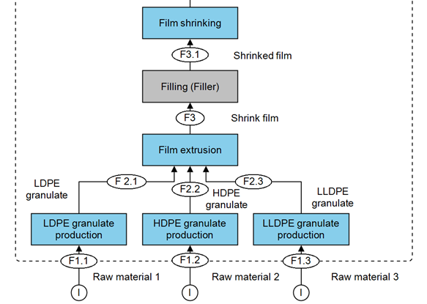

Flow Chart: Collation Shrinks – Paperboard Wrap

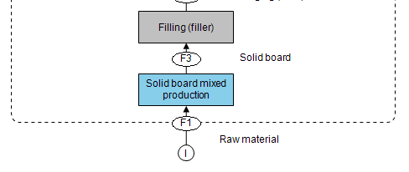
Flow Chart: Collation Shrinks – Cardboard Can Carrier & Cardboard Bottle Carrier

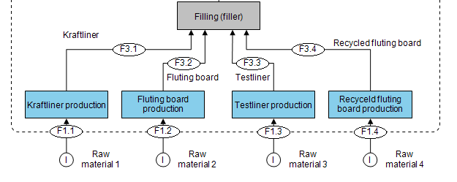

Tertiary Stretch Packaging for Pallets/ Shipping: Stretch Wraps
Flow Chart: Tertiary Stretch Packaging for Pallets/Shipping – LLDPE Stretch Film

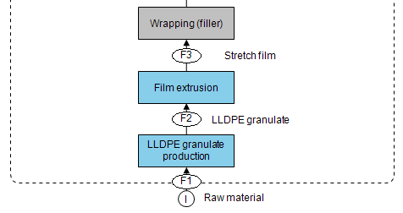

Flow Chart: Tertiary Stretch Packaging for Pallets/ Shipping – Paper Stretch Wrap

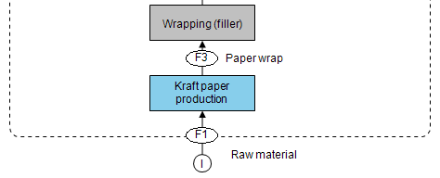

Rigid Packaging Non-Food
Body Lotion 150 mL
Flow Chart: Body Lotion 150 mL – HDPE Bottle
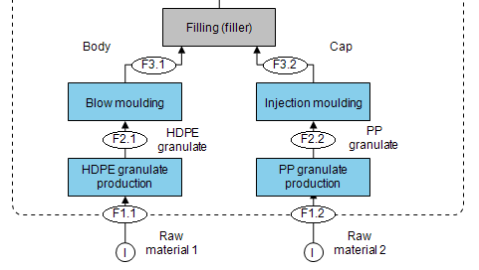

Flow Chart: Body Lotion 150 mL – Aluminium Can

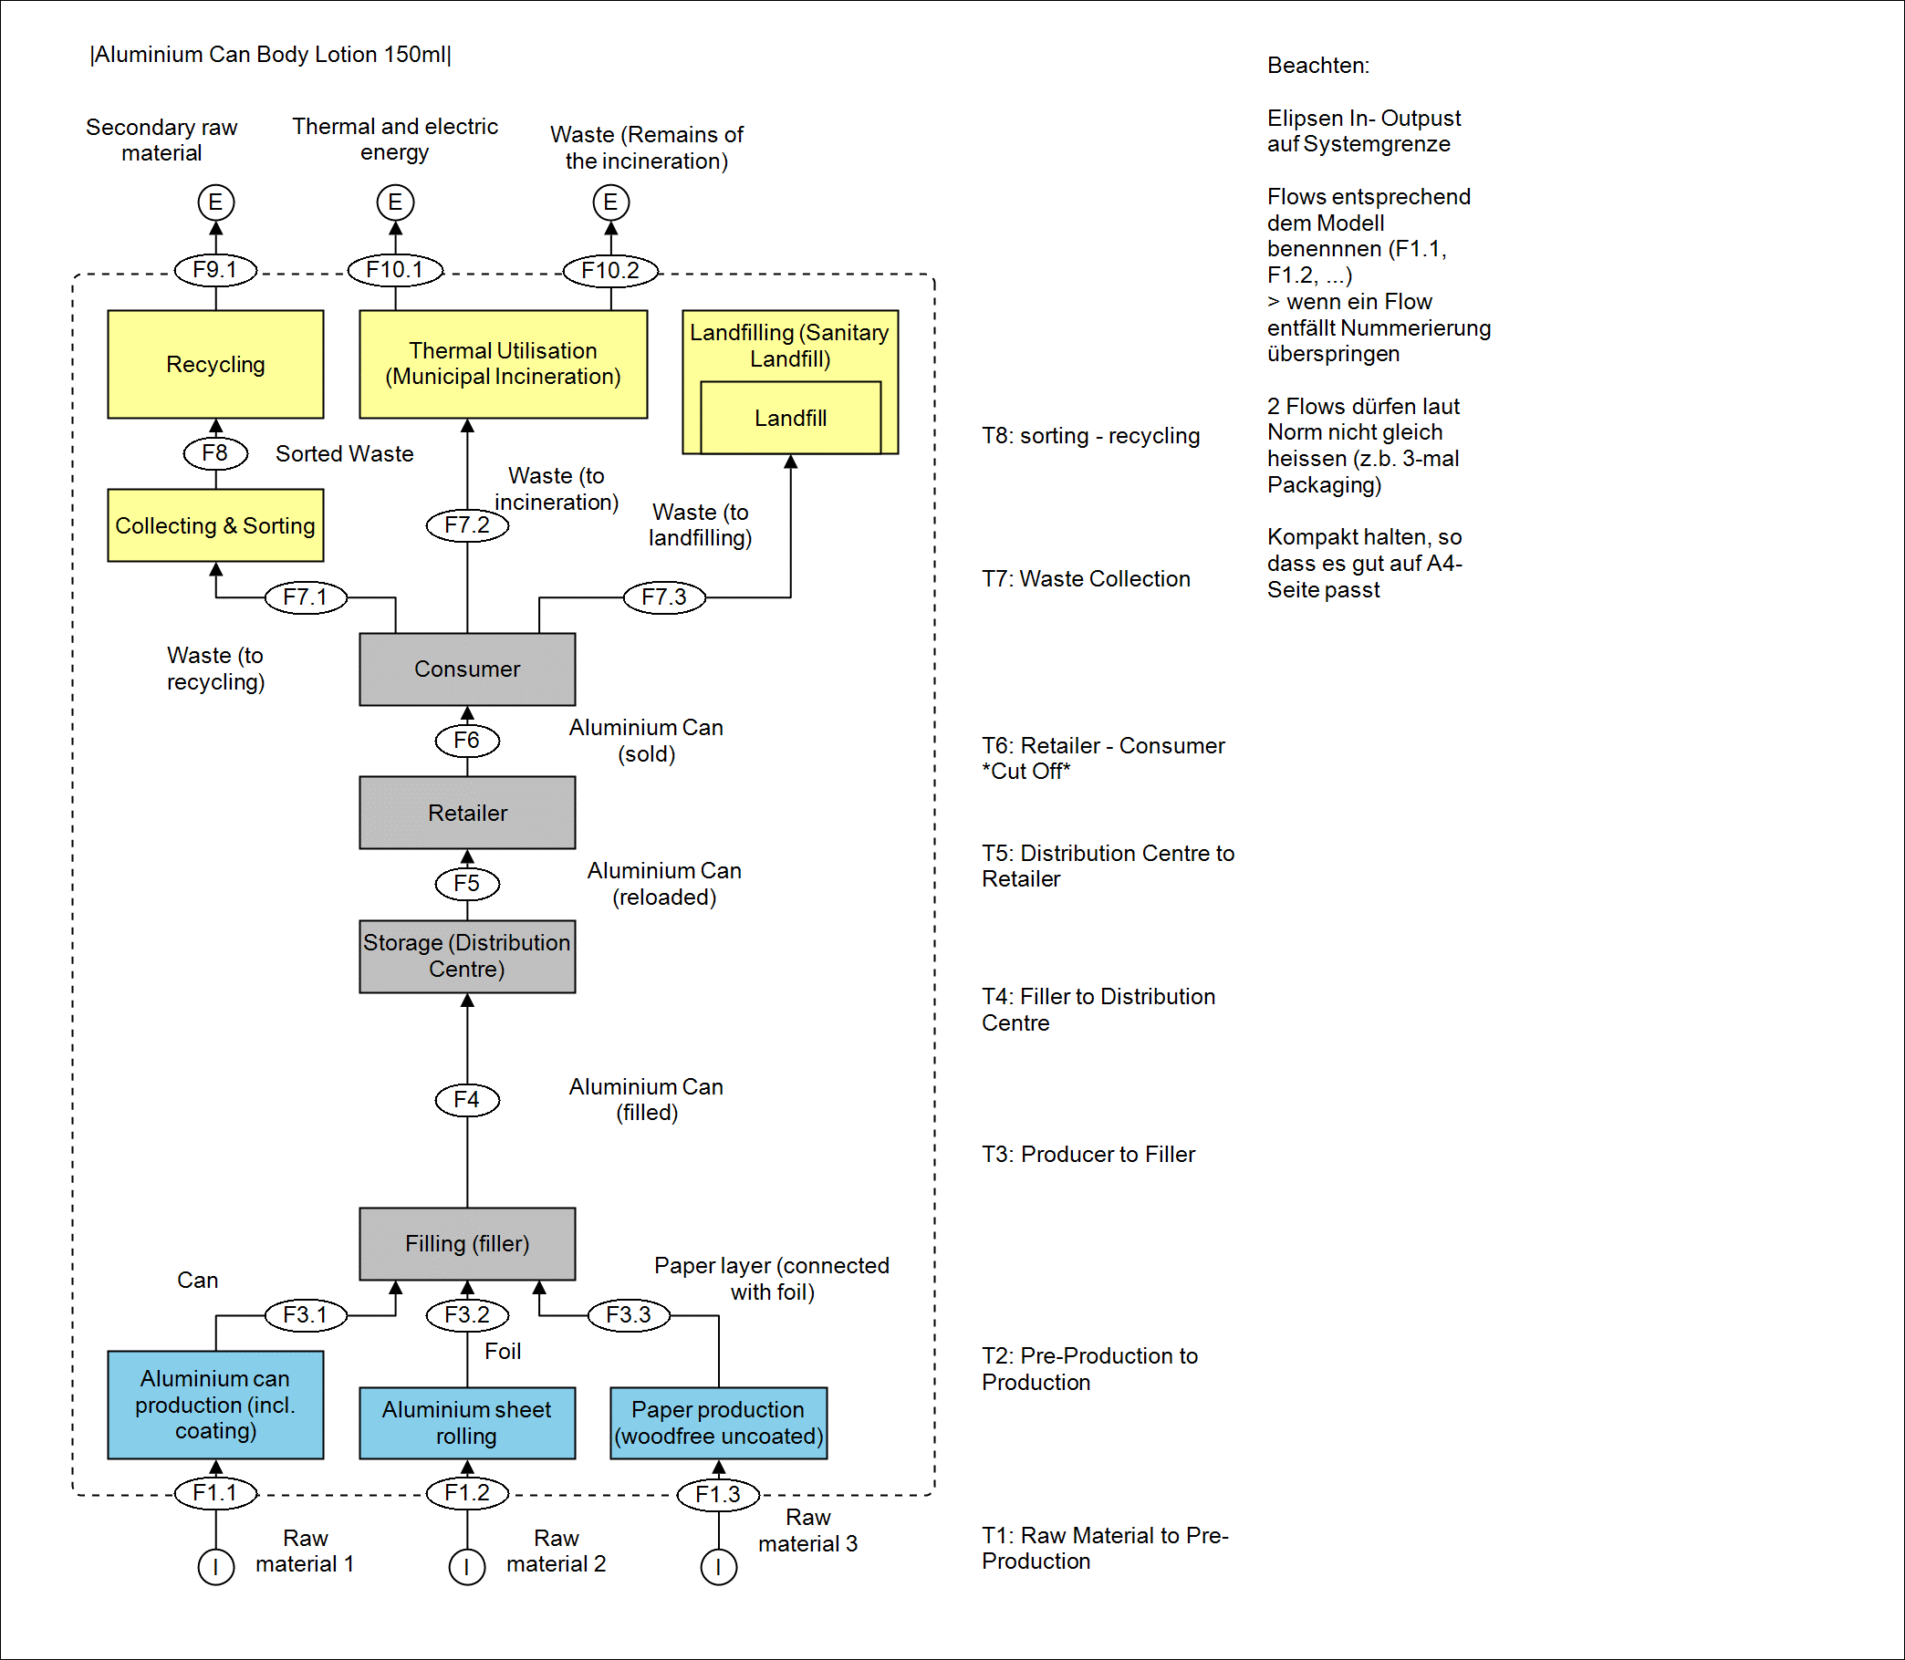
Flow Chart: Body Lotion 150 mL – Glass Jar

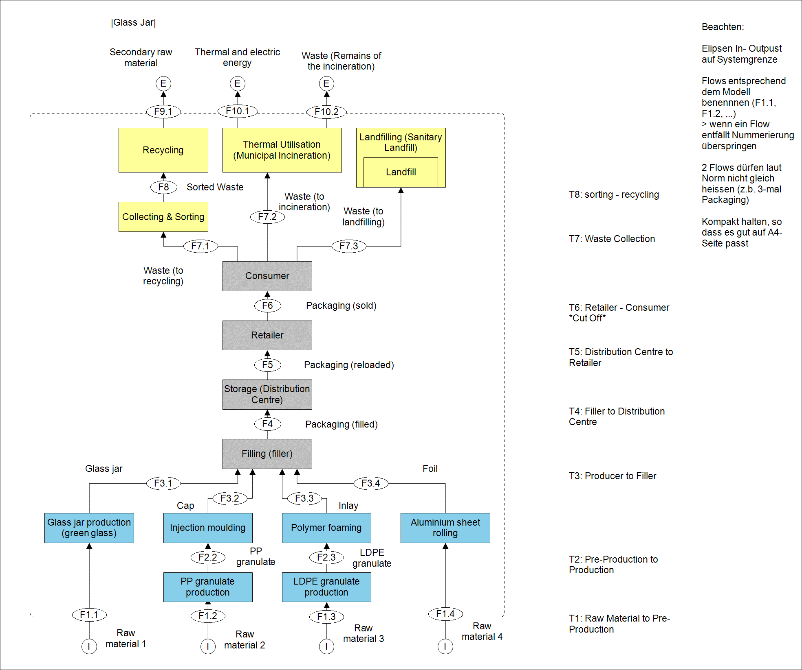

Body Lotion 250 mL
Flow Chart: Body Lotion 250 mL – Paper Bottle

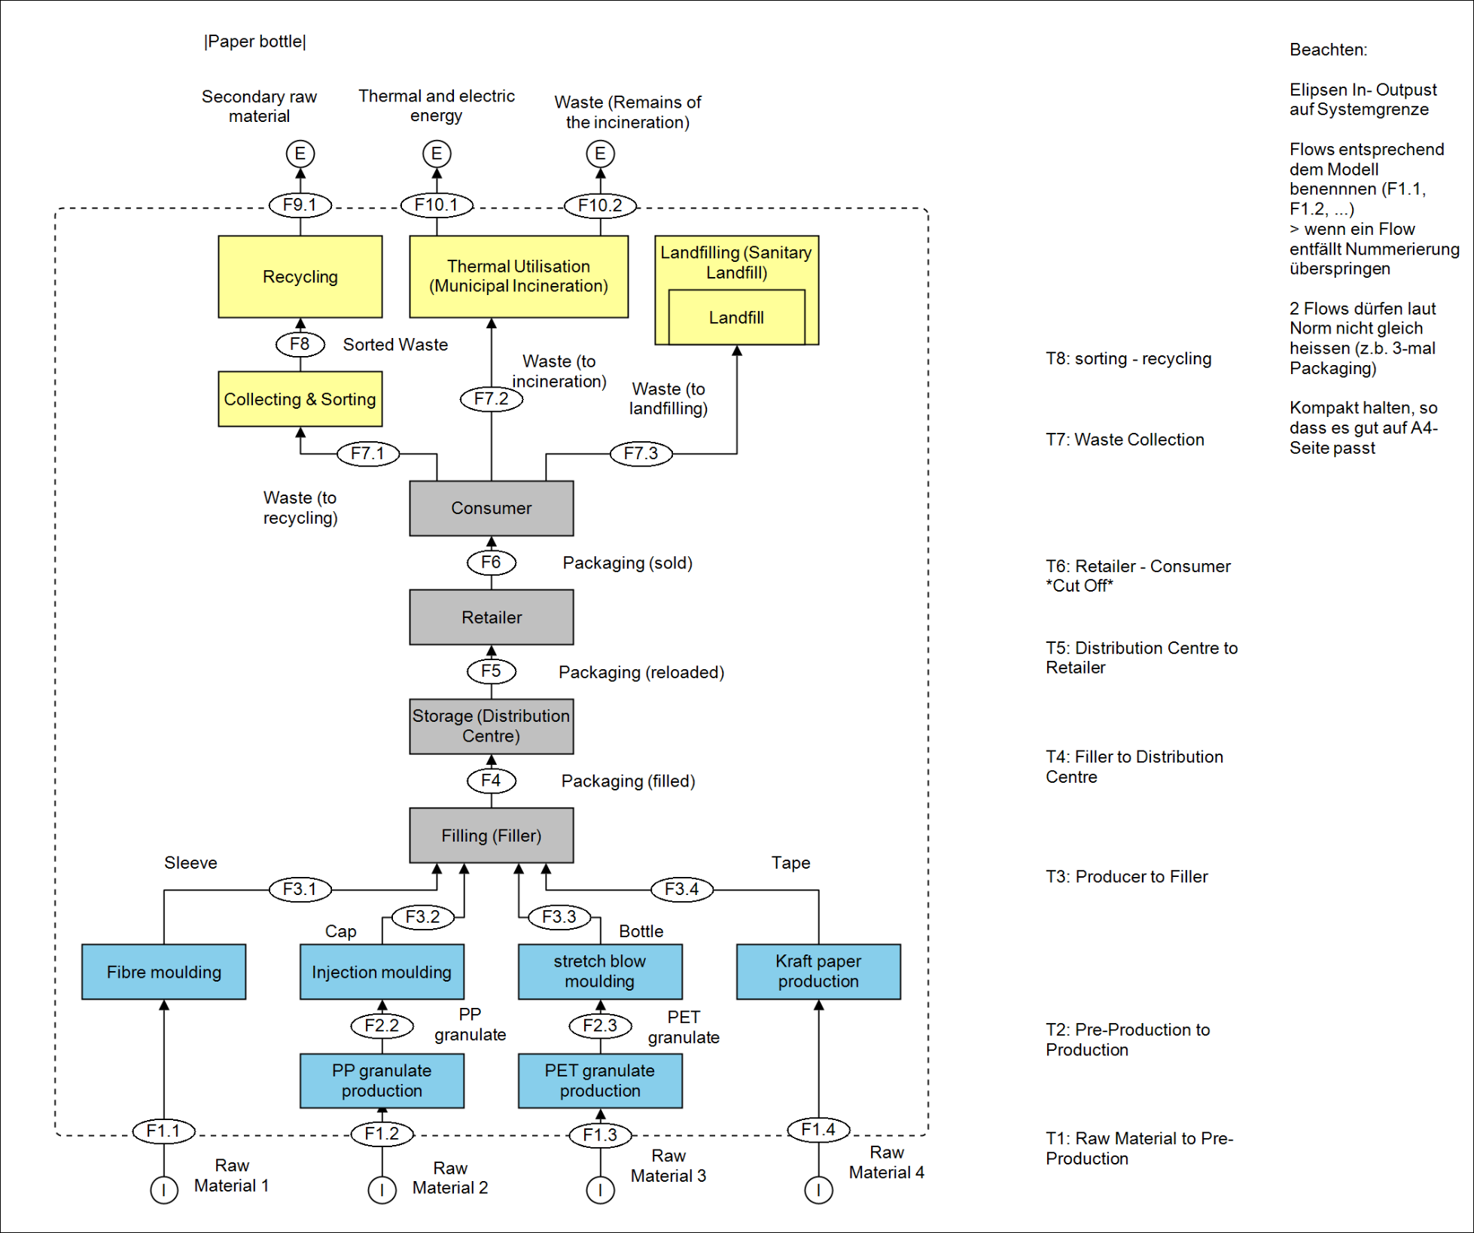

Flow Chart: Body Lotion 250 mL – HDPE Bottle

Shampoo 500 mL
Flow Chart: Shampoo 500 mL – Glass Bottle

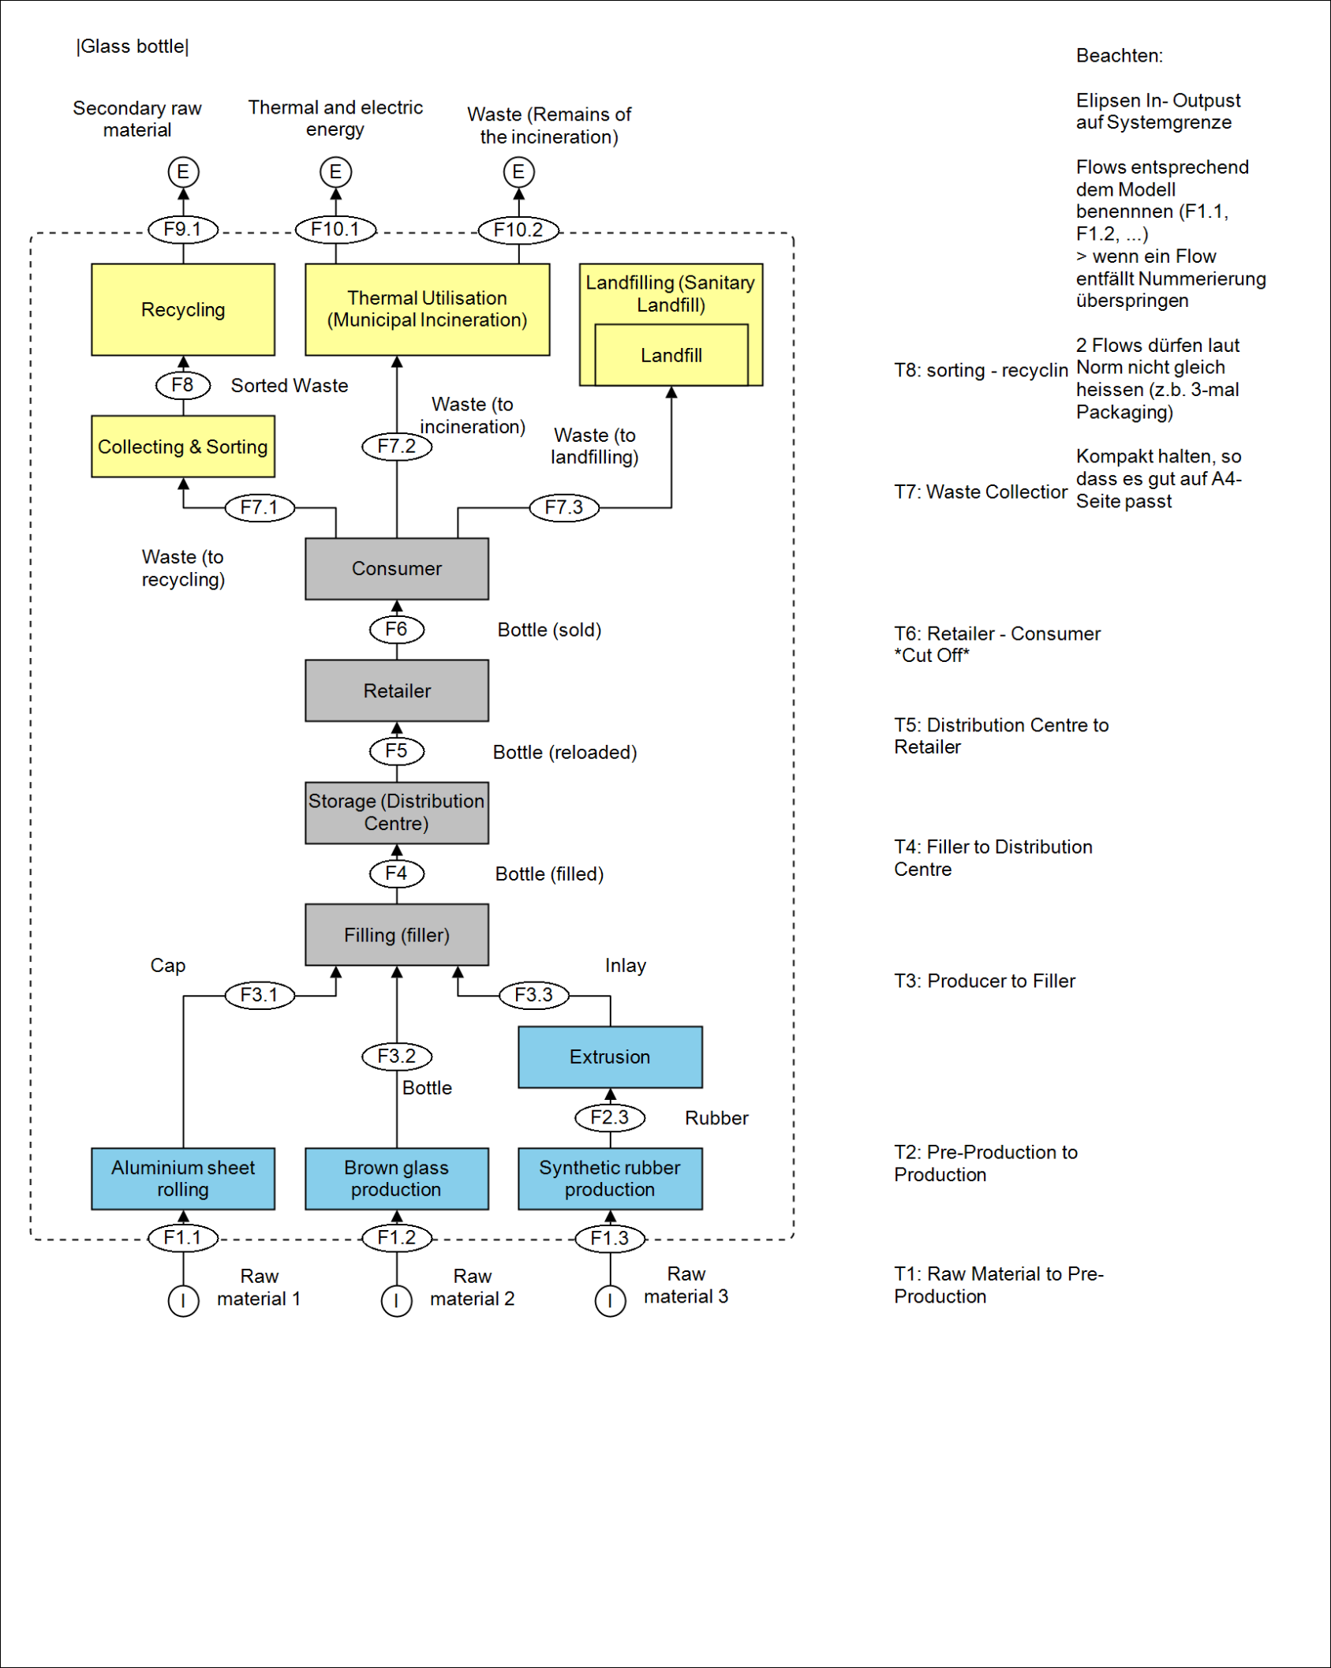

Flow Chart: Shampoo 500 mL – HDPE Bottle

Liquid Detergent 1.5 L
Flow Chart: Liquid Detergent 1.5 L – HDPE Bottle

Flow Chart: Liquid Detergent 1.5 L – Paper Bottle

Household Cleaner 1 L
Flow Chart: Household Cleaner 1 L – Glass Bottle

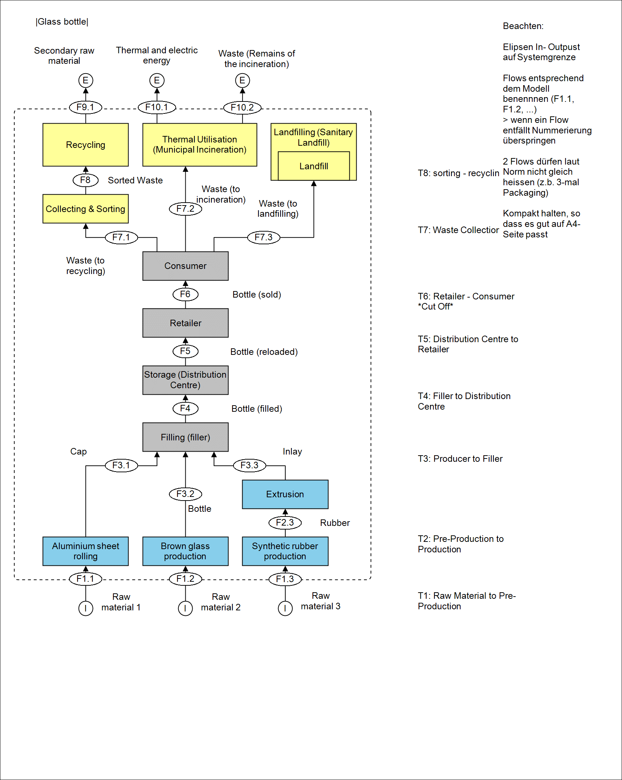

Flow Chart: Household Cleaner 1 L - HDPE Bottle

Flow Chart: Household Cleaner 1 L – Paper Bottle

Motor Oil 1 L
Flow Chart: Motor Oil 1 L – Tinplated Steel Canister

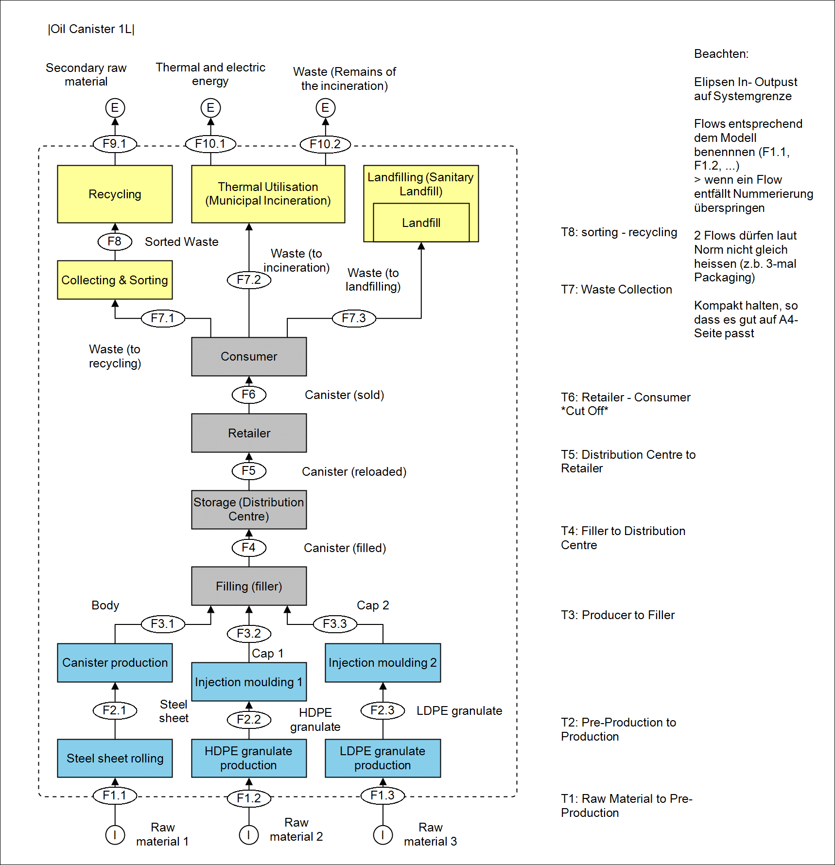

Flow Chart: Motor Oil 1 L – HDPE Canister

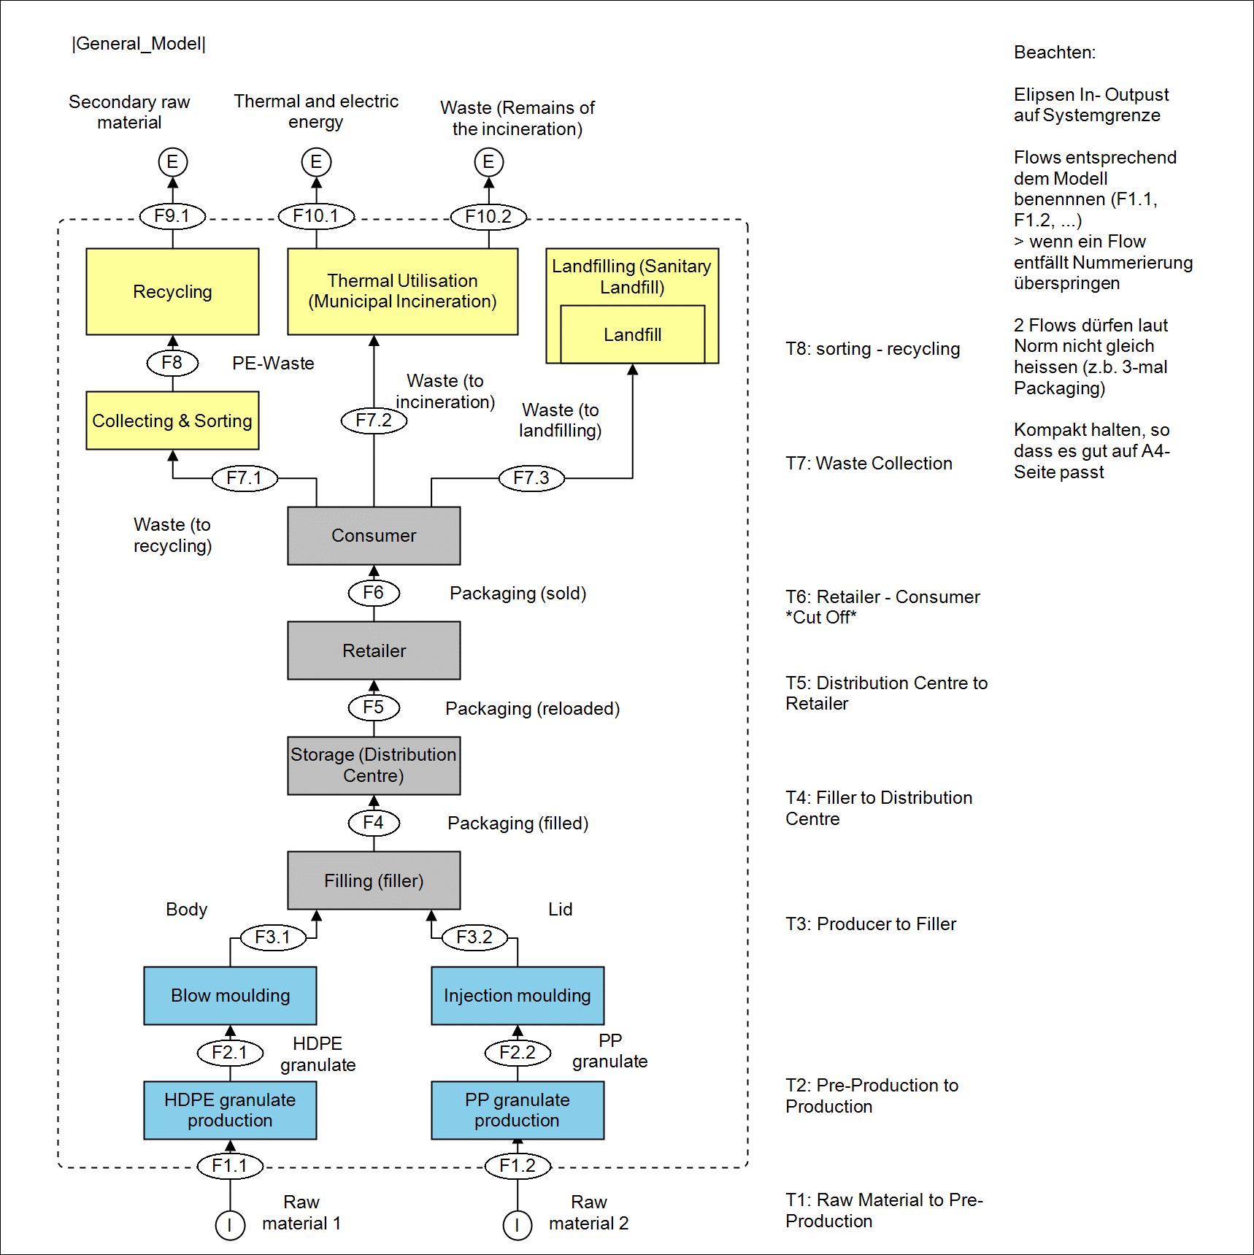

Dietary Supplements 140 mL
Flow Chart: Dietary Supplements 140 mL – HDPE Bottle

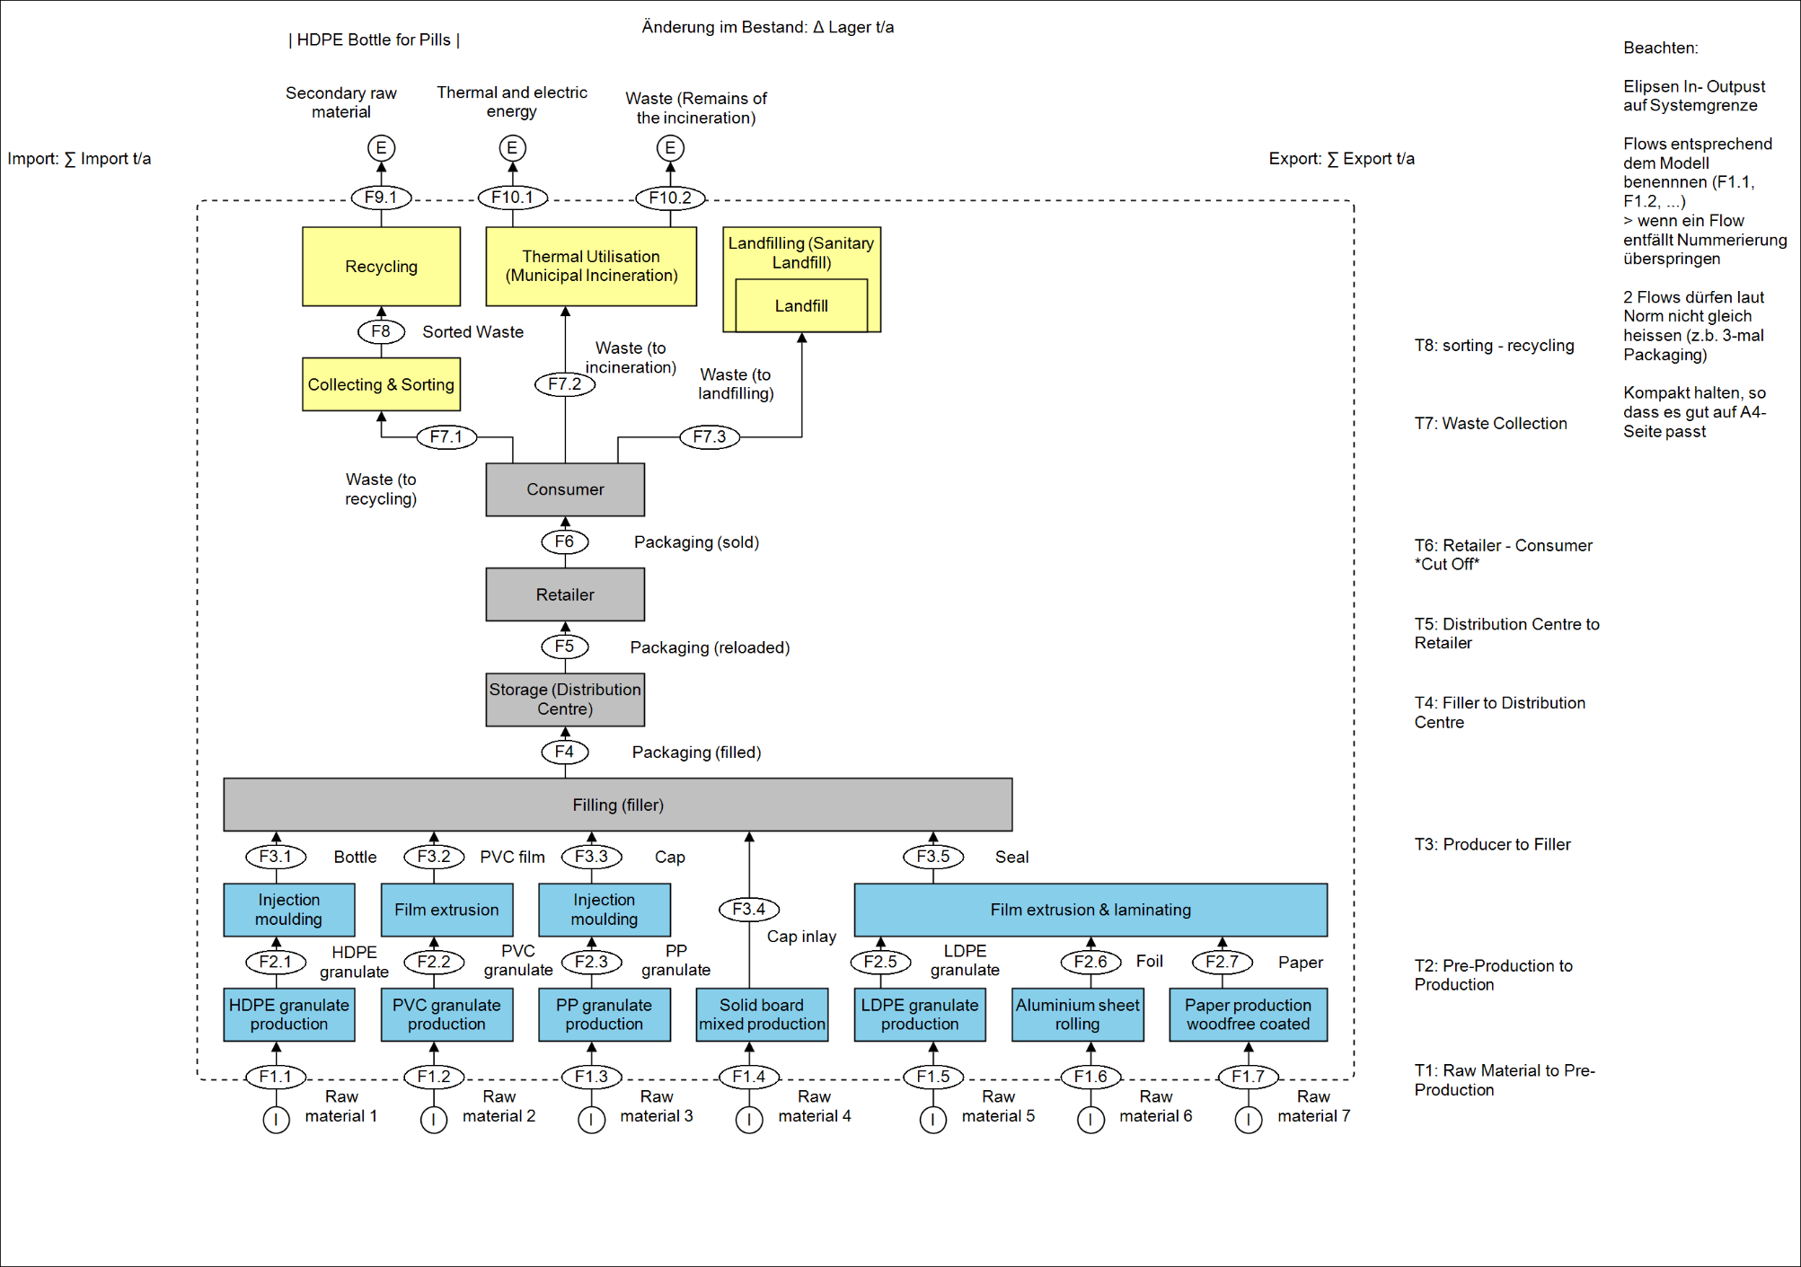

Flow Chart: Dietary Supplements 140 mL – Glass Bottle

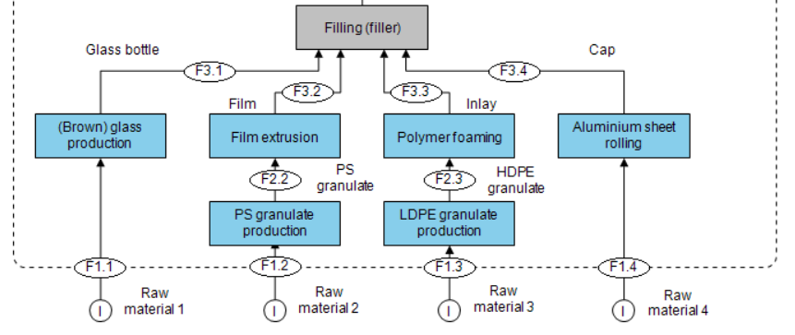

Wall Paint 2.7 L
Flow Chart: Wall Paint 2.7 L – HDPE Bucket

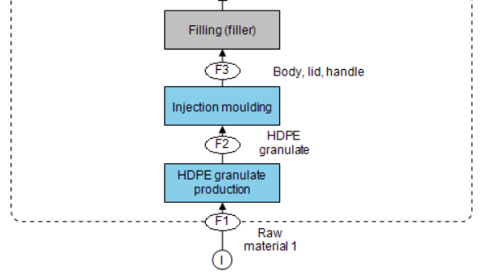

Flow Chart: Wall Paint 2.7 L – Tinplated Steel Bucket

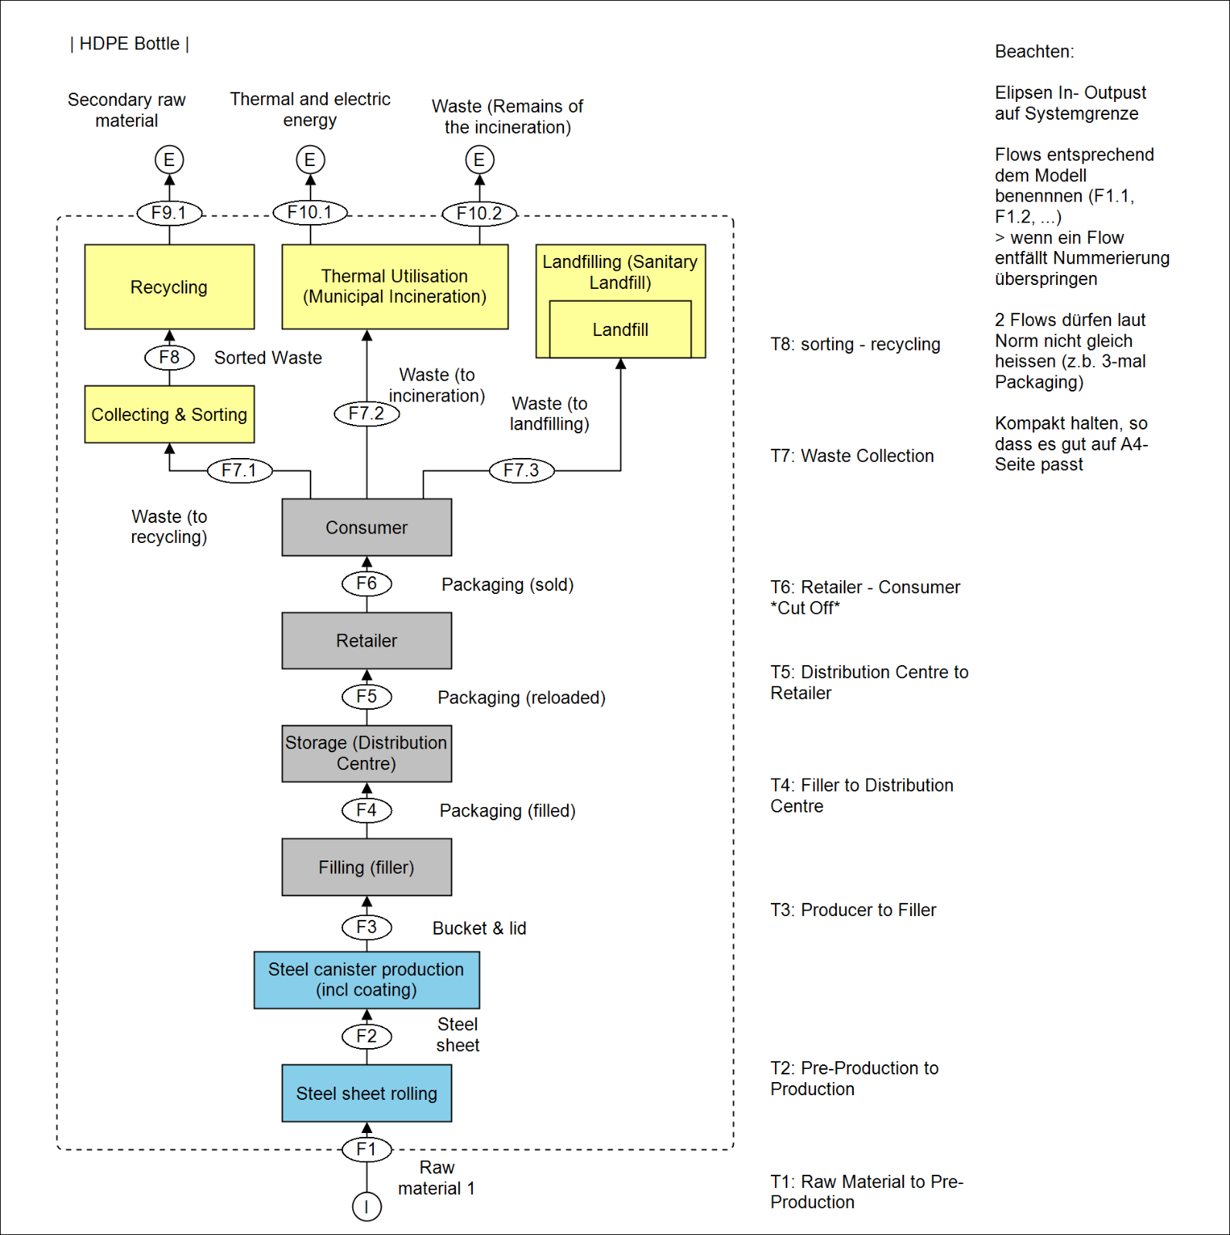
Wall Paint 10 L
Flow Chart: Wall Paint 10 L – HDPE Bucket

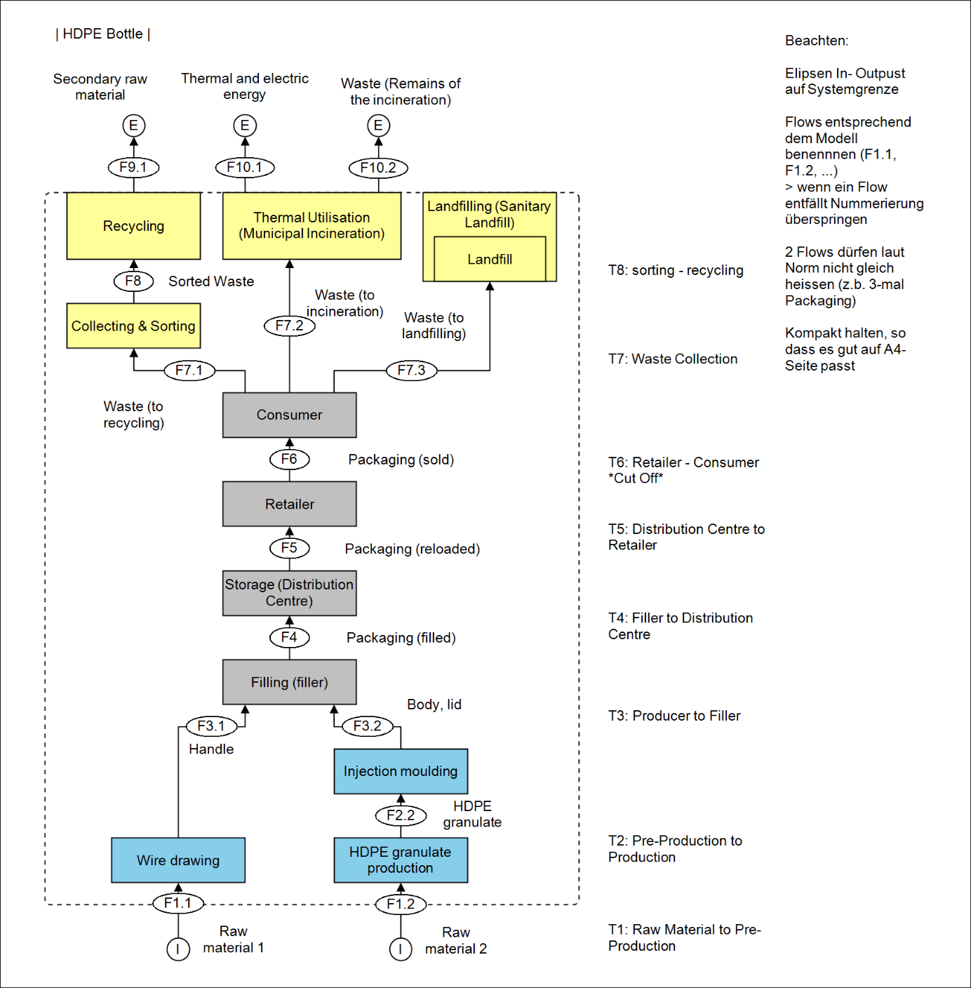

Flow Chart: Wall Paint 10 L – Tinplated Steel Bucket

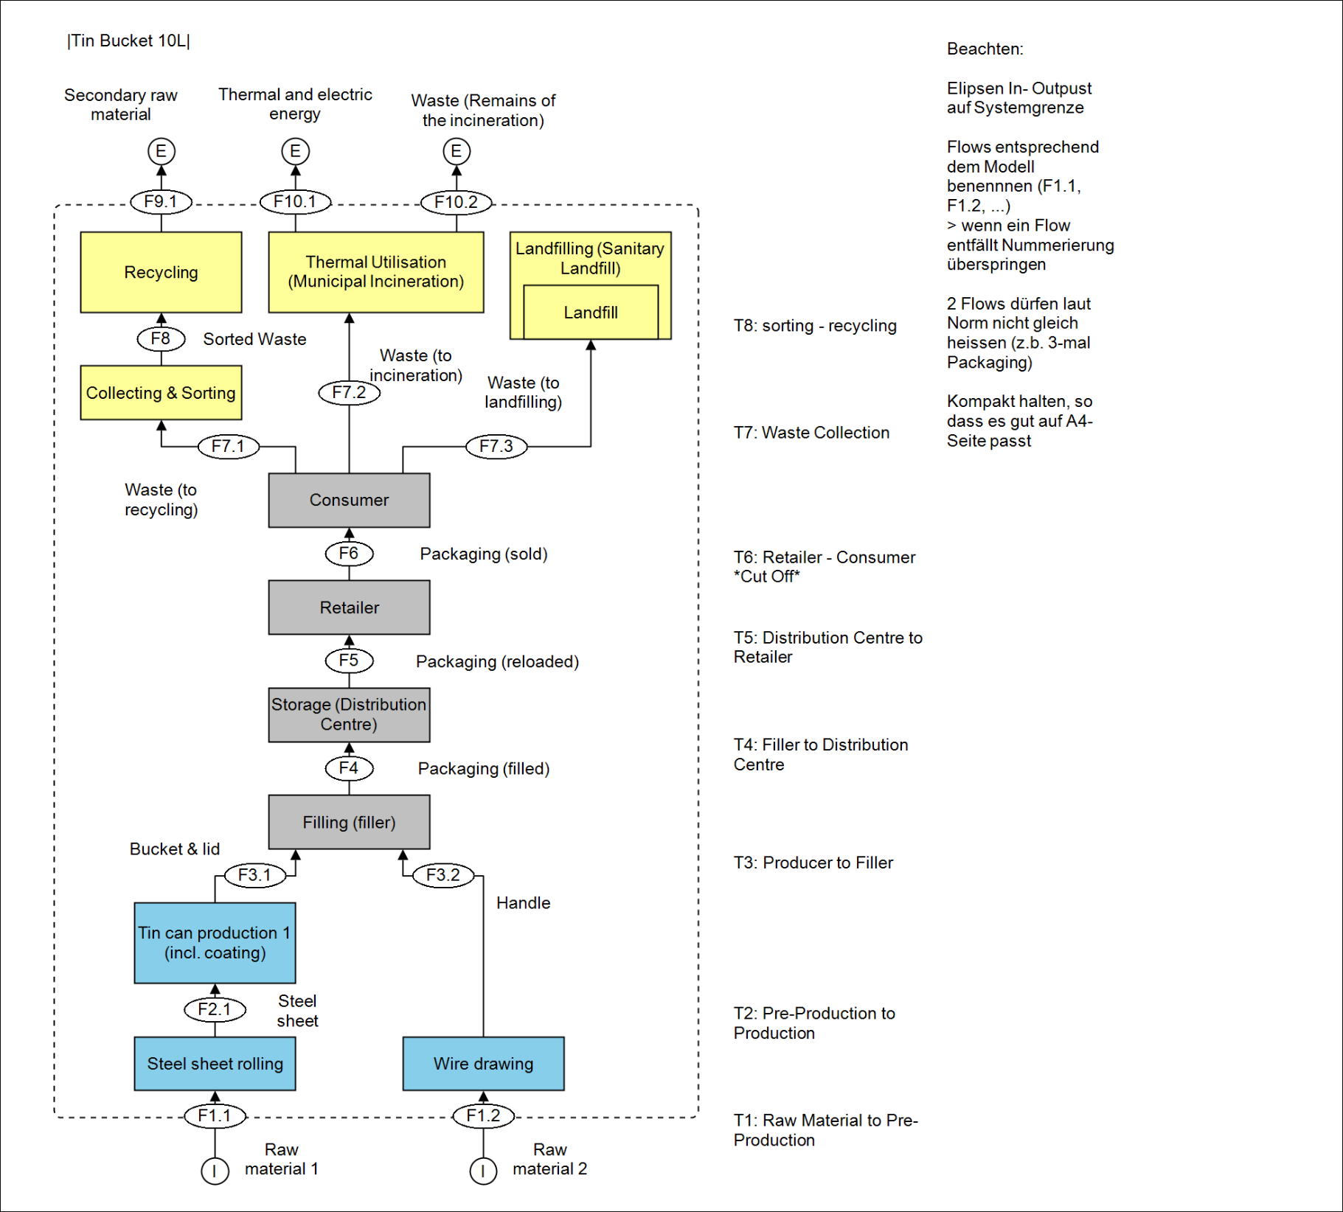

Heavy Duty Sacks
Pre-Mixed Cement 10 kg
Flow Chart: Pre-Mixed Cement 10 kg – Plastic HDS

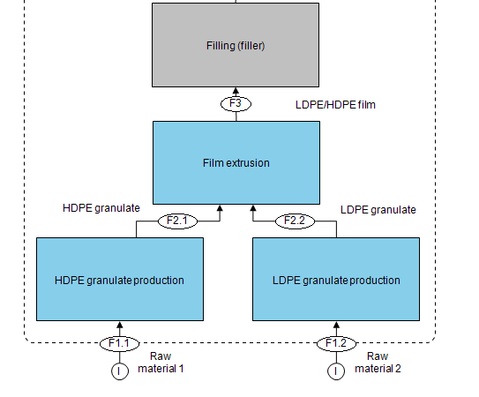

Flow Chart: Pre-Mixed Cement 10 kg – Paper HDS with Plastic Layer

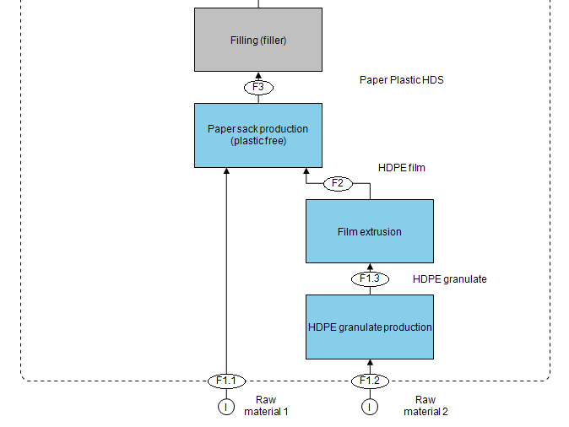
Cement 25 kg
Flow Chart: Cement 25 kg – Plastic HDS

Flow Chart: Cement 25 kg – Paper HDS with Plastic Layer

Chicken Fodder 20 kg
Flow Chart: Chicken Fodder 20 kg – Plastic HDS

Flow Chart: Chicken Fodder 20 kg – Paper HDS with Plastic Layer

Organic Fertiliser 10.5 kg
Flow Chart: Organic Fertiliser 10.5 kg – Plastic HDS

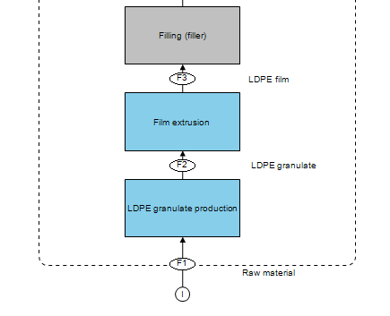

Organic Fertiliser 10.5 kg – Paper HDS

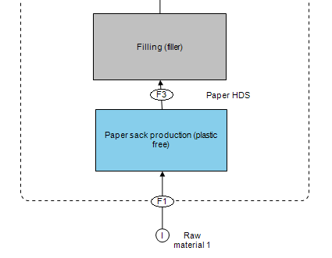
Fertiliser 20 kg
Flow Chart: Fertiliser 20 kg – Plastic HDS

Flow Chart: Fertiliser 20 kg – Paper HDS with Plastic Layer

Wood Pellets 15 kg
Wood Pellets 15 kg – Plastic HDS

Wood Pellets 15 kg – Paper HDS

Flexible Packaging
Frozen Mangos 500 g
Flow Chart: Frozen Mangos 500 g – LDPE/PET Stand-Up Pouch

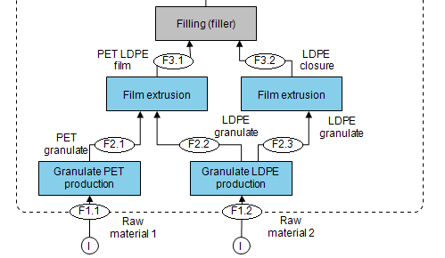

Flow Chart: Frozen Mangos 500 g – Laminated Paperboard Box

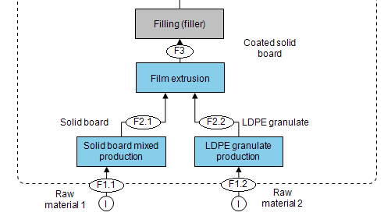

Frozen Raspberries 250 g
Flow Chart: Frozen Raspberries 250 g – LDPE Pillow Pouch

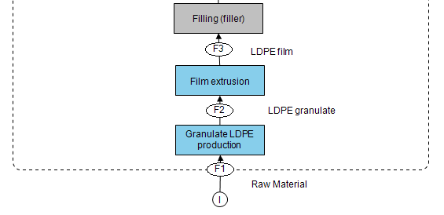

Flow Chart: Frozen Raspberries 250 g – Laminated Paperboard Box

Frozen Herbs 75 g
Flow Chart: Frozen Herbs 75 g – LDPE/PET Stand-Up Pouch

Flow Chart: Frozen Herbs 75 g – Laminated Paperboard Box

Frozen Peas 300 g
Flow Chart: Frozen Peas 300 g – LDPE Pillow Pouch

Flow Chart: Frozen Peas 300 g – Laminated Paperboard Box

Frozen Pizza Bread 300 g
Flow Chart: Pizza Bread 300 g – LDPE/PET Pillow Pouch

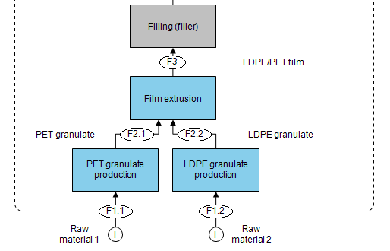

Flow Chart: Pizza Bread 300 g – Laminated Paperboard Box

Frozen Pizza 430 g
Appendix F, Figure 48: Flow Chart: Pizza 430 g – Shrink Film | * The process is actually arranged after the filler but is shown differently for reasons of simplification.

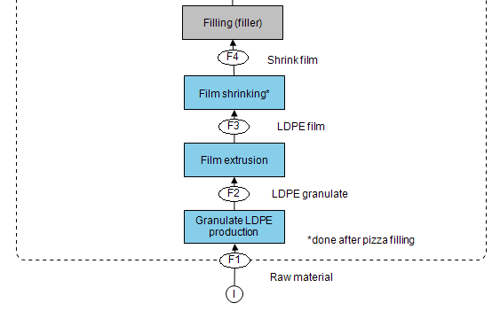

Flow Chart: Pizza 430 g – Laminated Paper Pouch
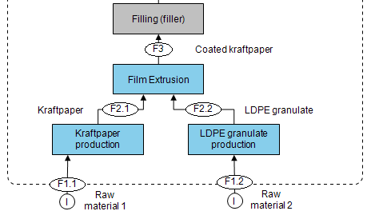

Flow Chart: Pizza 430 g – Laminated Paperboard Box
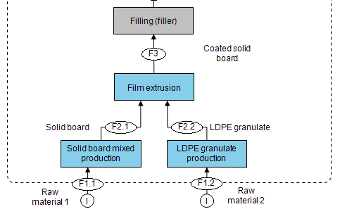

Flow Chart: Pizza 430 g – Paperboard Box and Shrink Film | * The process is actually arranged after the filler but is shown differently for reasons of simplification.
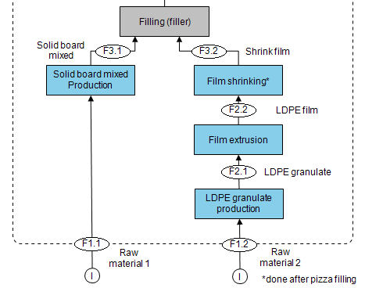

Coffee 250 g
Flow Chart: Coffee 250 g – LDPE/PP Gusseted Pouch

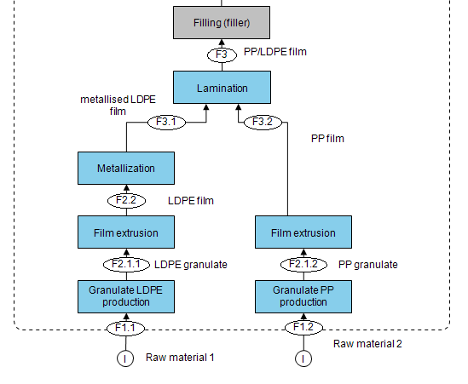
Flow Chart: Coffee 250 g – PET/Alu/PE Gusseted Pouch

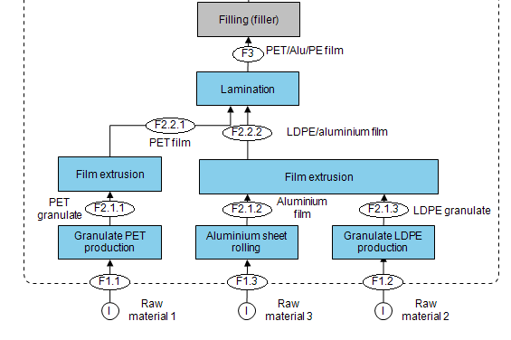

Coffee 250 g – Paper/PE Gusseted Pouch

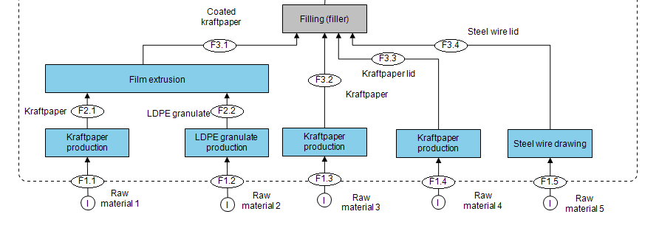

Coffee 250 g – Tinplate Can

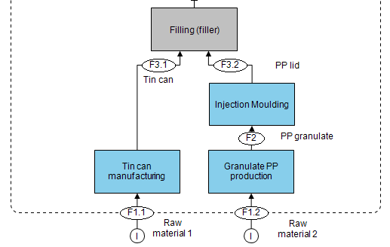

Instant Coffee 250 g
Instant Coffee 250 g – PET/Alu/PE Gusseted Pouch

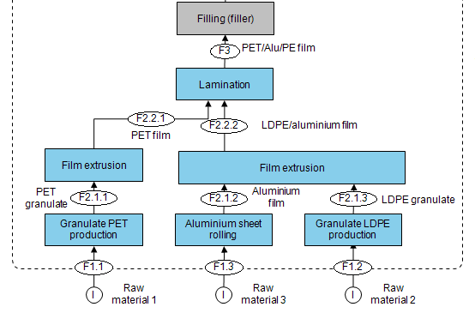

Instant Coffee 250 g – Tinplate Can

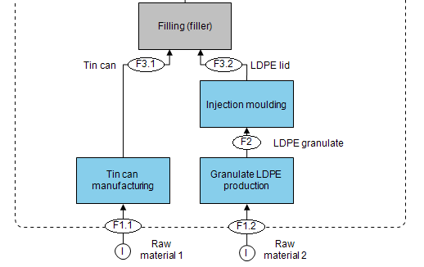

Flow Chart: Instant Coffee 250 g – Glass Container
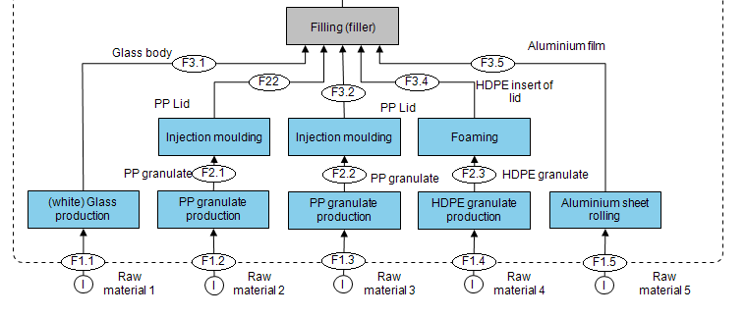

Hot Chocolate Powder 350 g
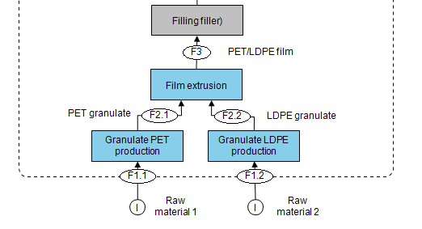
Flow Chart: Hot Chocolate Powder 350 g – LDPE/PET Pouch

Flow Chart: Hot Chocolate Powder 350 g – Paperboard Box

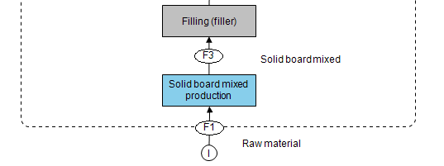
Flow Chart: Hot Chocolate Powder 350 g – Paperboard Box and Coated Paper Bag

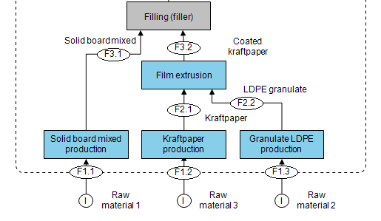
Mayonnaise 250 g
Mayonnaise 250 g – LDPE Spouted Stand-Up Pouch

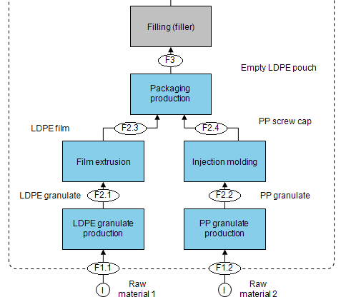

Flow Chart: Mayonnaise 250 g – Aluminium Tube
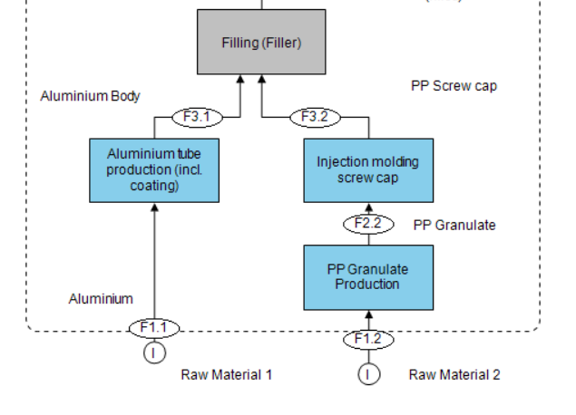

Flow Chart: Mayonnaise 250 g – Glass Jar
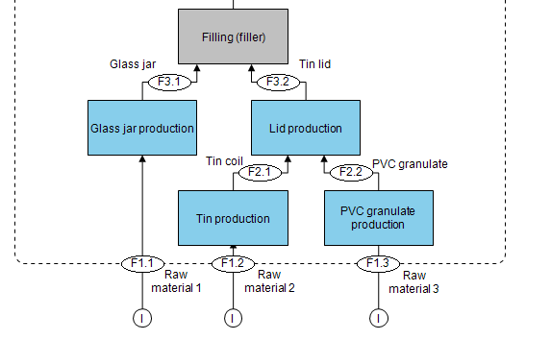

Apples 1 kg
Flow Chart: Apples 1 kg – LDPE Bag

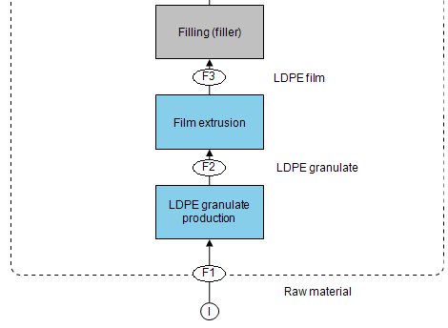

Flow Chart: Apples 1 kg – Cardboard Tray

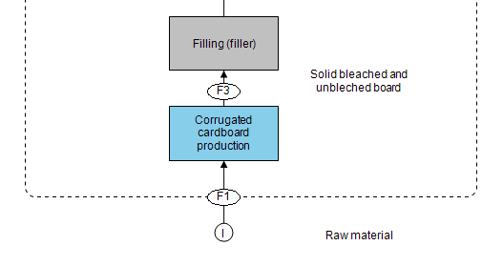

Flow Chart: Apples 1 kg – Paperboard Tray and LDPE Film

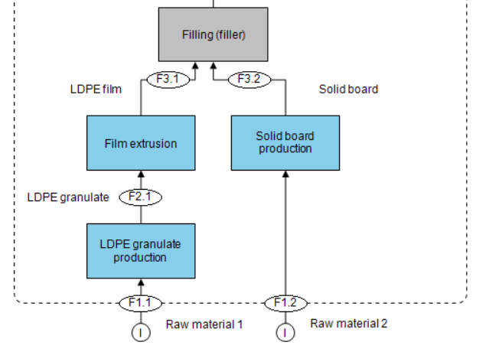

Produce Bags 1 kg
Flow Chart: Produce Bags 1 kg – LDPE Bag

Flow Chart: Produce Bags 1 kg – Paper Bag

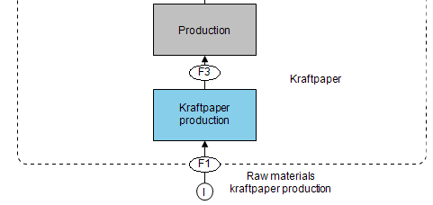
Juice 200 mL
Flow Chart: Juice 200 mL – PET/Alu/PE Stand-Up Pouch

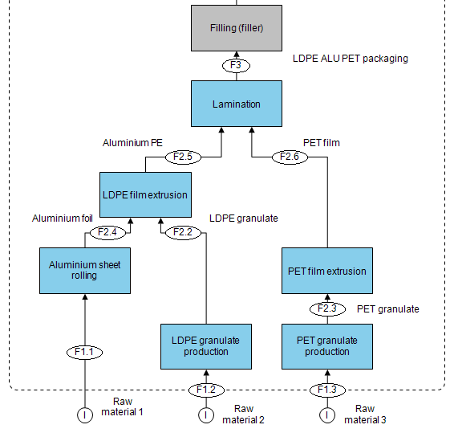

Flow Chart: Juice 200 mL – Beverage Carton

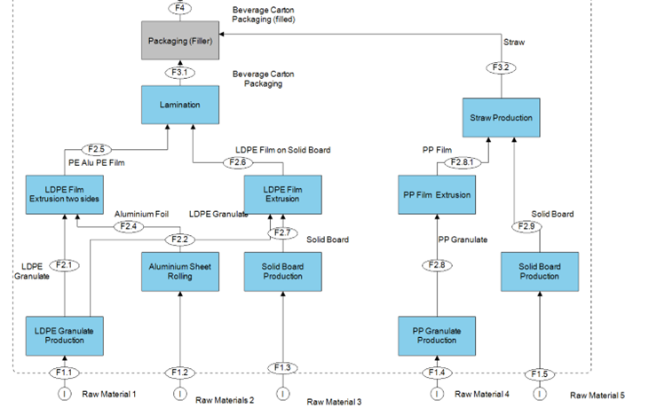

Flow Chart: Juice 200 mL – Non-Returnable Glass Bottle

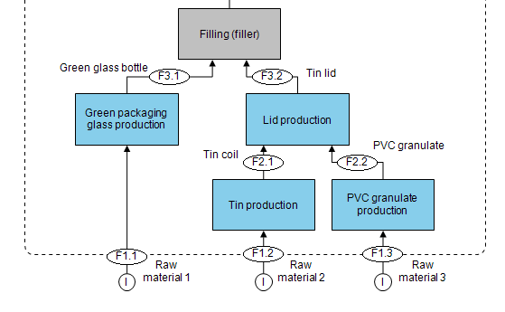
Sugar 1 kg
Flow Chart: Sugar 1 kg – LDPE/PET Pillow Pouch

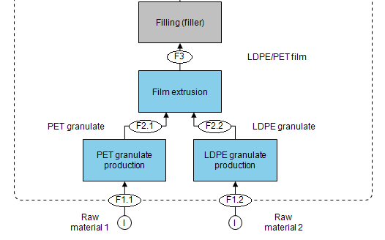

Flow Chart: Sugar 1 kg – Paper Bag

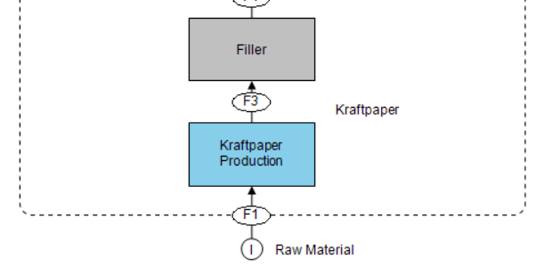

Flow Chart: Sugar 1 kg – Gable Top
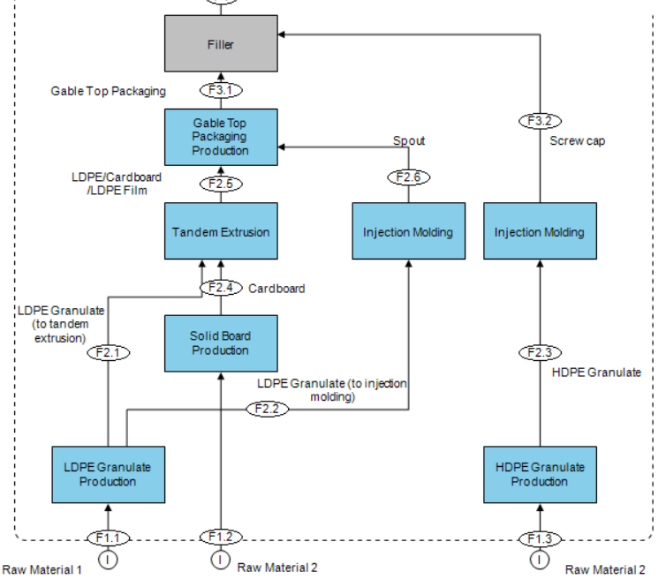

Salt 750 g
Flow Chart: Salt 750 g – LDPE Pillow Pouch

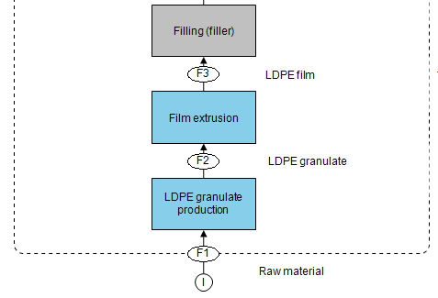
Flow Chart: Salt 750 g – Paperboard Tube and Plastic Lid

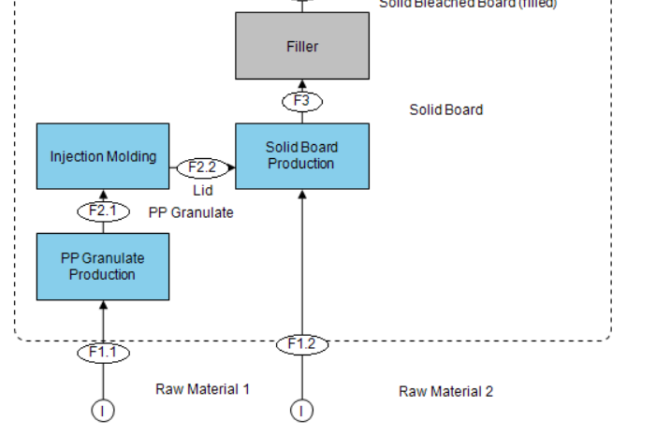

Flow Chart: Salt 750 g – Paperboard Box

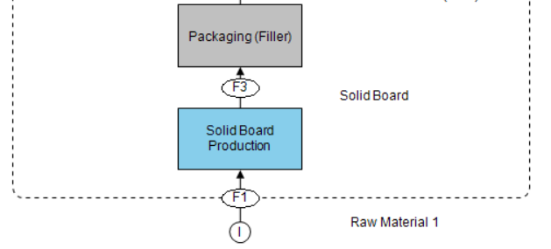
Cashew Nuts 150 g
Flow Chart: Cashew Nuts 150 g – Metallised LDPE Pillow Pouch
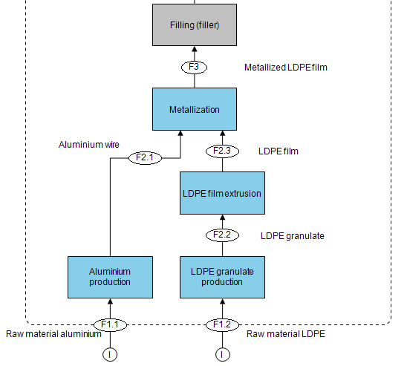

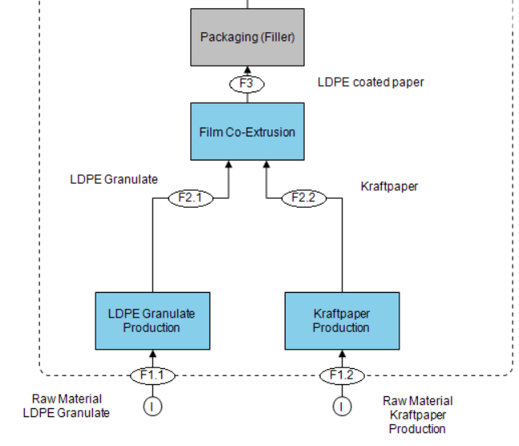
Flow Chart: Cashew Nuts 150 g – Paper Stand-Up Pouch

Flow Chart: Cashew Nuts 150 g – Tinplate Can

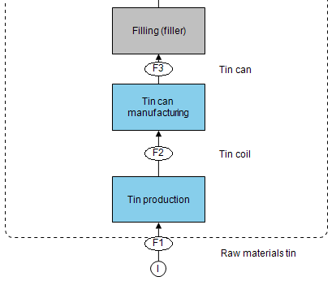

Potatoes 1.5 kg
Potatoes 1.5 kg – LDPE Bag

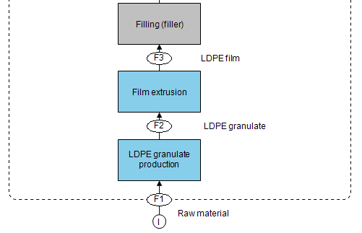

Flow Chart: Potatoes 1.5 kg – Gusseted Paper Sack

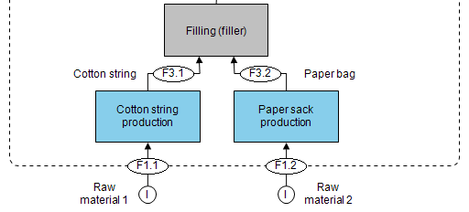

- Recyclability assessment
The following steps were conducted for the calculation of the technical recyclability:
- Definition of the disposal unit
- Determination of the recycling streams
- Classification of the materials
- Calculation of the technical recyclability
The classification is conducted according to the following scheme:
- Classification of Technical Recyclability
Level | Classification | Definition
A | Good  compatibility | The material can be recycled in the incoming material stream and the recycled material used for material-identical, high-quality applications. Here it can be assumed that the recycled material obtained is suitable for circular applications.
B | Limited  compatibility | The material can be recycled in the incoming material stream, but the quality of the recycled material is impaired. In addition, the recycled material quality of other materials in the disposal unit will be negatively affected. The obtained recycled material is mainly used for downcycling applications.
C | Poor  compatibility | The material cannot be recycled in the incoming material stream, but the recyclability and recycled material quality of other materials in the packaging unit is not affected.
D | No  compatibility | The material cannot be recycled in the incoming material stream and potentially negatively affects the recyclability and recycled material quality of other materials in the disposal unit. This may limit the application areas of recovered recycled material from other materials from circular applications to downcycling.
X | Knock-out | The material cannot be recycled in the incoming material stream and leads to contamination of the disposal unit. All materials in the disposal unit that are recycled with this material during the recycling process are considered contaminated and therefore not recyclable. In addition, this rating is also assigned if packaging main bodies are incorrectly sorted (major loss of recyclability) or if disposal units are immediately assigned to the thermal fraction due to their size.

To calculate the technical recyclability, the mass fractions of the materials of a packaging unit that have been rated A and B are divided by the total mass of the packaging unit and multiplied by 100.
$$\frac{(Weight of components \left(A+B\right))}{(Total weight disposal Unit) }*100=Recyclability in \%$$

Terminology
Technical Recyclability:
The proposed method calculated the technical recyclability of a packaging system on a material level. To be considered recyclable, a material had to meet the following four requirements:
• In the chosen country, a collection infrastructure for the material in question is in place.
• The material can be sorted into one of the predefined material streams in place in the chosen country with state-of-the-art sorting infrastructure and procedures.
• Within a material recycling process, the recycled material of the material can be gathered.
• The obtained recycled material has market potential and could further be used as a replacement for material identical virgin material applications.
Technical recyclability had to be differentiated from the following other definitions of recyclability:
• The recycling rate: The recycling rate describes the rate between the amount of material put into circulation and the amount of material which are recycled within a material recycling process. Within the European Union (EU), packaging waste is considered as recycled as soon as it is put into a recycling process according to 2018/852/EC to change guideline 94/62/EC.
• The recycling potential: The recycling potential is defined similarly to technical recyclability. However, only the potential of material recycling is considered. Hence, lacking sorting and recycling infrastructure in a given country or region can be neglected as well as missing the current market potential of the recycled material.
Assessment
The recyclability of the packaging systems analysed are assessed according to the FH Campus Vienna Circular Packaging Design Guideline (Gürlich, Kladnik, & Pavlovic, 2022) that is based on the relevant European Design for Recyclability standards. The actual calculation was performed using the PACO webtool.(Gürlich Ulla et al. 2023).

- Functional Units
- Functional Units

Packaging Category | Product | Functional Unit
Collation Shrink | Six cans 0.33 L | Secondary packaging holding together six standard-sized aluminium cans with a volume of 0.33 L
 | Six cans 0.5 L | Secondary packaging holding together six standard-sized aluminium cans with a volume of 0.5 L
 | Six bottles 0.5 L | Secondary packaging holding together six standard-sized PET bottles with a volume of 0.5 L
 | Six bottles 1.5 L | Secondary packaging holding together six standard-sized PET bottles with a volume of 1.5 L
Stretch Wraps | Pallet | Machine wrapping of a standard pallet configuration [1.2 m x 0.8 m x 1.15 m; 1000 kg]
Rigid packaging (non-food) | Body lotion 150 mL | Packaging of 150 mL body lotion
 | Body lotion 250 mL | Packaging of 250 mL body lotion
 | Shampoo 500 mL | Packaging of 500 mL shampoo
 | Liquid detergent 1.5 L | Packaging of 1.5 L liquid detergent
 | Household cleaner 1 L | Packaging of 1.0 L household cleaner
 | Motor oil 1 L | Packaging of 1 L motor oil
 | Dietary supplements 140 mL | Packaging of capsules in a volume of 140 mL
 | Wall paint 2.7 L | Packaging of 2.7 L wall paint
 | Wall paint 10 L | Packaging of 10 L wall paint
Heavy-duty sacks (HDS) | Pre-mixed cement, 10 kg | Packaging of 10 kg pre-mixed cement
 | Cement, 25 kg | Packaging of 25 kg standard cement
 | Chicken fodder, 20 kg | Packaging of 20 kg chicken fodder
 | Organic fertiliser, 10.5 kg | Packaging of 10.5 kg organic fertiliser
 | Fertiliser, 20 kg | Packaging of 20 kg fertiliser
 | Wood pellets, 15 kg | Packaging of 15 kg wood pellets
Flexible food | Frozen mangos, 500 g | Deep-freeze suitable packaging of 500 g mango cubes
 | Frozen raspberries, 250 g | Deep-freeze suitable packaging of 250 g raspberries whole
 | Frozen herbs, 75 g | Deep-freeze suitable packaging of 75 g frozen herbs cut
 | Frozen peas, 300 g | Deep-freeze suitable packaging of 300 g peas whole
 | Frozen pizza bread, 300 g | Deep-freeze suitable packaging of 300 g pizza bread
 | Frozen pizza, 430 g | Deep-freeze suitable packaging of 430 g pizza
 | Coffee, 250 g | Packaging of 250 g coffee beans not grounded
 | Instant coffee, 250 g | Packaging of 250 g instant coffee powder
 | Hot chocolate, 350 g | Packaging of 350 g hot chocolate powder
 | Mayonnaise, 250 g | Packaging of 250 g mayonnaise sauce
 | Apples, 1 kg | Packaging of 1 kg apples whole
 | Produce bag, 1 kg | Ready-to-use packaging for self-filled fruits & vegetables with a carrying capacity of 1 kg
 | Juice, 200 mL | Packaging of 200 mL juice carbon dioxide-free
 | Sugar, 1 kg | Packaging of 1 kg sugar
 | Salt, 750 g | Packaging of 750 g salt
 | Cashew nuts, 150 g | Packaging of 150 g cashew nuts whole
 | Potatoes, 1.5 kg | Packaging of 1.5 kg potatoes

Not included in the FU are the lifecycle of the packaged product itself, transports to consumer, construction site, etc. and the use phase of the packaging, which can be broken down into two components: (1) loss prevention (packaging breakage rates), and (2) cleaning packaging before disposing of it (for example flushing out cups or cans with tap water and cleaning agents).

- Cut-Off Criteria

- Cut-off criteria

Cut-off | Life cycle phase | Source | Assumption and justification
Filling (all processes) | Production |  | It is assumed that the filling process is strongly dependent on the filling good and not necessarily on the packaging. As the filling good does not significantly differ within a comparison, the filling is not considered relevant for the comparison.
Distribution centre (all processes) | Distribution |  | Not relevant for comparison (no relevant differences between the systems under examination expected); Impact assumed to be negligible.
Retailer (all processes) | Distribution |  | Not relevant for comparison (no relevant differences between the systems under examination expected); Impact assumed to be negligible.
Secondary and tertiary packaging | Distribution |  | It is expected to be negligible, as also shown by a sensitivity analysis (Chapter 5.6.2.6).
Consumer (all processes) | Use |  | High uncertainty expected due to lack of reliable data. Would exceed scope of study. Not relevant for comparison (no relevant differences between the systems under examination expected)
Transport (T6): retailer to consumer | Use | According to PEF, the transport: retailer - final client (customer) (T6) is calculated as follows: 5 km; 62% passenger car (allocated via transport volume and transported goods volume), 33% no impact, 5% van (European Commission 2018) | High uncertainty or variance expected. Impact assumed to be negligible.  According to the PEF, the effects of the recommended passenger cars should be calculated using the volume of the available transport space and the volume of the goods to be transported. However, as the volume should be allocated to the product and not the packaging (as it is not the packaging but the product that is purchased) and as it is assumed that the impact would be negligible, the transport T6 is cut-off.
Transport: consumer to civic amenity site | EOL |  | High uncertainty or variance expected; A transport consumer to waste treatment is assumed instead. Impact assumed to be negligible.
Labels and Prints | In general |  | Different manufacturers can use very different printing inks (Ink less than 0.2% impact in GWP), thus not considered; Not important for comparison; Due to the low expected impact, the printing and inks are cut off. In the case of metal packaging, the coating is not cut off as it serves both to protect the product and (especially in the case of steel packaging) to protect the packaging.
Labels | In general |  | Labels usually have a low weight compared to the rest of the packaging. This is especially true in the areas where labels are commonly used (rigid, stretch wraps [label weight <1%]); Different manufacturers can use very different labels (shape, size, materials) - this applies to all types of packaging. Not relevant for comparison (no relevant differences between the systems under examination expected).
Adhesives | In general |  | It is difficult to determine the components and used weights of adhesives. They occur in only small quantities (<1%) and therefore have little effect on the impact categories under investigation. (Lamination is included.)
Rejects & damaged packaging during production and transport. | In general |  | There is a lack of data on this point. However, it is assumed that only minimal quantities of packaging are produced as waste or are damaged during transport, which is why this point is cut off.

- Life Cycle Impact Assessment Methods
The life cycle impact assessment method chosen for this study is the Environmental Footprint method, published by the European Commission. More precisely, the EF method (adapted) as published via the software portal openLCA nexus by GreenDelta is used (European Commission 2018)(Green Delta 2024). However, due to the study’s limited scope, only three relevant impact categories were assessed and interpreted: climate change, expressed in kg CO₂-eq; water scarcity, expressed in m³ deprived; and fossil resource use, expressed in MJ.
The assessment was carried out using PAST version 4.0, an internally developed semi-automated software tool by Circular Analytics, which is partly based on the LCA software openLCA 2.0 and data from ecoinvent (v3.8).

- Impact categories and characterisation methods

EF Impact Category | Impact Category Indicator | Unit | Characterisation Model
Climate change,  total | Global warming  potential (GWP100) | kg CO₂-eq | Bern model – Global Warming Potentials (GWP) over a 100 year time horizon (based on IPCC 2013)
Water scarcity | User deprivation  potential (deprivation-weighted water consumption) | m³ water-eq of  deprived water | Available Water Remaining (AWARE) model (Boulay et al. 2018)
Resource use,  fossils | Abiotic resource  depletion – fossil  fuels (ADP-fossil) | MJ | (van Oers et al. 2002) as in CML 2002 method, v.4.8

- Life Cycle Inventory (LCI)

Collation shrink films

- Collation shrinks
Product/ Process |  | Assumptions and remarks | Source
Cans 0.33 L x 6 | shrink film | Multilayer film  composition:  53,1% LDPE  10,8% HDPE  36,1% LLDPE | Measured
 | paperboard wrap | No assumptions | Measured
 | paperboard can carrier 1 | Glue not included | Measured
 | cardboard can carrier 2 | Composition corrugated board: testliner: 33%, kraft liner: 23%, fluting board: 44% | Measured & source: Composition corrugated board ecoinvent 3.8
Cans 0.5 L x 6 | shrink film 1 & shrink film 2 | Multilayer film  Composition:  53.1% LDPE  10.8% HDPE  36.1 % LLDPE | Measured
 | paperboard wrap | No assumptions | Measured
 | cardboard can carrier | Composition corrugated board: testliner: 33%, kraft liner: 23%, fluting board: 44% | Measured, scaled & source: Composition corrugated board ecoinvent 3.8
Bottles 0.5 L x 6 | shrink film 1 & shrink film 2 | Multilayer film  Composition:  53.1% LDPE  10.8% HDPE  36.1% LLDPE | Measured
 | cardboard bottle carrier | Composition corrugated board: testliner: 33%, kraftliner: 23%, fluting board: 44%,  Scaled sized from the cardboard bottle carrier 1.5 L. Bottle diameters (9 cm for 1.5 L and 6.5 cm for 0.5 L) determined conversion factor. | Measured & source: Composition corrugated board ecoinvent 3.8
Bottles 1.5 L x 6 | shrink film 1 & shrink film 2 | Multilayer film  Composition:  53.1% LDPE  10.8% HDPE  36.1% LLDPE | Measured
 | carboard bottle carrier | Composition corrugated board: testliner: 33%, kraftliner: 23%, fluting board: 44% | Measured & source: Composition corrugated board ecoinvent 3.8

- LCI Cans 0.33 L x 6, shrink film
Shrink film |  |  | Recyclable
Component | Weight [g] | Material | GER | UK | EUR
Layer | 3.18 | LDPE | Yes | Yes | Yes
Layer | 0.65 | HDPE | Yes | Yes | Yes
Layer | 2.17 | LLDPE | Yes | Yes | Yes
Total | 6.00

- LCI Cans 0.33 L x 6, can carrier 1, solid board
Paperboard can carrier 1 |  |  | Recyclable
Component | Weight [g] | Material | GER | UK | EUR
Body | 22.43 | Solid board mixed | Yes | Yes | Yes
Total | 22.43

- LCI Cans 0.33 L x 6, can carrier 2, cardboard
Cardboard can carrier 2 |  |  | Recyclable
Component | Weight [g] | Material | GER | UK | EUR
Layer | 7.44 | Testliner | Yes | Yes | Yes
Layer | 5.24 | Kraftliner | Yes | Yes | Yes
Layer | 9.96 | Fluting board | Yes | Yes | Yes
Total | 22.64

- LCI Can 0.33 L x 6, paperboard wrap
Paperboard wrap |  |  | Recyclable
Component | Weight [g] | Material | GER | UK | EUR
Body | 30.15 | Solid board mixed | Yes | Yes | Yes
Total | 30.15

Cans 0.5 L x 6
- LCI Cans 0.5 L x 6, shrink film 1 and 2
Shrink film | Shrink film 1 | Shrink film 2 |  | Recyclable
Component | Weight [g] | Weight [g] | Material | GER | UK | EUR
Layer | 4.14 | 4.67 | LDPE | Yes | Yes | Yes
Layer | 2.82 | 3.18 | LLDPE | Yes | Yes | Yes
Layer | 0.84 | 0.95 | HDPE | Yes | Yes | Yes
Total | 7.80 | 8.80

- LCI Can 0.5 L x 6, cardboard can carrier
Cardboard can carrier |  |  | Recyclable
Component | Weight [g] | Material | GER | UK | EUR
Layer | 10.55 | Testliner | Yes | Yes | Yes
Layer | 7.43 | Kraftliner | Yes | Yes | Yes
Layer | 14.12 | Fluting board | Yes | Yes | Yes
Total | 32.10

- LCI Can 0.5 L x 6, paperboard wrap
Paperboard wrap |  |  | Recyclable
Component | Weight [g] | Material | GER | UK | EUR
Body | 41.7 | Solid board mixed | Yes | Yes | Yes
Total | 41.7

- LCI Bottles 0.5 L x 6, shrink film 1 and 2
Shrink film | Shrink film 1 | Shrink film 2 |  | Recyclable
Component | Weight [g] | Weight [g] | Material | GER | UK | EUR
Layer | 4.09 | 4.96 | LDPE | Yes | Yes | Yes
Layer | 2.79 | 3.38 | LLDPE | Yes | Yes | Yes
Layer | 0.83 | 1.01 | HDPE | Yes | Yes | Yes
Total | 7.71 | 9.35

- LCI Bottles 0.5 L x 6, cardboard bottle carrier, corrugated board
Cardboard bottle carrier |  |  | Recyclable
Component | Weight [g] | Material | GER | UK | EUR
Layer | 8.54 | Testliner | Yes | Yes | Yes
Layer | 6.01 | Kraftliner | Yes | Yes | Yes
Layer | 11.42 | Fluting board | Yes | Yes | Yes
Total | 25.97

- LCI Bottles 1.5 L x 6, shrink film 1 and 2
Shrink film | Shrink film 1 | Shrink film 2 |  | Recyclable
Component | Weight [g] | Weight [g] | Material | GER | UK | EUR
Layer | 10.79 | 5.66 | LDPE | Yes | Yes | Yes
Layer | 7.35 | 3.85 | LLDPE | Yes | Yes | Yes
Layer | 2.20 | 1.15 | HDPE | Yes | Yes | Yes
Total | 20.34 | 10.66

- LCI Bottles 1.5 L x 6, cardboard bottle carrier, corrugated board
Cardboard bottle carrier |  |  | Recyclable
Component | Weight [g] | Material | GER | UK | EUR
Layer | 11.82 | Testliner | Yes | Yes | Yes
Layer | 8.32 | Kraftliner | Yes | Yes | Yes
Layer | 15.81 | Fluting board | Yes | Yes | Yes
Total | 35.95

Stretch films for pallet wrap

- Stretch wraps - different weights. Details: Stretchability in % | LLDPE stretch films and paper wraps are recyclable | *Corresponding to FU (Film 25/400, Film 23/150, PaperWrap10, PaperWrap30, PaperWrap40) | FU: standard pallet configuration (0.8 x 1.2 x 1.15m, 1t)| Approach: Calculation: weights are calculated using pallet configuration and manufacturer information (on stretch wraps and wrapping techniques). Retailer information: Retailers were contacted (average values). Literature: Weights from the literature were examined.

Material | Approach | Sample | Details | Weight | Source
LLDPE | Calculation | Film25/400* | 25μm/400% | 177 g | (Personal communica-tion with specialist at Interpack, 2023)
 |  | Film17/200 | 17μm/200% | 200 g
 |  | Film23/150* | 23μm/150% | 325 g
 | Retailer Information | RetailerFilm1 |  | 255 g | (Personal communication with retailer [1]: Information about pallet configurations, 2023)
 |  | RetailerFilm2 |  | 300 g | (Personal communication with retailer [2]: Information about pallet configurations 2023)
 | Literature | Lantech2022:Film |  | 132 g | (Lantech 2017)
 |  | SWAP2022 | other pallet size: 48" x 40" x 50" | 160 g | (Microsoft 2022)
 |  | Mondi2021:Film1 |  | 300 g
 |  | Mondi2021:Film2 |  | 400 g
Paper | Calculation | PaperWrap40* | 40% | 600 g
 |  | PaperWrap30* | 30% | 646 g
 |  | PaperWrap10* | 10%
 | Literature | Mondi2021:Paper | 30%; Optimized | 680 g | (Mondi 2021)
 |  | Mondi2021:Paper | 30%; Standard | 840 g
 |  | Lantech2022:Paper | 30% | 964 g | (Lantech 2017)

Rigid non-food
- Rigid non-food packaging: Assumptions and remarks. If nothing is specified at “Source”, or only one component is affected by the assumption, the rest is read off the product label, or it was measured. | All investigated glass bottles have aluminium lids. In practice lids from e.g. PP, are also common.
Product/Process |  | Assumptions and remarks | Source
Body lotion 150 mL | HDPE bottle | 0% PCR | Measured
 | Glass jar | Aluminium foil coating: PE layer (3 μm inside, 10 μm outside); Lid inlay: LDPE (Burning test); Green glass 90% PCR, other materials 0% PCR | Measured;
 | Aluminium can | Coating lid and can: epoxy/ polyester/ acrylic; 0% PCR | Measured, Coating: (Niero und Olsen 2016; Li und Qiu 2013; Lestido-Cardama et al. 2022)
Body lotion 250 mL | HDPE bottle | 0% PCR | Measured
 | Paper (+PET) bottle | Scaled from 455 mL to 250 mL (Cap and bottleneck remain the same); 0% PCR | 455 mL bottle measured
Shampoo 500 mL | HDPE bottle | Cap: PP; 0% PCR | Measured
 | Glass bottle | Inlay: Rubber; Brown glass 70% PCR, other materials 0% PCR | Measured
Liquid detergent 1.5 L | HDPE bottle | 0% PCR | Measured
 | Paper (+PET) bottle | Scaled from 0.455 L to 1.5 L (Cap and bottleneck remain the same); 0% PCR | 455 mL bottle measured
Household cleaner 1 L | HDPE bottle | Nozzle: PP; 0% PCR | Measured
 | Paper (+PET) bottle | Scaled from 0.455 L to 1.5 L (Cap and bottleneck remain the same); 0% PCR | 455 mL bottle measured
 | Glass bottle | Cap and inlay from the shampoo bottle; bottle weight from datasheet: The weight of the cap (which is estimated to be very low compared to the bottle) is not subtracted from the bottle weight, as it is not known what it weighs and whether it is included in the stated weight at all.; Brown glass 70% PCR, other materials 0% PCR | Datasheet: (Flaschenland 2023)
Motor oil 1 L | HDPE canister | Scaled from 956 mL to 1000 mL; 0% PCR | 956 mL canister measured, Datasheet: (Bukowsky Todd und Richmond Michale 2018)
 | Tin canister | Nozzle: LDPE; coating body: epoxy/ polyester/ acrylic; 55% PCR, other materials 0% PCR | Measured, Nozzle: (Niero und Olsen 2016; Li und Qiu 2013; Lestido-Cardama et al. 2022)
Dietary supplements 140 mL | HDPE bottle | Seal: Data set with coated paper is chosen to represent the lacquer portion of the seal; 0% PCR  Inlay for cap: Solid board mixed; Scaled from 135 mL to 140 mL | 135 mL bottle measured
 | Glass bottle | Inlay for cap: HDPE (burning test); Scaled from 139 mL to 140 mL; Brown glass 70% PCR, other materials 0% PCR; | 139 mL bottle measured
Wall paint 2.7 L | HDPE bucket | Scaled from 2.6 L to 2.7 L and PP to PE (density); Datasheet; Steel 55% PCR, other materials 0% PCR | Datasheet
 | Tin bucket | Datasheets; Tin 19% PCR, steel 55% PCR | Datasheets: (Menke Industrieverpackungen 2023)
Wall paint 10 L | HDPE bucket | Datasheet; 0% PCR | (Fries Kunststofftechnik)
 | Tin bucket | Handle: length estimated with the help of a technical drawing; seal bottom: cut off; Tension ring & seal: cut off; seal & tension ring: The weight is considered as a sheet metal part of the bucket, as the weight of the individual components is not known; 19% PCR | Datasheet and technical drawing: (Hildering Packaging 2023)

The weights of the wrapping materials were calculated based on a standard pallet configuration and a manufacturer's hand-wrapping data for the specific scenario (standard pallet configuration). The loaded standard pallet measures 80 cm x 120 cm x 115 cm composed of an Europallet (80 cm x 120 cm x 115 cm) that is loaded with 40 boxes (one box: 40 cm x 30 cm x 20 cm). Those dimensions were chosen to stay below a total height of 120 cm and thus correspond to the pallet configuration EUL1 (ECR Austria, n.d.). The weight of the standard pallet configuration is set at 1 t (= 1000 kg).

- LCI Body lotion 150 mL, HDPE bottle
HDPE bottle |  |  | Recyclable
Component | Weight [g] | Material | GER | UK | EUR
Body | 18.04 | HDPE | Yes | Yes | Yes
Cap | 4.40 | PP | No | No | No
Total | 22.44

- LCI Body lotion 150 mL, glass jar
Glass Jar |  |  | Recyclable
Component | Weight [g] | Material | GER | UK | EUR
Jar | 129.76 | Glass | Yes | Yes | Yes
Cap | 7.20 | PP | No | No | No
Foil | 0.36 | Aluminium | Yes | Yes | Yes
Foil Coating | 0.05 | PE | No | No | No
Lid inlay | 1.56 | LDPE | No | No | No
Total | 138.88

Aluminium Can |  |  | Recyclable
Component | Weight [g] | Material | GER | UK | EUR
Can (incl. Coating) | 9.50 | Aluminium | Yes | Yes | Yes
Cap (incl. Coating) | 6.39 | Aluminium | Yes | Yes | Yes
Foil | 0.33 | Aluminium | Yes | Yes | Yes
Paper layer | 0.23 | Paper | No | No | No
Total | 16.45

- LCI Body lotion 250 mL, HDPE bottle
HDPE bottle |  |  | Recyclable
Component | Weight [g] | Material | GER | UK | EUR
Body | 28.09 | HDPE | Yes | Yes | Yes
Cap | 7.18 | PP | No | No | No
Total | 35.27

- LCI Body lotion 250 mL, paper (+PET) bottle
Paper (+PET) bottle 250 mL |  |  | Recyclable
Component | Weight [g] | Material | GER | UK | EUR
Body | 8.97 | PET | No | No | No
Sleeve | 16.86 | Fibres | No | No | No
Cap | 2.97 | PP | No | No | No
Tape | 0.42 | Paper | No | No | No
Total | 29.22

- LCI Shampoo 500 mL, HDPE bottle
HDPE Bottle |  |  | Recyclable
Component | Weight [g] | Material | GER | UK | EUR
Body | 33.83 | HDPE | Yes | Yes | Yes
Cap | 10.09 | PP | No | No | No
Total | 43.92

- LCI Shampoo 500 mL, glass bottle
Glass Bottle |  |  | Recyclable
Component | Weight [g] | Material | GER | UK | EUR
Bottle | 263.83 | Brown Glass | Yes | Yes | Yes
Cap (incl. coating) | 1.26 | Aluminium | Yes | Yes | Yes
Inlay | 0.91 | Rubber | No | No | No
Total | 266.00

- LCI Liquid detergent 1.5 L, HDPE bottle
HDPE Bottle |  |  | Recyclable
Component | Weight [g] | Material | GER | UK | EUR
Body | 62.2 | HDPE | Yes | Yes | Yes
Cap | 7.02 | PP | No | No | No
Total | 69.22

- LCI Liquid detergent 1.5 L, paper (+PET) bottle
Paper (+PET) bottle |  |  | Recyclable
Component | Weight [g] | Material | GER | UK | EUR
Body | 26.46 | PET | No | No | No
Sleeve | 94.40 | Fibres | No | No | No
Cap | 2.97 | PP | No | No | No
Tape | 0.42 | Paper | No | No | No
Total | 124.24

- LCI Household cleaner 1 L, HDPE bottle
HDPE Bottle |  |  | Recyclable
Component | Weight [g] | Material | GER | UK | EUR
Body | 55.45 | HDPE | Yes | Yes | Yes
Cap | 3.57 | PP | No | No | No
Nozzle | 1.45 | PP | No | No | No
Total | 60.47

- LCI Household cleaner 1 L, paper (+PET) bottle
Paper (+PET) bottle |  |  | Recyclable
Component | Weight [g] | Material | GER | UK | EUR
Body | 19.46 | PET | No | No | No
Sleeve | 63.38 | Fibres | No | No | No
Cap | 2.97 | PP | No | No | No
Tape | 0.42 | Kraft paper | No | No | No
Total | 86.23

- LCI Household cleaner 1 L, glass bottle
Glass Bottle |  |  | Recyclable
Component | Weight [g] | Material | GER | UK | EUR
Bottle | 490 | Brown Glass | Yes | Yes | Yes
Cap | 1.26 | Aluminium | Yes | Yes | Yes
Inlay | 0.91 | Rubber | No | No | No
Total | 492.17

- LCI Motor oil 1 L, HDPE canister
HDPE Canister |  |  | Recyclable
Component | Weight [g] | Material | GER | UK | EUR
Body | 56.6 | HDPE | No | No | No
Lid | 3.0 | PP | No | No | No
Total | 59.6

- LCI Motor oil 1 L, tinplated steel canister
Tinplated steel canister |  |  | Recyclable
Component | Weight [g] | Material | GER | UK | EUR
Body (incl. coating) | 138.73 | Steel (coated) | Yes | Yes | Yes
Lid1 | 2.26 | HDPE | No | No | No
Lid2 (nozzle) | 3.98 | LDPE | No | No | No
Total | 144.97

- LCI Dietary supplements 140 mL, HDPE bottle
HDPE Bottle |  |  | Recyclable
Component | Weight [g] | Material | GER | UK | EUR
Bottle | 15.87 | HDPE | Yes | Yes | Yes
Film | 0.19 | PVC | No | No | No
Inlay Cap | 0.43 | Solid board mixed | No | No | No
Cap | 2.9 | PP | No | No | No
Seal (multilayer) | 0.04 | Aluminium | Yes | Yes | Yes
Seal (multilayer) | 0.02 | Paper +Lacquer | No | No | No
Seal (multilayer) | 0.05 | LDPE | No | No | No
Total | 19.5

- LCI Dietary supplements 140 mL, glass bottle
Glass Bottle |  |  | Recyclable
Component | Weight [g] | Material | GER | UK | EUR
Bottle | 121.02 | Brown glass | Yes | Yes | Yes
Cap (incl. coating) | 2.03 | Aluminium | Yes | Yes | Yes
Inlay | 0.41 | HDPE | No | No | No
Film | 1.22 | PS | No | No | No
Total | 124.68

- LCI Wall paint 2.7 L, HDPE bucket

HDPE Bucket |  |  | Recyclable
Component | Weight [g] | Material | GER | UK | EUR
Body, Lid & Handle | 101.59 | HDPE granulate | Yes | Yes | Yes
Total | 101.59

- LCI Wall paint 2.7 L, tinplated steel bucket; (incl. coating)
Tinplated steel Bucket |  |  | Recyclable
Component | Weight [g] | Material | GER | UK | EUR
Body | 191 | Tinplated steel | Yes | Yes | Yes
Lid | 52 | Tinplated steel | Yes | Yes | Yes
Total | 243

- LCI Wall paint 10 L, HDPE bucket
HDPE Bucket |  |  | Recyclable
Component | Weight [g] | Material | GER | UK | EUR
Body | 372 | HDPE | No | No | No
Lid | 114 | HDPE | No | No | No
Handle | 41 | Steel wire | Yes | Yes | Yes
Total | 527

- LCI Wall paint 10 L, tinplated steel bucket
Tinplated steel Bucket |  |  | Recyclable
Component | Weight [g] | Material | GER | UK | EUR
Body & Lid (incl. coating) | 871.53 | Steel tin | Yes | Yes | Yes
Handle | 9.47 | Steel wire | Yes | Yes | Yes
Seal Bottom | Cut off | Rubber
Tension Ring & Seal | Cut off
Total | 881

Heavy Duty Sacks

- Heavy duty sacks: Assumptions and remarks
Product/ Process |  |  | Assumptions and remarks |  | Source
Pre-mixed cement 10 kg | plastic sack |  | 5-layer 125 µm LLDPE, LDPE and HDPE film, gusseted sack. Calculated as cuboid with a correction factor of 0.807 to adjust surface for a gusseted bag and actual size. Size: 29 x 18 x 12 cm. 0% PCR. Grammage: 116.4 g/m2 |  | (Personal communication with Eurosac, 2023
 | paper sack |  | 3-layer paper sack: white kraft paper 70 g/m², HDPE film 10 µm, brown kraft paper 70 g/m². Calculated as cuboid with no correction factor, since paper sack is similar to a cuboid. Size: 29 x 18 x 12 cm. 0% PCR. Grammage: 149.6 g/m2 |  | (Personal communication with Eurosac, 2023)
Cement 25 kg | plastic sack |  | 5-layer 125 µm LLDPE, LDPE and HDPE film, gusseted sack. Calculated as cuboid with a correction factor of 0.807 to adjust surface for a gusseted bag and actual size. Size: 40 x 30 x 28 cm. 0% PCR. Grammage: 116.4 g/m2 |  | (Personal communication with Eurosac, 2023)
 | paper sack |  | 3-layer paper sack: white kraft paper 70 g/m², HDPE film 10 µm, brown kraft paper 70 g/m². Calculated as cuboid with no correction factor, since paper sack is similar to a cuboid. Size: 40 x 30 x 28 cm. 0% PCR. Grammage: 149.6 g/m2 |  | (T.J.Cottis Transport LTD, 2023; Personal communication with Eurosac, 2023)
Chicken fodder 20 kg | plastic sack |  | 5-layer 100 µm LLDPE HDPE film, gusseted sack. Calculated as cuboid with a correction factor of 0.807 to adjust surface for a gusseted bag and actual size. Size: 72 x 36 x 14 cm. 0% PCR. Grammage: 93.5 g/m2 |  | (Windmöller & Hölscher, 2023)
 | paper sack |  | 4-layer sewn open mouth paper sack: white kraft paper 70 g/m², brown kraft paper 80 g/m², HDPE film 15 µm, brown kraft paper 70 g/m². Calculated as cuboid with a correction factor of 0.886 to adjust surface for an open mouth paper sack. Size: 72 x 36 x 14 cm. 0% PCR. Grammage: 234.3 g/m2 |  | (Personal communication with Eurosac, 2023; “Gallugold Hühnerfutter”, n.d.)
Organic fertiliser 10.5 kg | plastic sack |  | 110 µm LDPE film. Surface area 5168 cm². 0% PCR. Grammage: 101.6 g/m2 |  | Measured
 | paper sack |  | 2-layer sewn open mouth paper sack: brown kraft paper 90 g/m², brown kraft paper 70 g/m². Surface area: 6916 cm². 0% PCR. Grammage: 164.5 g/m2 |  | Measured
Fertiliser 20 kg | plastic sack |  | 3-layer 140 µm LLDPE (112 µm), LDPE (7 µm) and HDPE film (21 µm), gusseted sack. Calculated as cuboid with a correction factor of 0.807 to adjust surface for a gusseted bag and actual size. Size: 69 x 50 x 13 cm. 0% PCR. Grammage: 129.6 g/m2 |  | (Personal communication with ExxonMobil, 2023)
 | paper sack |  | 3-layer sewn open mouth paper sack: white kraft paper 90g/m², brown kraft paper 90 g/m², HDPE film 20 µm. Size: 69 x 50 x 13 cm. 0% PCR. Grammage: 199.1 g/m2 |  | (Personal communication with Eurosac, 2023)
Wood pellets 15 kg | plastic sack |  | 74 µm LDPE film. Surface area 6200 cm². 0% PCR. Grammage: 68.5 g/m2 |  | Measured
 |  | paper sack |  | 2-layer paper sack: white kraft paper 70 g/m², brown kraft paper 70 g/m². Surface area 9243 cm². 0% PCR. Grammage: 140 g/m2 | (Personal communication with Eurosac, 2023; Personal communi-cation with specialist on paper HDS, 2023)

- LCI Pre-mixed cement 10 kg, plastic sack
HDS plastic |  |  | Recyclable
Component | Weight [g] | Material | GER | UK | EUR
Layer | 20.52 | LLDPE | Yes | Yes | Yes
Layer | 0.32 | LDPE | Yes | Yes | Yes
Layer | 10.55 | HDPE | Yes | Yes | Yes
Masterbatch (cut-off) | 0.76 | Ink, Additives | No | No | No
Total | 31.39

- LCI Pre-mixed cement 10 kg, paper sack
HDS paper |  |  | Recyclable
Component | Weight [g] | Material | GER | UK | EUR
Layer | 47.88 | Mixed Kraft Paper | Yes | Yes | Yes
Layer | 3.27 | HDPE | No | No | No
Glue | 1.06 | Starch and PVA glue | No | No | No
Ink (cut-off) | 1.95 | Ink | No | No | No
Total | 52.79

- LCI Cement 25 kg, plastic sack
HDS plastic |  |  | Recyclable
Component | Weight [g] | Material | GER | UK | EUR
Layer | 37.90 | LLDPE | Yes | Yes | Yes
Layer | 0.58 | LDPE | Yes | Yes | Yes
Layer | 19.50 | HDPE | Yes | Yes | Yes
Masterbatch (cut-off) | 1.44 | Ink, Additives | No | No | No
Total | 59.42

- LCI Cement 25 kg, paper sack
HDS paper |  |  | Recyclable
Component | Weight [g] | Material | GER | UK | EUR
Layer | 88.48 | Mixed Kraft Paper | Yes | Yes | Yes
Layer | 6.04 | HDPE | No | No | No
Glue | 1.95 | Starch and PVA glue | No | No | No
Ink (cut-off) | 1.08 | Ink | No | No | No
Total | 97.55

- LCI chicken fodder 20 kg, plastic sack
HDS plastic |  |  | Recyclable
Component | Weight [g] | Material | GER | UK | EUR
Layer | 37.71 | LLDPE | Yes | Yes | Yes
Layer | 27.38 | HDPE | Yes | Yes | Yes
Masterbatch (cut-off) | 1.95 | Ink, Additives | No | No | No
Total | 66.99

- LCI chicken fodder 20 kg, paper sack
HDS paper |  |  | Recyclable
Component | Weight [g] | Material | GER | UK | EUR
Layer | 172.83 | Mixed Kraft Paper | Yes | Yes | Yes
Layer | 11.25 | HDPE | No | No | No
String (cut-off) | 0.42 | Cotton | No | No | No
Total | 184.5

- LCI Organic fertiliser 10.5 kg, plastic sack
HDS plastic |  |  | Recyclable
Component | Weight [g] | Material | GER | UK | EUR
Layer | 49.95 | LDPE | Yes | Yes | Yes
Total | 49.95

- LCI Organic fertiliser 10.5 kg, paper sack
HDS paper |  |  | Recyclable
Component | Weight [g] | Material | GER | UK | EUR
Layer | 113.51 | Mixed Kraft Paper | Yes | Yes | Yes
String (cut-off) | 0.42 | Cotton | No | No | No
Total | 113.93

- LCI Fertiliser 20 kg, plastic sack
HDS plastic |  |  | Recyclable
Component | Weight [g] | Material | GER | UK | EUR
Layer | 86.30 | LLDPE | Yes | Yes | Yes
Layer | 5.42 | LDPE | Yes | Yes | Yes
Layer | 16.80 | HDPE | Yes | Yes | Yes
Total | 108.51

- LCI Fertiliser 20 kg, paper sack
HDS paper |  |  | Recyclable
Component | Weight [g] | Material | GER | UK | EUR
Layer | 186.74 | Mixed Kraft Paper | Yes | Yes | Yes
Layer | 19.81 | HDPE | No | No | No
Total | 206.55

- LCI Wood pellets 15 kg, plastic sack
HDS plastic |  |  | Recyclable
Component | Weight [g] | Material | GER | UK | EUR
Layer | 42.44 | LDPE | Yes | Yes | Yes
Total | 42.44

- LCI Wood pellets 15 kg, paper sack
HDS paper |  |  | Recyclable
Component | Weight [g] | Material | GER | UK | EUR
Layer | 114.48 | Mixed Kraft Paper | Yes | Yes | Yes
Total | 114.48

Flexible food category

- Flexible packaging: Assumptions and remarks
Product/ Process |  | Assumptions and remarks | Source
Frozen mangos 500 g | LDPE/PET stand-up pouch | LDPE stand-up pouch labelled as LDPE/PET. 12 µm PET layer on the outside assumed. Closing mechanism assumed to be LDPE. 0% PCR | Measured
 | Laminated paperboard box | 8 µm LDPE layer assumed on the inside. Scaled from 300 g. 0% PCR | Measured + scaled
Frozen raspberries 250 g | LDPE pillow pouch | Scaled from 500g. 0% PCR | Measured + scaled
 | Laminated paperboard box | 8 µm LDPE layer assumed on the inside. 0% PCR | Measured
Frozen herbs 75 g | LDPE stand-up pouch | Closing mechanism assumed to be LDPE. 0% PCR | Measured
 | Laminated paperboard box | 8 µm LDPE layer assumed on the inside. Scaled from 40 g. 0% PCR | Measured + scaled
Frozen peas 300 g | LDPE pillow pouch | 0% PCR | Measured
 | Laminated paperboard box | 8 µm LDPE layer assumed on the inside. Scaled from 330 g. 0% PCR | Measured + scaled
Pizza bread 300 g | LDPE/PET pillow pouch | LDPE pillow pouch labelled as LDPE/PET. 12 µm PET layer on the outside assumed. 0% PCR | Measured
 | Laminated paperboard box | 8 µm LDPE layer assumed on the inside. Scaled from 420 g. 0% PCR | Measured + scaled
Frozen pizza 430 g | LDPE shrink film | Assumed to be the same film as in combination with paperboard. 0% PCR | Measured
 | paperboard box + LDPE shrink film | 0% PCR | Measured
 | Laminated paperboard box | 8 µm LDPE layer assumed on the inside. 0% PCR | Measured
 | Laminated paper pouch | 5 µm LDPE layer assumed on the inside. Scaled from 400 g. 0% PCR | Measured + scaled
Coffee 250 g | PET/Alu/PE gusseted pouch | Gusseted pouch labelled as PET/Alu/PE. 12 µm PET layer on the outside assumed. 5 µm aluminium foil assumed. 0% PCR | Measured
 | Tinplate can | Tin 19% PCR, PP 0% PCR | Measured
 | Paper-PE gusseted pouch | 8 µm LDPE layer assumed on the inside. Steel wire 55% PCR, other materials 0% PCR | Measured
 | LDPE/PP gusseted pouch | 0.1 µm aluminium metallization assumed. Valve assumed to be PP. Scaled from 180 g. 0% PCR | Measured + scaled
Instant coffee 250 g | PET/Alu/PE pouch | 0% PCR | Measured
 | Glass container | Lid assumed to be PP, insert into lid assumed to be HDPE. Scaled from 100 g. White glass 60% PCR, other materials 0% PCR | Measured + scaled
 | Tinplate can | Insert tinplate lid labelled as LDPE. Tin 19% PCR, other materials 0% PCR | Measured
Hot chocolate powder 350 g | LDPE/PET gusseted pouch | LDPE gusseted pouch labelled as LDPE/PET. 12 µm PET layer on the outside assumed. 0% PCR | Measured
 | Paperboard box | Glue not included. Scaled from 350 g packaging. 0% PCR | Measured + scaled
 | Paperboard + coated paper bag | Coating assumed as 8 µm LDPE layer. Scaled from 250 g packaging. 0% PCR | Measured + scaled
Mayonnaise 250 g | LDPE spouted stand-up pouch | Lid assumed to be PP. Scaled from 268 g packaging. 0% PCR | Measured
 | Aluminium tube | Coating on the inside of tube not included. Sealant (latex) not included. Scaled from 258 g packaging (lid not scaled). 0% PCR | Measured + scaled
 | Glass jar | Sealant in lid is PVC. Flame test. White glass 60% PCR, tin 19% PCR, other 0% PCR. | Measured
Apples 1 kg | LDPE bag | 0% PCR | Measured
 | Paperboard tray + LDPE film | Glue not included. Scaled from 0.585 kg packaging. 0% PCR | Measured + scaled
 | Cardboard tray | 33% testliner with 95% PCR, 23% kraftliner with 24% PCR and 44% fluting with 5% PCR assumed. Glue not included. Scaled from 0.858 kg packaging. | Composition corrugated board from ecoinvent 3.8  Measured + scaled
Produce bag 1 kg | Paper single use bag | Glue not included. 0% PCR | Measured
 | PE single use bag | 0% PCR | Measured
Juice 200 mL | PET/Alu/PE stand-up pouch | Glue not included. 0% PCR, secondary material 33% testliner with 95% PCR, 23% kraftliner with 24% PCR and 44% fluting with 5% PCR. | Measured
 | Beverage carton | 19% LDPE, 77% solid board mixed, 5% aluminium foil. Production assumed as film extrusion. 0% PCR, secondary material 33% testliner with 95% PCR, 23% kraftliner with 24% PCR and 44% fluting with 5% PCR. | Measured and composition is average of internal data.
 | Glass bottle | Lid sealant same as mayonnaise glass. Green glass 90% PCR, tin 19% PCR, secondary material 33% testliner with 95% PCR, 23% kraftliner with 24% PCR and 44% fluting with 5% PCR. | Measured
Sugar 1 kg | LDPE/PET pillow pouch | Bag labelled as PE/PET. 12 µm PET layer on the outside assumed. 0% PCR | Measured
 | Paper bag | Glue not included. 0% PCR | Measured
 | Gable top | 4% LDPE outside, 88% solid board mixed, 8% LDPE inside. 0% PCR | Measured + scaled and composition is average of internal data.
Salt 750 g | LDPE pillow pouch | 0% PCR | Measured
 | Paperboard box | Scaled from 1 kg packaging. 0% PCR | Measured + scaled
 | Paperboard tube + plastic lid | Lid assumed to be PP. Scaled from 500 g packaging. 0% PCR | Measured
Cashew nuts 150 g | Metallised LDPE pillow pouch | Metallised LDPE with 0.1 µm aluminium layer. 0% PCR | Measured
 | Tinplate can | Can lid and pull tab assumed to be tinplate. Tin 19% PCR | Measured
 | Paper stand-up pouch | 10 µm LDPE film assumed as proxy for coating. Scaled from 175 g packaging. 0% PCR | Measured + scaled
Potatoes 1.5 kg | LDPE bag | Scaled from 5 kg packaging.  0% PCR | Measured + scaled
 | Paper bag | Modelled as paper sack.  0% PCR | Measured

- LCI Frozen mango 500 g, LDPE/PET stand-up pouch
LDPE/PET stand-up pouch |  |  | Recyclable
Component | Weight [g] | Material | GER | UK | EUR
Body | 9.28 | LDPE | No | No | No
Body | 1.73 | PET | No | No | No
Closure | 1.60 | LDPE | No | No | No
Total | 12.61

- LCI Frozen mango 500 g, laminated paperboard box
Laminated paperboard box |  |  | Recyclable
Component | Weight [g] | Material | GER | UK | EUR
Body | 31.67 | Solid mixed board | Yes | Yes | Yes
Body | 0.90 | LDPE | No | No | No
Total | 32.57

- LCI Frozen raspberries 250 g, LDPE pillow pouch
LDPE pillow pouch |  |  | Recyclable
Component | Weight [g] | Material | GER | UK | EUR
Body | 3.11 | LDPE | Yes | Yes | Yes
Total | 3.11

- LCI Frozen raspberries 250 g, laminated paperboard box
Laminated Paperboard box |  |  | Recyclable
Component | Weight [g] | Material | GER | UK | EUR
Body | 18.14 | Solid mixed board | Yes | Yes | Yes
Body | 0.53 | LDPE | No | No | No
Total | 18.67

- LCI Frozen herbs 75 g, LDPE stand-up pouch
LDPE stand-up pouch |  |  | Recyclable
Component | Weight [g] | Material | GER | UK | EUR
Body | 3.52 | LDPE | Yes | Yes | Yes
Closure | 2.16 | LDPE | Yes | Yes | Yes
Total | 5.68

- LCI Frozen herbs 75 g, laminated paperboard box
Laminated paperboard box |  |  | Recyclable
Component | Weight [g] | Material | GER | UK | EUR
Body | 23.66 | Solid mixed board | Yes | Yes | Yes
Body | 0.59 | LDPE | No | No | No
Total | 24.24

- LCI Frozen peas 300 g, LDPE pillow pouch
LDPE pillow pouch |  |  | Recyclable
Component | Weight [g] | Material | GER | UK | EUR
Body | 6.97 | LDPE | Yes | Yes | Yes
Total | 6.97

- LCI Frozen peas 300 g, laminated paperboard box
Laminated paperboard box |  |  | Recyclable
Component | Weight [g] | Material | GER | UK | EUR
Body | 18.52 | Solid mixed board | Yes | Yes | Yes
Body | 0.54 | LDPE | No | No | No
Total | 19.06

- LCI Pizza bread 300 g, LDPE/PET pillow pouch
LDPE/PET pillow pouch |  |  | Recyclable
Component | Weight [g] | Material | GER | UK | EUR
Body | 12.43 | LDPE | No | No | No
Body | 1.18 | PET | No | No | No
Total | 13.61

- LCI Pizza bread 300 g, laminated paperboard box
Laminated paperboard box |  |  | Recyclable
Component | Weight [g] | Material | GER | UK | EUR
Body | 49.77 | Solid board mixed | Yes | Yes | Yes
Body | 1.70 | LDPE | No | No | No
Total | 51.47

- LCI Pizza 430 g, shrink film
LDPE shrink film |  |  | Recyclable
Component | Weight [g] | Material | GER | UK | EUR
Shrink | 3.51 | LDPE | Yes | Yes | Yes
Total | 3.51

- LCI Pizza 430 g, laminated paper pouch
Paper Pouch |  |  | Recyclable
Component | Weight [g] | Material | GER | UK | EUR
Body | 17.70 | Kraft paper | Yes | Yes | Yes
Body | 1.15 | LDPE | No | No | No
Total | 18.85

- LCI Pizza 430 g, laminated paperboard box
laminated paperboard box |  |  | Recyclable
Component | Weight [g] | Material | GER | UK | EUR
Body | 72.08 | Solid board mixed | Yes | Yes | Yes
Body | 1.70 | LDPE | No | No | No
Total | 73.78

Paperboard Box and Shrink Film
- LCI Pizza 430 g, cardboard box and shrink film
Paperboard box + LDPE shrink |  |  | Recyclable
Component | Weight [g] | Material | GER | UK | EUR
Body | 96.20 | Solid board mixed | Yes | Yes | Yes
Film | 3.51 | LDPE | Yes | Yes | Yes
Total | 99.71

- LCI Coffee 250 g, LDPE/PP gusseted pouch
LDPE/PP Gusseted Pouch |  |  | Recyclable
Component | Weight [g] | Material | GER | UK | EUR
Body | 0.03 | Aluminium (cut off) | No | No | No
Body | 1.15 | PP | Yes | No | No
Body | 10.72 | LDPE | Yes | No | No
Total | 11.90

- LCI Coffee 250 g, PET/Alu/PE gusseted pouch
PET/Alu/PE Gusseted Pouch |  |  | Recyclable
Component | Weight [g] | Material | GER | UK | EUR
Body | 0.93 | PET | No | No | No
Body | 0.77 | Aluminium | No | No | No
Body | 5.90 | LDPE | No | No | No
Total | 7.60

- LCI Coffee 250 g, paper/PE gusseted pouch
Paper/PE Gusseted Pouch |  |  | Recyclable
Component | Weight [g] | Material | GER | UK | EUR
Body | 6.96 | Paper | Yes | Yes | Yes
Body | 0.58 | LDPE | No | No | No
Body | 5.34 | Paper | Yes | Yes | Yes
Lid | 0.58 | Steel wire for lid | Yes | Yes | Yes
Lid | 0.13 | Paper | No | No | No
Total | 13.59

- LCI Coffee 250 g, tinplate can; (incl. coating)
Tinplate Can |  |  | Recyclable
Component | Weight [g] | Material | GER | UK | EUR
Body can | 88.80 | Tinplate | Yes | Yes | Yes
Can lid | 8.37 | Tinplate | Yes | Yes | Yes
Pull tap | 1.57 | Tinplate | Yes | Yes | Yes
Insert Lid | 11.88 | PP | No | No | No
Lid | 25.32 | Tinplate | Yes | Yes | Yes
Total | 135.94

- : LCI Instant coffee 250 g, PET/Alu/PE gusseted pouch
Pouch |  |  | Recyclable
Component | Weight [g] | Material | GER | UK | EUR
Body | 1.37 | PET | No | No | No
Body | 1.14 | Aluminium | Yes | Yes | Yes
Body | 7.13 | LDPE | No | No | No
Total | 9.64

- LCI Instant coffee 250 g, tinplate can; (incl. coating)
Tinplate can |  |  | Recyclable
Component | Weight [g] | Material | GER | UK | EUR
Body | 94.40 | Tinplate | Yes | Yes | Yes
Can lid | 12.11 | Tinplate | Yes | Yes | Yes
Pull tap | 1.50 | Tinplate | Yes | Yes | Yes
Lid | 8.70 | LDPE | Yes | Yes | Yes
Total | 116.71

- LCI Instant coffee 250 g, glass container
Glass container |  |  | Recyclable
Component | Weight [g] | Material | GER | UK | EUR
Body | 482.58 | Glass | Yes | Yes | Yes
Lid | 17.92 | PP | No | No | No
Lid | 9.14 | PP | No | No | No
Insert Lid | 2.87 | HDPE | No | No | No
Platine | 0.26 | Aluminium | Yes | Yes | Yes
Total | 512.77

- LCI Hot chocolate powder 350 g, LDPE/PET pouch
LDPE/PET Gusseted Pouch |  |  | Recyclable
Component | Weight [g] | Material | GER | UK | EUR
Body | 4.43 | LDPE | No | No | No
Body | 0.46 | PET | No | No | No
Total | 4.89

- LCI Hot chocolate powder 350 g, paperboard box
Paperboard box |  |  | Recyclable
Component | Weight [g] | Material | GER | UK | EUR
Body | 31.29 | Solid mixed board | Yes | Yes | Yes
Total | 31.29

- LCI Hot chocolate powder 350 g, paperboard box, and coated paper bag
Paperboard box + paper bag |  |  | Recyclable
Component | Weight [g] | Material | GER | UK | EUR
Body | 41.96 | Solid mixed board | Yes | Yes | Yes
Bag | 9.70 | Paper | Yes | Yes | Yes
Coating | 0.76 | LDPE | No | No | No
Total | 52.42

- LCI Mayonnaise 250 g, LDPE spouted stand-up pouch
LDPE spouted stand-up pouch |  |  | Recyclable
Component | Weight [g] | Material | GER | UK | EUR
Body | 6.28 | LDPE | Yes | Yes | Yes
Lid/Spout | 2.53 | PP | Yes | No | No
Total | 8.81

- LCI Mayonnaise 250 g, aluminium tube; (incl. coating)
Alu tube |  |  | Recyclable
Component | Weight [g] | Material | GER | UK | EUR
Body | 20.12 | Aluminium | Yes | Yes | Yes
Lid | 1.92 | PP | No | No | No
Sealant, Latex (cut-off) | 0.50 | Latex | No | No | No
Total | 22.54

- LCI Mayonnaise 250 g, c
Glass jar |  |  | Recyclable
Component | Weight [g] | Material | GER | UK | EUR
Body | 199.49 | Glass, white | Yes | Yes | Yes
Lid (incl. coating) | 9.85 | Tinplate | Yes | Yes | Yes
Lid | 1.72 | PVC (sealant lid) | No | No | No
Label (cut off) | 1.46 | Paper | No | No | No
Total | 212.52

- LCI Apples 1 kg, LDPE bag
LDPE Bag |  |  | Recyclable
Component | Weight [g] | Material | GER | UK | EUR
Body | 6.39 | LDPE | Yes | Yes | Yes
Total | 6.39

- LCI Apples 1 kg, cardboard tray
Cardboard tray |  |  | Recyclable
Component | Weight [g] | Material | GER | UK | EUR
Body | 26.82 | Corrugated Cardboard (1,2,3) | Yes | Yes | Yes
Body | 8.85 | 1 Testliner | Yes | Yes | Yes
Body | 6.17 | 2 Kraftliner | Yes | Yes | Yes
Body | 11.80 | 3 Fluting | Yes | Yes | Yes
Label (cut-off) | 0.31 | Paper label | No | No | No
Glue (cut-off) | 0.35 | Glue | No | No | No
Total | 27.48

- LCI Apples 1 kg, paperboard tray, and LDPE film
Paperboard tray + LDPE film |  |  | Recyclable
Component | Weight [g] | Material | GER | UK | EUR
Body | 27.88 | Solid Board mixed | Yes | Yes | Yes
Closure/Film | 4.05 | LDPE | Yes | Yes | Yes
Label (cut-off) | 0.54 | Paper label | No | No | No
Total | 32.48

- LCI Produce bag 1 kg, LDPE bag
PE single use bag |  |  | Recyclable
Component | Weight [g] | Material | GER | UK | EUR
Body | 3.27 | LDPE | Yes | Yes | Yes
Total | 3.27

Paper Bag
- LCI Produce bag 1 kg, paper bag
Paper single use bag |  |  | Recyclable
Component | Weight [g] | Material | GER | UK | EUR
Body | 10.12 | Kraft paper, mixed | Yes | Yes | Yes
Total | 10.12

- LCI Juice 200 mL, PET/Alu/PE stand-up pouch
PET/Alu/PE stand-up pouch |  |  | Recyclable
Component | Weight [g] | Material | GER | UK | EUR
Body | 0.59 | PET (outside layer) | No | No | No
Body | 1.02 | Aluminium (middle layer) | Yes | Yes | Yes
Body | 2.39 | LDPE (inside layer) | No | No | No
Body | 0.03 | LDPE (straw opening) | No | No | No
Straw | 0.49 | Solid board mixed (straw) | Yes | Yes | Yes
Straw | 0.09 | PP (straw packaging) | No | No | No
Total | 4.61
Secondary packaging per unit |  |  | Recyclable
Component | Weight [g] | Material | GER | UK | EUR
Secondary packaging | 8.52 | Corrugated Board (1, 2, 3) | Yes | Yes | Yes
Secondary packaging | 2.81 | 1 Testliner | Yes | Yes | Yes
Secondary packaging | 1.96 | 2 Kraftliner | Yes | Yes | Yes
Secondary packaging | 3.75 | 3 Fluting | Yes | Yes | Yes
Total | 8.52

- LCI Juice 200 mL, beverage carton
Beverage carton |  |  | Recyclable
Component | Weight [g] | Material | GER | UK | EUR
Body | 1.60 | LDPE | No | No | No
Body | 6.55 | Solid Board mixed | Yes | Yes | Yes
Body | 0.40 | Aluminium | No | No | No
Straw | 0.63 | Solid Board mixed (Straw) | Yes | Yes | Yes
Body | 0.10 | LDPE | No | No | No
Straw | 0.10 | PP (Packaging straw) | No | No | No
Total | 9.38
Secondary packaging per unit |  |  | Recyclable
Component | Weight [g] | Material | GER | UK | EUR
Secondary packaging | 0.67 | Collation shrink (a, b, c) | Yes | Yes | Yes
Secondary packaging | 0.24 | a LLDPE | Yes | Yes | Yes
Secondary packaging | 0.36 | b LDPE | Yes | Yes | Yes
Secondary packaging | 0.07 | c HDPE | Yes | Yes | Yes
Secondary packaging | 1.83 | Corrugated Board (1, 2, 3) | Yes | Yes | Yes
Secondary packaging | 0.60 | 1 Testliner | Yes | Yes | Yes
Secondary packaging | 0.42 | 2 Kraftliner | Yes | Yes | Yes
Secondary packaging | 0.81 | 3 Fluting | Yes | Yes | Yes
Total | 2.50

- LCI Juice 200 mL, glass bottle
Glass bottle |  |  | Recyclable
Component | Weight [g] | Material | GER | UK | EUR
Body | 121.89 | Glass green | Yes | Yes | Yes
Lid | 3.65 | Tinplate | Yes | Yes | Yes
Lid | 0.64 | PVC (sealant lid) | No | No | No
Label (cut-off) | 0.71 | Paper, label
Total | 126.89
Secondary packaging per unit |  |  | Recyclable
Component | Weight [g] | Material | GER | UK | EUR
Secondary packaging | 0.96 | Collation shrink (a, b, c) | Yes | Yes | Yes
Secondary packaging | 0.35 | a LLDPE | Yes | Yes | Yes
Secondary packaging | 0.51 | b LDPE | Yes | Yes | Yes
Secondary packaging | 0.10 | c HDPE | Yes | Yes | Yes
Secondary packaging | 2.75 | Corrugated Board (1, 2, 3) | Yes | Yes | Yes
Secondary packaging | 0.91 | 1 Testliner | Yes | Yes | Yes
Secondary packaging | 0.63 | 2 Kraftliner | Yes | Yes | Yes
Secondary packaging | 1.21 | 3 Fluting | Yes | Yes | Yes
Total | 3.71

- LCI Sugar 1 kg, LDPE/PET pillow pouch
LDPE PET pillow pouch |  |  | Recyclable
Component | Weight [g] | Material | GER | UK | EUR
Body | 10.30 | LDPE | No | No | No
Body | 1.67 | PET | No | No | No
Total | 11.97

- LCI Sugar 1 kg, paper bag
Paper bag |  |  | Recyclable
Component | Weight [g] | Material | GER | UK | EUR
Body | 8.83 | Kraft paper, mixed | Yes | Yes | Yes
Glue (cut-off)
Total | 8.83

- LCI Sugar 1 kg, gable top
Gable top |  |  | Recyclable
Component | Weight [g] | Material | GER | UK | EUR
Body | 1.89 | LDPE inside | No | No | No
Body | 38.36 | Solid board mixed | Yes | Yes | Yes
Body | 3.49 | LDPE outside | No | No | No
Spout | 1.34 | LDPE | No | No | No
Screw cap | 1.24 | HDPE | No | No | No
Total | 46.32 | Total

- LCI Salt 750 g, LDPE pillow pouch
LDPE pillow pouch |  |  | Recyclable
Component | Weight [g] | Material | GER | UK | EUR
Body | 4.85 | LDPE | Yes | Yes | Yes
Total | 4.85

- LCI Salt 750 g, cardboard box
Cardboard box |  |  | Recyclable
Component | Weight [g] | Material | GER | UK | EUR
Body | 25.67 | Solid Board Mixed | Yes | Yes | Yes
Glue (cut-off)
Total | 25.67

- LCI Salt 750 g, cardboard tube, and plastic lid
Cardboard tube + plastic lid |  |  | Recyclable
Component | Weight [g] | Material | GER | UK | EUR
Body | 49.70 | Solid Board Mixed | Yes | Yes | Yes
Lid | 15.39 | PP | No | No | No
Total | 65.09

- LCI Cashew nuts 150 g, metallised LDPE pillow pouch
Metallised LDPE pillow pouch |  |  | Recyclable
Component | Weight [g] | Material | GER | UK | EUR
Body | 3.55 | LDPE | Yes | Yes | Yes
Body | 0.01 | Aluminium (cut off) | No | No | No
Total | 3.56

- LCI Cashew nuts 150 g, tinplate can; (incl. coating)
Tinplate can |  |  | Recyclable
Component | Weight [g] | Material | GER | UK | EUR
Body | 41.04 | Tinplate | Yes | Yes | Yes
Can lid | 5.97 | Tinplate | Yes | Yes | Yes
Pull tab | 1.35 | Tinplate | Yes | Yes | Yes
Total | 48.36

- LCI Cashew nuts 150 g, paper stand-up pouch
Paper stand-up pouch |  |  | Recyclable
Component | Weight [g] | Material | GER | UK | EUR
Body | 5.86 | Kraft paper | Yes | Yes | Yes
Body | 0.62 | LDPE | No | No | No
Total | 6.48

- LCI Potatoes 1.5 kg, LDPE bag
LDPE bag |  |  | Recyclable
Component | Weight [g] | Material | GER | UK | EUR
Body | 5.21 | LDPE | Yes | Yes | Yes
Total | 5.21

- LCI Potatoes 1.5 kg, paper bag
Paper bag |  |  | Recyclable
Component | Weight [g] | Material | GER | UK | EUR
Body (incl. handle) | 28.77 | Paper sack | Yes | Yes | Yes
Closure | 0.48 | Cotton string | No | No | No
Total | 29.25

- Potential life cycle GWP impacts of substituting PE-based packaging in Europe
- Estimated PE packaging sales volumes (million metric tons per annum, MTA) in the Europe, material requirements to substitute PE-based materials (material weight substitution ratios) and estimates of potential annual life cycle GWP impacts (in MTA of CO₂e) of substituting PE-based packaging.

Product | Packaging material and format | Weight ratio | Life cycle GWP | Packaging CI | Estimated Sales Volume | PE Packaging GWP | Alternative Packaging GWP  (Lowest GWP Alternative) |  | Alternative Packaging GWP  (Highest GWP Alternative)
 |  | wt./ wt. PE | kgCO₂e /FU | kgCO₂e /kg | MTA | MTA CO₂-eq | MTA CO₂-e | % Reduction | MTA CO₂e | % Reduction
Collation Shrink |  |  |  |  |  | 1.207 | 0.748 | 38% | 0.893 | 26%
1.5 L bottles | PE Shrink film 1 | 1.00 | 0.11 | 5.17 | 0.127 | 0.658
 | Corrugated carrier [P1] | 1.77 | 0.04 | 1.23 | 0.225 |  | 0.277 | 58% | 0.277 | 58%
0.5 L bottles | PE Shrink film 2 | 1 | 0.048 | 5.17 | 0.021 | 0.110
 | Corrugated carrier [P2] | 2.78 | 0.032 | 1.23 | 0.059 |  | 0.073 | 34% | 0.073 | 34%
0.5 L cans | PE Shrink film 2 | 1 | 0.046 | 5.17 | 0.042 | 0.219
 | Corrugated carrier [P3] | 3.65 | 0.04 | 1.23 | 0.155 |  | 0.191 | 13%
 | Paperboad box [P4] | 4.74 | 0.055 | 1.31 | 0.201 |  |  |  | 0.264 | 17%
0.33 L cans | PE Shrink film 1 | 1 | 0.031 | 5.17 | 0.042 | 0.219
 | Paperboard carrier 1 [P5] | 3.74 | 0.029 | 1.31 | 0.159 |  | 0.208 | 5%
 | Paperboard box [P7] | 5.03 | 0.04 | 1.31 | 0.213 |  |  |  | 0.280 | -28%
Shrink wrap for pallet |  |  |  |  |  | 7.144 | 9.310 | -30% | 9.310 | -30%
Pallet | PE Stretch Film | 1 | 0.591 | 3.34 | 2.140 | 7.144
 | Paper wrap [P8] | 3.65 | 0.77 | 1.19 | 7.810 |  | 9.310 | -30% | 9.310 | -30%
Heavy duty sacks |  |  |  |  |  | 1.067 | 1.065 | 0.1% | 1.065 | 0.1%
Wood pellets | PE bag | 1 | 0.144 | 3.38 | 0.098 | 0.330
 | Paper bag [P9] | 2.7 | 0.145 | 1.27 | 0.263 |  | 0.334 | -1% | 0.334 | -1%
Fertilizer | PE bag | 1 | 0.36 | 3.32 | 0.062 | 0.206
 | Paper bag* [M1] | 1.9 | 0.315 | 1.53 | 0.118 |  | 0.180 | 13% | 0.180 | 13%
Organic fertilizer | PE bag | 1 | 0.167 | 3.38 | 0.062 | 0.210
 | Paper bag [P10] | 2.3 | 0.144 | 1.27 | 0.142 |  | 0.180 | 14% | 0.180 | 14%
Chicken fodder | PE bag | 1 | 0.214 | 3.29 | 0.083 | 0.272
 | Paper bag* [M2] | 2.83 | 0.264 | 1.43 | 0.234 |  | 0.335 | -23% | 0.335 | -23%
Cement | PE bag | 1 | 0.191 | 3.3 | 0.008 | 0.025
 | Paper bag* [M3] | 1.66 | 0.139 | 1.44 | 0.012 |  | 0.018 | 28% | 0.018 | 28%
Pre-mixed cement | PE bag | 1 | 0.104 | 3.3 | 0.008 | 0.025
 | Paper bag* [M4] | 1.66 | 0.075 | 1.44 | 0.012 |  | 0.018 | 28% | 0.018 | 28%
Rigid nonfood bottles |  |  |  |  |  | 5.915 | 9.984 | -68.8% | 10.497 | -77.5%
Paint 10L | PE bucket | 1 | 2.221 | 4.21 | 0.086 | 0.361
 | Tinplated steel bucket [S1] | 1.67 | 2.9 | 3.29 | 0.143 |  | 0.472 | -31% | 0.472 | -31%
Paint 2.7L | PE bucket | 1 | 0.377 | 3.71 | 0.086 | 0.318
 | Tinplated steel bucket [S2] | 2.39 | 0.805 | 3.31 | 0.205 |  | 0.679 | -113% | 0.679 | -113%
Supplements | PE bottle | 1 | 0.074 | 3.77 | 0.044 | 0.164
 | Glass bottle [G1] | 6.39 | 0.134 | 1.07 | 0.279 |  | 0.299 | -82% | 0.299 | -82%
Motor oil | PE bottle | 1 | 0.257 | 4.32 | 0.046 | 0.198
 | Tinplated steel can [S3] | 2.43 | 0.487 | 3.36 | 0.111 |  | 0.374 | -89% | 0.374 | -89%
House cleaner | PE bottle | 1 | 0.221 | 3.65 | 0.372 | 1.358
 | Paper bottle* [M5] | 1.43 | 0.364 | 4.22 | 0.531 |  | 2.238 | -65%
 | Glass bottle [G2] | 8.14 | 0.437 | 0.89 | 3.028 |  |  |  | 2.688 | -98%
Detergent | PE bottle | 1 | 0.254 | 3.66 | 0.372 | 1.363
 | Paper bottle* [M6] | 1.8 | 0.522 | 4.2 | 0.668 |  | 2.807 | -106% | 2.807 | -106%
Shampoo | PE bottle | 1 | 0.165 | 3.75 | 0.437 | 1.639
 | Glass bottle [G3] | 6.06 | 0.243 | 0.91 | 2.644 |  | 2.417 | -47% | 2.417 | -47%
Lotion 250mL | PE bottle | 1 | 0.132 | 3.74 | 0.069 | 0.257
 | Paper bottle* [M7] | 0.83 | 0.126 | 4.32 | 0.057 |  | 0.247 | 4% | 0.247 | 4%
Lotion 150mL | PE bottle | 1 | 0.084 | 3.73 | 0.069 | 0.257
 | Glass jar [G4] | 6.19 | 0.147 | 1.06 | 0.426 |  | 0.452 | -76%
 | Aluminum foil [A1] | 0.72 | 0.168 | 10.41 | 0.049 |  |  |  | 0.515 | -101%
Flexible food pouches |  |  |  |  |  | 2.207 | 3.391 | -53.6% | 6.888 | -212.1%
Potatoes | PE bag | 1 | 0.018 | 3.38 | 0.074 | 0.251
 | Paper bag [P11] | 5.61 | 0.045 | 1.53 | 0.417 |  | 0.637 | -154% | 0.637 | -154%
Cashew nuts | PE pillow pouch | 1 | 0.012 | 3.51 | 0.054 | 0.190
 | Tinplated steel can [S4] | 13.62 | 0.16 | 3.31 | 0.738 |  | 0.144 | 24%
 | Paper stand-up pouch* [M20] | 1.83 | 0.009 | 1.46 | 0.099 |  |  |  | 2.442 | -1186%
Salt | PE pillow pouch | 1 | 0.016 | 3.38 | 0.000 | 0.002
 | Paperboard box [P12] | 5.29 | 0.034 | 1.31 | 0.003 |  | 0.003 | -106%
 | Paperboard tube* [M8] | 13.41 | 0.131 | 2.02 | 0.007 |  |  |  | 0.013 | -701%
Sugar | PE pouch | 1 | 0.049 | 4.1 | 0.090 | 0.369
 | Paper gable top* [M9] | 3.87 | 0.083 | 1.8 | 0.348 |  | 0.079 | 79%
 | Paper pouch [P13] | 0.74 | 0.011 | 1.19 | 0.066 |  |  |  | 0.627 | -70%
Juice | PE stand-up pouch | 1 | 0.034 | 2.55 | 0.000 | 0.000
 | Carton* [M10] | 0.9 | 0.028 | 2.35 | 0.000 | 0.000
 | Glass bottle [G5] | 9.89 | 0.127 | 0.97 | 0.000 | 0.000
Produce bag | PE bag | 1 | 0.011 | 3.38 | 0.074 | 0.251
 | Paper bag [P14] | 3.09 | 0.012 | 1.19 | 0.230 |  | 0.274 | -9% | 0.274 | -9%
Apples | PE bag | 1 | 0.022 | 3.38 | 0.074 | 0.251
 | Corrugated tray [P15] | 4.2 | 0.033 | 1.23 | 0.312 |  | 0.384 | -53%
 | Paperboard tray* [M11] | 5 | 0.05 | 1.58 | 0.371 |  |  |  | 0.585 | -133%
Mayonnaise | PE stand-up pouch | 1 | 0.032 | 3.65 | 0.016 | 0.059
 | Aluminum tube [A2] | 2.5 | 0.226 | 10.26 | 0.041 |  | 0.405 | -584%
 | Glass jar [G6] | 23.96 | 0.22 | 1.04 | 0.389 |  |  |  | 0.417 | -604%
Hot chocolate | PE pouch | 1 | 0.02 | 4 | 0.007 | 0.029
 | Paperboard + bag [P16] | 6.4 | 0.041 | 1.31 | 0.046 |  | 0.061 | -110%
 | Paperboard box* [M12] | 10.72 | 0.07 | 1.33 | 0.077 |  |  |  | 0.103 | -256%
Instant coffee | PE gusseted pouch | 1 | 0.045 | 4.63 | 0.007 | 0.033
 | Tinplated steel can [S5] | 12.11 | 0.391 | 3.35 | 0.087 |  | 0.293 | -776%
 | Glass container [G7] | 53.19 | 0.547 | 1.07 | 0.384 |  |  |  | 0.409 | -1125%
Coffee | PE pouch | 1 | 0.049 | 4.14 | 0.007 | 0.030
 | Paper gusseted pouch* [13] | 1.14 | 0.017 | 1.27 | 0.008 |  | 0.011 | 65%
 | Tinplated steel can | 11.45 | 0.462 | 3.4 | 0.083 |  |  |  | 0.281 | -840%
Frozen pizza | PE shrink film | 1 | 0.018 | 5.21 | 0.084 | 0.438
 | Paper pouch* [M14] | 5.37 | 0.026 | 1.36 | 0.452 |  | 0.616 | -41% | 0.616 | -41%
Frozen pizza bread | PE pillow pouch | 1 | 0.055 | 4.06 | 0.027 | 0.108
 | Paperboard box* [M15] | 3.78 | 0.072 | 1.4 | 0.101 |  | 0.141 | -31% | 0.141 | -31%
Frozen peas | PE pillow pouch | 1 | 0.024 | 3.38 | 0.027 | 0.090
 | Paperboard box* [M16] | 2.73 | 0.026 | 1.39 | 0.073 |  | 0.101 | -12% | 0.101 | -12%
Frozen herbs | PE stand-up pouch | 1 | 0.019 | 3.38 | 0.002 | 0.006
 | Paperboard box* [M17] | 4.27 | 0.033 | 1.38 | 0.008 |  | 0.011 | -74% | 0.011 | -74%
Frozen raspberries | PE pillow pouch | 1 | 0.011 | 3.38 | 0.027 | 0.090
 | Paperboard box* [M18] | 6 | 0.026 | 1.39 | 0.160 |  | 0.223 | -146% | 0.223 | -146%
Frozen mangos | PE stand-up pouch | 1 | 0.052 | 4.13 | 0.002 | 0.008
 | Paperboard box* [M19] | 2.58 | 0.045 | 1.39 | 0.005 |  | 0.007 | 13% | 0.007 | 13%
Total |  |  |  |  | 4.85 | 17.54 | 24.50 |  | 28.65

Asterisk (*) indicates a multi-material paper format, with the primary material and format listed before the asterisk. MTA = million metric tons per annum; PE: polyethylene-based; FU: functional unit

- Sensitivity Analyses

Different sensitivity analyses were performed on the shrink film, paperboard wrap, and cardboard can carrier 2 for cans 0.33 L x 6 in EUR and geographical ones for all four products.
Alternative polymer composition of the shrink film (70% LDPE + 30% LLDPE instead of 54% LDPE + 37% LLDPE + 9% HDPE)
Higher amount of PCR content of the shrink film (30% instead of 0%)
Higher plastic recycling rates (RR) of 50% and 70% instead of 41.4%.
Lower paper recycling rates of 50% and 71.4% in addition to the baseline paper recycling rate of 84.2% on the examples of the cardboard can carrier 2 and the paperboard wrap (cans 0.33 L x 6).
The A-factor for fibre-based materials is changed (default: 0.2) to A = 0, 0.5, 0.8 and 1. The A-factor for plastic (default 0.5) is changed to A = 0, 0.5, 0.8, 1.
Geographical scenarios for Germany and the United Kingdom with changed rates for recycling, incineration and landfilling at EOL.

Collation shrinks

- Sensitivity analysis for plastic collation shrink (cans 0.33 L x 6) EUR. |positive values indicate higher impacts than the baseline scenario, negative values indicate lower impacts than the baseline scenario; only significant if difference is greater than 10%
Nr. | Sensitivity analysis on collation shrink film  (cans 0.33 L x 6) | Climate change | Water  scarcity | Resources,  fossil
1. | Other composition (70% LDPE, 30% LLDPE) | 0% | 0% | +1%
2. | 30% PCR | -8% | -11% | -12%
3. | RR 50% | -3% | -1% | -1%
3. | RR 70% | -8% | -4% | -3%
5. | A-factor = 0 | -3% | -7% | -8%
5. | A-factor = 0.2 | -2% | -4% | -5%
5. | A-factor = 0.8 | +2% | +4% | +5%
5. | A-factor = 1 | +3% | +7% | +8%
6. | Geographical scenarios | GER: +22%, UK: -10% | GER: -18%, UK: -19% | GER: -9.9%, UK: -5%
 | 54% LDPE, 37% LLDPE, 9% HDPE; PCR 0% RR 41.4%, A = 0.5, EUR | Baseline | Baseline | Baseline

- Results sensitivity analysis for paperboard wrap (cans 0.33 L x 6) EUR. |positive values indicate higher impacts than the baseline scenario, negative values indicate lower impacts than the baseline scenario; only significant if difference is greater than 10%
Nr. | Sensitivity analysis on paperboard wrap  (cans 0.33 L x 6) | Climate change | Water  scarcity | Resources,  fossil
4. | RR 50% | +18% | +1% | +1%
4. | RR 71.4% | +7% | +1% | 0%
5. | A-factor = 0 | +1% | -3% | -4%
5. | A-factor = 0.5 | -1% | +4% | +6%
5. | A-factor = 0.8 | -2% | +9% | +12%
5. | A-factor = 1 | -2% | +12% | +17%
6. | Geographical scenarios | GER: -23%, UK: -20% | GER: -14%, UK: -16% | GER: -22%, UK: -20%
 | RR 84.2%, A=0.2, EUR | Baseline | Baseline | Baseline

- Results sensitivity analysis for cardboard can carrier 2 (cans 0.33 L x 6) EUR. |positive values indicate higher impacts than the baseline scenario, negative values indicate lower impacts than the baseline scenario; only significant if difference is greater than 10%
Nr. | Sensitivity analysis on cardboard can carrier 2 (cans 0.33 L x 6) | Climate change | Water  scarcity | Resources,  fossil
4. | RR 50% | +16.3% | -6.8% | -11.0%
4. | RR 71.4% | +6.2% | -2.5% | -4.1%
6. | Geographical scenarios | GER: -30%, UK: -19% | GER: -8%,  UK: -10% | GER: -26%, UK: -30%
 | RR 84.2%, EUR | Baseline | Baseline | Baseline

- Results sensitivity analysis for paperboard can carrier 1 (cans 0.33 L x 6) EUR. |positive values indicate higher impacts than the baseline scenario, negative values indicate lower impacts than the baseline scenario; only significant if difference is greater than 10%
Nr. | Sensitivity analysis on cans 0.33 L x 6 | Climate change | Water  scarcity | Resources, fossil
6. | Geographical scenarios | GER: -23%, UK: -20% | GER: -14%,  UK: -16% | GER: -22%, UK: -20%
 | EUR | Baseline | Baseline | Baseline

Stretch films for pallet wraps
The sensitivity analysis included:
- Additional packaging formats. Different weights of eight stretch films and six paper wraps.
- Different recycling rates
  - Lower paper recycling rate of 71.4% instead of 84.2% for stretch wraps.
  - Lower paper recycling rate of 50% instead of 84.2% for stretch wraps.
  - Higher plastics recycling rate of 50% instead of 41.4% for stretch films.
  - Higher plastics recycling rate of 70% instead of 41.4% for stretch films.
- Higher amount of secondary raw material of 30% instead of 0% for stretch wraps
- Different transport modes for paper wrap: van instead of a truck for T5 (250 km).
- The renewable energy mix instead of the European for stretch wraps. The raw material & production phase is investigated.)
- The impact of stretch films (tertiary packaging) compared to primary/secondary packaging on a pallet loaded with cardboard boxes on the three considered categories.
- Manipulating the A-factor (0, 0.2, 0.5, 0.8, 1) of a stretch film and a paper wrap.
- The stretch wraps are calculated with the cut-off approach to determine the influence of the EOL allocation method (burden sharing) of the CFF.
- Geographical scenarios for Germany and the United Kingdom with changed rates for recycling, incineration and landfilling at EOL.

- Results Sensitivity analysis for stretch films (LLDPE, 177 g) EUR | positive values indicate higher impacts than the baseline scenario, negative values indicate lower impacts than the baseline scenario; only significant if difference is greater than 10%
Nr. | Sensitivity analysis  on stretch films | Climate change | Water  scarcity | Resources,  fossil
1. | Other weights (132 g – 400 g) | -25% to +126% | -25% to 126% | -25% to 126%
2. | RR 50% | -4% | -2% | -1%
2. | RR 70% | -13% | -5% | -4%
3. | PCR 30% | -8% | -13% | -16%
5. | Renewable energy mix (raw material & production phase) | -16% | -3% | -11%
6. | Tertiary and secondary packaging (cardboard boxes compared to 177 g stretch film) | +2737% | +1264% | +1656%
7. | A = 0 | -4% | -9% | -11%
7. | A = 0.2 | -3% | -6% | -7%
7. | A = 0.8 | +3% | +6% | +7%
7. | A = 1 | +4% | +9% | +11%
8. | Cut-off instead of CFF | +13% | +12% | +18%
9. | Geographical scenarios | GER: +8%,  UK: -4% | GER: -4%,  UK: -4% | GER: -11%,  UK: -8%
 | 177 g, EUR, RR 41.4%, A = 0.5 | Baseline | Baseline | Baseline
- Results Sensitivity analysis for paper wraps (Paper, 646g) EUR | positive values indicate higher impacts than the baseline scenario, negative values indicate lower impacts than the baseline scenario; only significant if difference is greater than 10%
Nr. | Sensitivity analysis on paper wraps | Climate change | Water  scarcity | Resources, fossil
1. | Other weights (600 g – 964 g) | -7% to +49% | -7% to +49% | -7% to +49%
2. | RR 71.5% | +5% | +2% | -4%
2. | RR 50% | +14% | +5% | -11%
4. | Van (instead of truck for T5) | +37% | +10% | +46%
5. | Renewable energy mix (raw material & production phase) | -27% | -7% | -41%
7. | A = 0 | +4% | -5% | 3%
7. | A = 0.5 | -6% | +7% | -4%
7. | A = 0.8 | -12% | +14% | -8%
7. | A = 1 | -16% | +19% | -11%
8. | Cut-off instead of CFF | -14% | +21% | -8%
9. | Geographical scenarios | GER: -30, UK: -21 | GER: -4%, UK: -12% | GER: -22%, UK: -28%
 | 646 g, EUR, RR 84.2%, A = 0.2 | Baseline | Baseline | Baseline

Rigid Packaging Non-Food
For rigid non-food packaging the following sensitivity analysis were performed:
Modified PCR content on the example of the HDPE bottle (30% PCR) and the aluminium can (50% and 75% PCR) of the body lotion 150 mL is examined
Furthermore, different geographical scenarios were calculated using the example of shampoo 500 mL (see Table 118) and liquid detergents 1.5 L

- Results Sensitivity analysis for HDPE bottle (body lotion 150 mL) EUR. | positive values indicate higher impacts than the baseline scenario, negative values indicate lower impacts than the baseline scenario; only significant if difference is greater than 10%
Nr. | Sensitivity analysis on HDPE bottle (body lotion 150 mL) | Climate change | Water  scarcity | Resources,  fossil
1. | 30% PCR | -6% | -11% | -10%
 | 0% PCR | Baseline | Baseline | Baseline

- Results Sensitivity analysis for aluminium can (body lotion 150 mL) EUR. | positive values indicate higher impacts than the baseline scenario, negative values indicate lower impacts than the baseline scenario; only significant if difference is greater than 10%
Nr. | Sensitivity analysis on aluminium can (body lotion 150 mL) | Climate change | Water  scarcity | Resources,  fossil
1. | 50% PCR | -21% | -15% | -21%
1. | 75% PCR | -32% | -22% | -31%
 | 0% PCR | Baseline | Baseline | Baseline

- Results Sensitivity analysis geographical scenarios – shampoo 500 mL | positive values indicate higher impacts than the baseline scenario, negative values indicate lower impacts than the baseline scenario; only significant if difference is greater than 10%
Nr. | Sensitivity analysis on shampoo 500 mL | Climate change | Water  scarcity | Resources,  fossil
2. | Geographical scenarios: HDPE bottle | GER: +8%,  UK: -5% | GER: -17%,  UK: -15% | GER: -13%,  UK: -7%
2. | Geographical scenarios: glass bottle | GER: -22%,  UK: -23% | GER: -11%,  UK: -11% | GER: -24%,  UK: -24%
 | EUR | Baseline | Baseline | Baseline

- Results Sensitivity analysis geographical scenarios – liquid detergent 1.5 L | positive values indicate higher impacts than the baseline scenario, negative values indicate lower impacts than the baseline scenario; only significant if difference is greater than 10%
Nr. | Sensitivity analysis on liquid detergent 1.5 L | Climate change | Water  scarcity | Resources,  fossil
2. | Geographical scenarios: HDPE bottle | GER: +13%,  UK: -6% | GER: -16%,  UK: -16% | GER: -12%,  UK: -7%
2. | Geographical scenarios: paper bottle | GER: +3%,  UK: -21% | GER: -23%,  UK: -25% | GER: -14%,  UK: -6%
 | EUR | Baseline | Baseline | Baseline

Heavy Duty Sacks
The following parameters were checked by sensitivity analyses:
- Different recycling rates are examined using the examples of HDS cement 25 kg paper and plastic.
- Incorporation of secondary material: A PCR content of 30% is examined on the wood pellet plastic sack of 15 kg.
- Different film strength: Other film thicknesses (100 µm, 140 µm) are examined using the example of HDS plastic cement 25 kg.
- Geographical sensitivities (GER and UK) on the example of HDS cement 25 kg, chicken fodder 20 kg, and wood pellets 15 kg.

- Results Sensitivity analysis RR and thickness plastic HDS cement 25 kg | positive values indicate higher impacts than the baseline scenario, negative values indicate lower impacts than the baseline scenario; only significant if difference is greater than 10%
Nr. | Sensitivity analysis on plastic HDS cement 25 kg | Climate change | Water  scarcity | Resources, fossil
1. | RR 0% | +20% | +8% | +8%
1. | RR 50% | -4% | -2% | -2%
1. | RR 70% | -14% | -5% | -6%
3. | 100 µm | -20% | -23% | -20%
3. | 140 µm | +15% | +21% | +15%
4. | Geographical scenarios | GER: -22%, UK: -15% | GER: -5%, UK: -0% | GER: -22%, UK: -22%
 | RR 41.4%, EUR | Baseline | Baseline | Baseline

- Results Sensitivity analysis RR paper HDS cement 25 kg | positive values indicate higher impacts than the baseline scenario, negative values indicate lower impacts than the baseline scenario; only significant if difference is greater than 10%
Nr. | Sensitivity analysis on paper HDS cement 25 kg | Climate change | Water  scarcity | Resources, fossil
1. | RR 0% | +34% | +19% | -13%
1. | RR 35% | +20% | +11% | -7%
1. | RR 50% | +14% | +8% | -5%
1. | RR 71.4% | +5% | +3% | -2%
4. | Geographical scenarios | GER: +8%, UK: -5% | GER: -5%, UK: -4% | GER: -12%, UK: -8%
 | RR 84.2%, EUR | Baseline | Baseline | Baseline

- Results Sensitivity analysis PCR and geographies plastic HDS wood pellets 15 kg| positive values indicate higher impacts than the baseline scenario, negative values indicate lower impacts than the baseline scenario; only significant if difference is greater than 10%

Nr. | Sensitivity analysis on wood pellets 15 kg plastic sack | Climate change | Water  scarcity | Resources, fossil
2. | PCR 30% | -8% | -10% | -16%
4. | Geographical scenarios | GER: +11%, UK: -6% | GER: -7%, UK: -6% | GER: -11%, UK: -7%
 | PCR 0%, EUR | Baseline | Baseline | Baseline

- Results Sensitivity analysis geographies paper HDS wood pellets 15 kg. | positive values indicate higher impacts than the baseline scenario, negative values indicate lower impacts than the baseline scenario; only significant if difference is greater than 10%
Nr. | Sensitivity analysis on wood pellets 15 kg paper sack | Climate change | Water  scarcity | Resources, fossil
4. | Geographical scenarios | GER: -30%, UK: -18% | GER: -5%, UK: +1% | GER: -24%, UK: -26%
 | EUR | Baseline | Baseline | Baseline

Flexible Packaging
A sensitivity analysis on the recycling rate of aluminium was performed on the Coffee PET/Alu/PE pouch
- Results Sensitivity analysis recycling rate - Coffee PET/Alu/PE pouch EUR | positive values indicate higher impacts than the baseline scenario, negative values indicate lower impacts than the baseline scenario; only significant if difference is greater than 10%
Sensitivity analysis on Coffee PET/Alu/PE Pouch | Climate change | Water  scarcity | Resources, fossil
RR 55% Aluminium | -8% | -4% | -6%
RR 0% Aluminium | Baseline | Baseline | Baseline

Moreover, the impacts of packaging for frozen mango, frozen peas, frozen pizza, produce bags and juice were examined for other regional scenarios

- Results Sensitivity analysis geographical scenarios - frozen mangos 500 g | positive values indicate higher impacts than the baseline scenario, negative values indicate lower impacts than the baseline scenario; only significant if difference is greater than 10%
Sensitivity analysis on frozen mangos 500 g | Climate change | Water  scarcity | Resources, fossil
LDPE/PET stand-up pouch (GER, UK) | GER: +19%, UK: +1% | GER: -7%,  UK: -6% | GER: -13%, UK: -7%
Laminated paperboard box (GER, UK) | GER: -20%, UK: -18% | GER: -13%, UK: -15% | GER: -21%, UK: -18%
EUR | Baseline | Baseline | Baseline

- Results Sensitivity analysis geographical scenarios - frozen peas 300 g | positive values indicate higher impacts than the baseline scenario, negative values indicate lower impacts than the baseline scenario; only significant if difference is greater than 10%
Sensitivity analysis on frozen peas 300 g | Climate change | Water  scarcity | Resources, fossil
LDPE pillow pouch (GER, UK) | GER: +11%, UK: -6% | GER: -7%,  UK: -6% | GER: -11%, UK: -7%
paperboard box (GER, UK) | GER: -20%, UK: -18% | GER: -13%, UK: -15% | GER: -21%, UK: -18%
EUR | Baseline | Baseline | Baseline

- Results Sensitivity analysis geographical scenarios - frozen pizza 430 g | positive values indicate higher impacts than the baseline scenario, negative values indicate lower impacts than the baseline scenario; only significant if difference is greater than 10%
Sensitivity analysis on frozen pizza 430 g | Climate change | Water  scarcity | Resources, fossil
LDPE shrink film | GER: +23%, UK: -11% | GER: -19%, UK: -21% | GER: -10%, UK: -5%
Laminated paper pouch | GER: -21%, UK: -15% | GER: -7%,  UK: -6% | GER: -23%, UK: -19%
Laminated paperboard box | GER: -20%, UK: -18% | GER: -13%, UK: -15% | GER: -22%, UK: -19%
Paperboard box + shrink film | GER: -17%, UK: -18% | GER: -15%, UK: -13% | GER: -20%, UK: -17%
EUR | Baseline | Baseline | Baseline

- Results Sensitivity analysis geographical scenarios – produce bags 1 kg | positive values indicate higher impacts than the baseline scenario, negative values indicate lower impacts than the baseline scenario; only significant if difference is greater than 10%

Sensitivity analysis on produce bags 1 kg | Climate change | Water  scarcity | Resources, fossil
LDPE bag (GER, UK) | GER: +11%, UK: -6%% | GER: -7%,  UK: -6% | GER: -11%, UK: -7%
Paper bag (GER, UK) | GER: -30%, UK: -22% | GER: -7%,  UK: -5% | GER: -26%, UK: -30%
EUR | Baseline | Baseline | Baseline

- Results Sensitivity analysis geographical scenarios - juice 200 mL | positive values indicate higher impacts than the baseline scenario, negative values indicate lower impacts than the baseline scenario; only significant if difference is greater than 10%

Sensitivity analysis on juice 200 mL | Climate change | Water  scarcity | Resources, fossil
PET/Alu/PE stand-up pouch (GER, UK) | GER: -4%,  UK: -11% | GER: -7%,  UK: -8% | GER: -15%,  UK: -14%
Beverage carton (GER, UK) | GER: -2%,  UK: -10% | GER: -9%,  UK: -10% | GER: -14%, UK: -11%
Glass bottle (GER, UK) | GER: -19%, UK: -22% | GER: -11%, UK: -11% | GER: -23%, UK: -22%
EUR | Baseline | Baseline | Baseline

List of references:
APEAL (2024): Statistics. Association of European Producers of steel for packaging. Online verfügbar unter https://www.apeal.org/statistics/?_gl=1*1p9kec0*_up*MQ.*_ga*NDE4MzkwNzQ0LjE3MTgwMDQ5NzY.*_ga_Y7QMD6NMVV*MTcxODAwNDk3Ni4xLjAuMTcxODAwNDk3Ni4wLjAuMA., zuletzt geprüft am 10.06.2024.
Boulay, Anne-Marie; Bare, Jane; Benini, Lorenzo; Berger, Markus; Lathuillière, Michael J.; Manzardo, Alessandro et al. (2018): The WULCA consensus characterization model for water scarcity footprints: assessing impacts of water consumption based on available water remaining (AWARE). In: Int J Life Cycle Assess 23 (2), S. 368–378. DOI: 10.1007/s11367-017-1333-8.
Bukowsky Todd; Richmond Michale (2018): A Holistic View of the Role of Flexible Packaging in a Sustainable World. Flexible Packaging Association. Online verfügbar unter www.flexpack.org/publication, zuletzt geprüft am 10.06.2024.
European Aluminium Foil Association (2024): Recycling & Recovery of Aluminium Foil Packaging. European Aluminium Foil Association. Online verfügbar unter https://www.alufoil.org/recycling-recovery, zuletzt geprüft am 10.06.2024.
European Commission (2018): Product Environmental Footprint Category Rules Guidance. Version 6.3. European Commission. Online verfügbar unter https://eplca.jrc.ec.europa.eu/permalink/PEFCR_guidance_v6.3-2.pdf, zuletzt geprüft am 23.05.2024.
Eurostat (2023): Food waste per capita in the EU remained stable in 2021. Online verfügbar unter https://ec.europa.eu/eurostat/web/products-eurostat-news/w/ddn-20230929-2, zuletzt geprüft am 31.05.2024.
Eurostat (2024): Packaging waste statistics. Eurostat. Online verfügbar unter https://ec.europa.eu/eurostat/databrowser/view/env_waspac__custom_11505561/default/table?lang=en, zuletzt geprüft am 23.05.2024.
Flaschenland (2023): 1000 ml Medizinflasche. Flaschenland. Online verfügbar unter https://www.flaschenland.de/1-000-ml-medizinflasche-braun-glas-muendung-pp-28-100013690, zuletzt geprüft am 10.11.2023.
Fries Kunststofftechnik: Rundeimer 10 Liter. Fries Kunststofftechnik. Online verfügbar unter https://www.fries-kt.com/wp-content/uploads/Rundeimer-10l-PE.pdf, zuletzt geprüft am 10.10.2023.
Green Delta (2024): openLCA 2.0. Green Delta. Online verfügbar unter https://www.openlca.org/download/, zuletzt geprüft am 23.05.2024.
Gürlich Ulla; Kladnik Veronika; Pavlovic Katharina (2023): Packaging Design for Recycling. World Packaging Organization; Ecoplus. Vienna. Online verfügbar unter https://ecr-austria.at/2020/06/22/packaging-design-for-recycling/, zuletzt geprüft am 10.06.2024.
Hildering Packaging (2023): https://www.hildering.com/cms/de/weissblechverpackungen-und-faesser/konische-farbeimer. Hildering Packaging. Online verfügbar unter https://www.hildering.com/cms/de/weissblechverpackungen-und-faesser/konische-farbeimer, zuletzt geprüft am 10.10.2023.
Lantech (2017): Shipping damage. The hidden costs. Lantech. Online verfügbar unter https://www.lantech.com/shipping-damage-the-hidden-costs/, zuletzt geprüft am 04.06.2024.
Lestido-Cardama, Antía; Sendón, Raquel; Bustos, Juana; Nieto, María Teresa; Paseiro-Losada, Perfecto; Rodríguez-Bernaldo de Quirós, Ana (2022): Food and beverage can coatings: A review on chemical analysis, migration, and risk assessment. In: Comprehensive reviews in food science and food safety 21 (4), S. 3558–3611. DOI: 10.1111/1541-4337.12976.
Li, Ning; Qiu, Keqiang (2013): Study on delacquer used beverage cans by vacuum pyrolysis for recycle. In: Environmental science & technology 47 (20), S. 11734–11738. DOI: 10.1021/es4022552.
Menke Industrieverpackungen (2023): Weißblech Eindrückdeckel. Menke Industrieverpackungen. Online verfügbar unter https://www.menke-industrieverpackungen.de/deckel/weissblech-eindrueckdeckel-58-00-0163-15-00-028, zuletzt geprüft am 10.06.2024.
Microsoft (2022): Stretch Wrap Alternative Project. Microsoft. Online verfügbar unter https://flex.com/downloads/white-paper-stretch-wrap-alternative-project, zuletzt geprüft am 10.06.2024.
Mondi (2021): Comparison of Mondi Advantage StretchWrap to ploastic stretch film. Mondi. Vienna. Online verfügbar unter ttps://www.mondigroup.com/en/products-and-solutions/speciality-kraft-paper/speciality-kraft-paper-products/advantage-stretchwrap/, zuletzt geprüft am 28.02.2023.
Niero, Monia; Olsen, Stig Irving (2016): Circular economy: To be or not to be in a closed product loop? A Life Cycle Assessment of aluminium cans with inclusion of alloying elements. In: Resources, Conservation and Recycling 114, S. 18–31. DOI: 10.1016/j.resconrec.2016.06.023.
UK Government (2024): Statistics on Waste. UK Government. Online verfügbar unter https://www.gov.uk/government/statistics/uk-waste-data/uk-statistics-on-waste, zuletzt geprüft am 10.06.2024.
Umwelt Bundesamt (2024): Verpackungsabfälle. Umwelt Bundesamt Deutschland. Online verfügbar unter https://www.umweltbundesamt.de/daten/ressourcen-abfall/verwertung-entsorgung-ausgewaehlter-abfallarten/verpackungsabfaelle#verpackungen-uberall, zuletzt geprüft am 10.06.2024.
van Oers, L.; Koning, A. de; Guinee, J. B.; Huppes G. (2002): Abiotic resource depletion in LCA. Ministerie van Verkeer en Waterstaat, Netherlands. Online verfügbar unter https://web.universiteitleiden.nl/cml/ssp/projects/lca2/report_abiotic_depletion_web.pdf, zuletzt geprüft am 3.6.20024.

